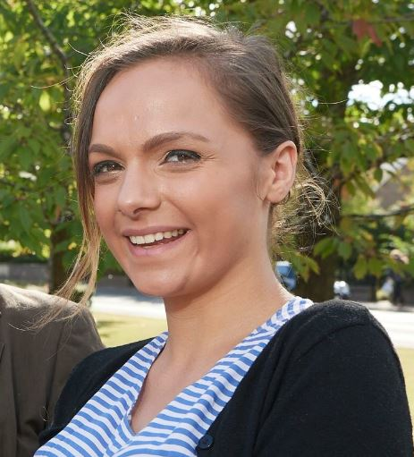
Highland Youth Convener 2018-2019 Report

Esme Leitch (21) from Duror, Lochaber took up the role as the 13th Highland Youth Convener in August 2018.

Role

As Highland Youth Convener, Esme’s role was to:

- assist in ensuring that young people’s views in the Highlands are being heard and being voiced in partnership with The Highland Council and Community Planning Partners.
- act as a representative for young people and Highland Youth Parliament in various council and community planning partner meetings discussing issues, policies and developments which have an impact on young people.
- contribute in making the Highlands the best place for young people to live, grow and develop.
- work for a good quality of life for young people and work towards maximising the availability of services for young people’s personal, social and education development.

Priorities this year:
As highlighted in her Youth Convener Action Plan 2018-2019, Esme’s priorities were Rural Empowerment and Engagement, Gender Equality, Inclusivity and Communication and Engagement.

Working with the Highland Youth Parliament and Youth Forums and their Priorities:
She has worked closely with the Highland Youth Parliament (HYP) and Youth Forums to help to make progress on some of the issues and projects young people are working on at a local level:
- Personal Social Education – improve content, delivery, relationships
- Rural areas - Improve opportunities for young people
- Additional Support Needs (ASN) - Strengthen voice, support, integration & raise awareness
- LGBTI+ - Strengthen voice and support & raise awareness for LGBTI+
- Care Experienced Young people – increase awareness, support and joint working with CHAMPs
- Sexual health - Improve sexual health relationships info and training
- Mental Health - Strengthen voice and support & raise awareness re young people’s mental health issues
- Transport – discuss issues and solutions at local level
- Local Democracy - Continue to work on young people’s engagement in their local communities (youth forums, Community Partnership meetings, school meetings etc)
- Promote Area forums and events for young people to have a voice
- Employment - promote job & college opportunities apprenticeships and Living Wage for young people
- Rights – know and use your rights & promote to other young people
- Drugs – investigate what is being done to decrease drug use amongst young people
- Environment – area forum activity

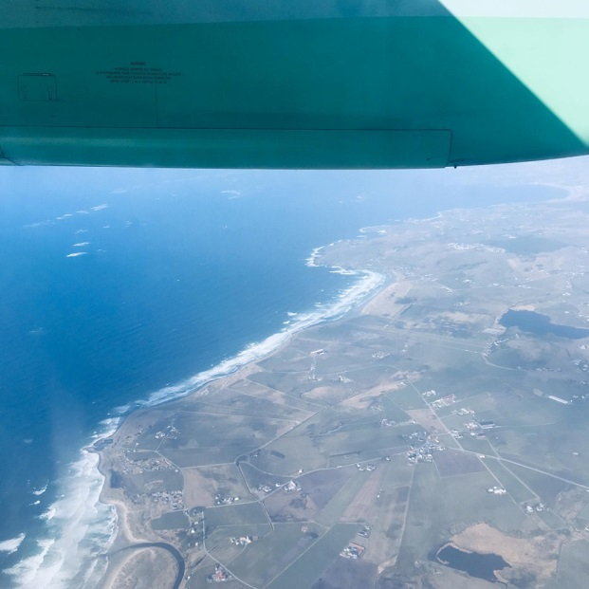
Over her term, Esme introduced herself, met up with and worked with a wide range of organisations across Highland with the aim to increase youth participation, for example:

- The Community Planning Board
- For Highland’s Children 4 Leadership Group
- UHI Foundation
- MFR Cash For Kids Board
- The Highland Council Single Use Plastic Working Group
- Highland Environment Forum
- NHS Highland
- Highland Fire and Rescue Service
- Police Scotland
- Worker’s Education Association (WEA)
- Scottish Health Council
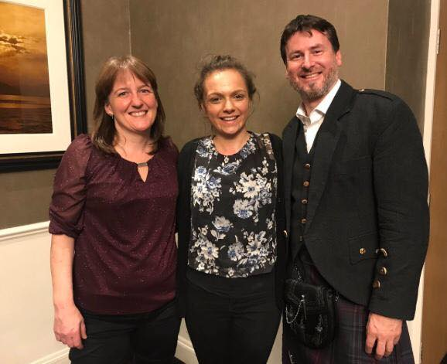
- Highland and Island’s Student Association
- Youth Highland
- Highland Children’s Forum
- Highland Senior Citizen’s Network
- CHAMPS Board (Highland Champion’s Board for care experienced people)
- Rape & Sexual Abuse Service Highland (RASASH)
- Highland CashBack Panel
- HIE
- LGBTi Sub-group
- WAVE Highland (Waverley Care’s sexual education project)
- ProudNess
- Highland One World - Start the Change
- Climate Change team
- Various other Highland Council Services

Esme also had meetings and delivered presentations and worshops to WEA, the Rural Transport Conference, the Rural Parliament, local youth forums, area youth conferences, Community Partnerships and Secondary schools on HYP/YC role. She represented The Highland Council at the Eurocities conference in Edinburgh, presented about Highland’s youth participation structure at a North Sea Commission Youth Conference in Norway and advised the NS Commission on their youth engagement

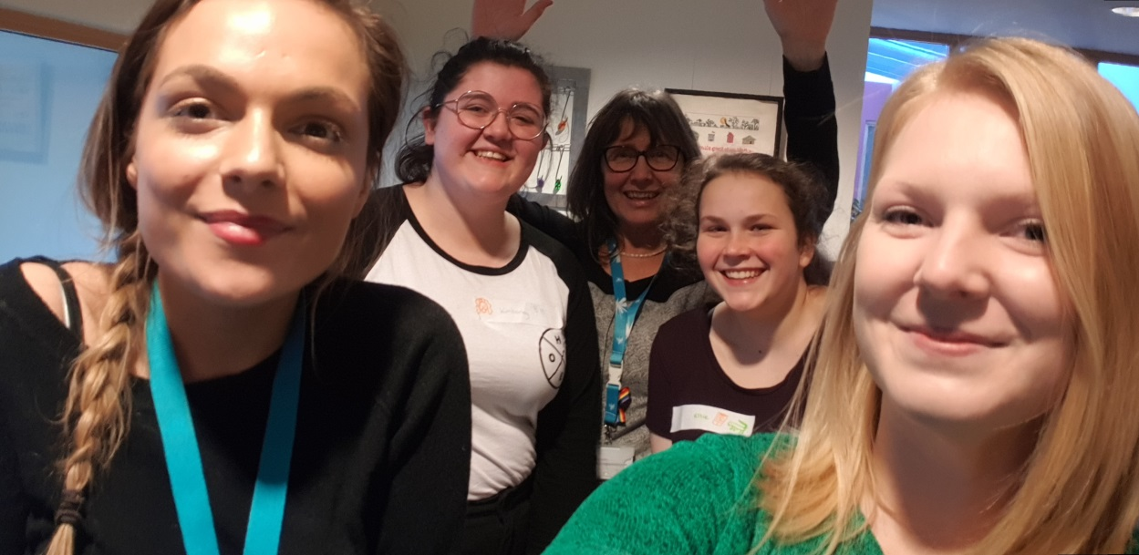
Projects:
- Youth Work Strategy – the Youth Work Strategy had being co-designed with young people and relevant stakeholders. Esme has co-chaired the meetings to progress this and led on the youth side of co-production, data analysis and working with partner organisations. She also delivered a presentation on the strategy to the Care, Learning and House Committee.

- Mental Health – Esme listened to project ideas from youth forums which are focused on supporting young people’s mental health – i.e. a Parent’s Evening at Nairn to raise parents’ awareness of young people’s mental health and another idea to develop peer support mental health first-aid training for young people. This led to a session at the June HYP Conference on this.

- Sexual Health – Worked with NHS Highland on a condom distribution plan to young people and WAVE Highland on developing youth-led sexual health programmes

- LGBTi – Worked with the Northern Alliance to progress on LGBTi pledges made by HYP members at the HYP June 18 Conference. Esme also attended and promoted the Proud Ness events 18/19

- Transport – Delivered the opening speech and ran a workshop at the Rural Transport Convention. Also facilitated a consultation discussing the issues and barriers faced by young people surrounding transport in Highland. Plan took these issues to the Rural Parliament in Stranraer in November 2018 and worked with Highland Members of the Scottish Youth Parliament on their ‘All Aboard’ Transport Campaign, feeding in Highland young people’s transport issues.

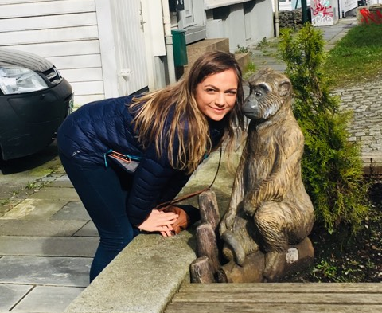
Esme was also involved in The Highland Council’s CLD Inspection October 2018 and worked with The Highland Council’s Corporate Resources team on The Highland Council Survey of Performance and Attitudes to develop some questions on perceptions of young people.

Over her term as Youth Convener, Esme completed her Gold Duke of Edinburgh Award which will recognise her work over the year.

Since attending the North Sea Commission’s Youth Participation Conference in Norway, Esme has been offered a part-time job within the NSC as Youth Advisor, leading their youth participation on an international level. She aims to start this in late 2019.
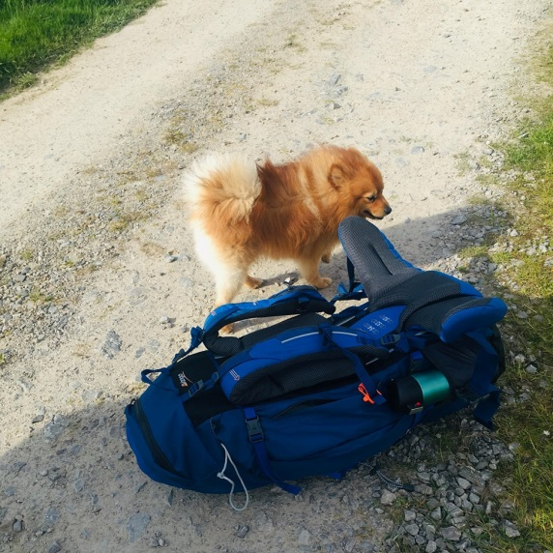

Esme would like to thank everyone in the team at Highlife Highland and partner organisations for their support and encouragement over the last year.

