HIGH LIFE HIGHLAND  REPORT TO BOARD OF DIRECTORS  27 August 2019 | AGENDA ITEM REPORT No HLH /18

Performance Report - Report by Chief Executive

Summary

The purpose of this report is to present performance information for the period April to June 2019.

It is recommended Directors:-

- comment on the report and agree that the overall health check on the Company for the period is assessed as green; and
- note that the delivery of the business plan is assessed as green.

1. | Business Plan Contribution
1.1 | This report supports all of the Business Outcomes from the High Life Highland (HLH) Business Plan:  - Sustain a high standard of health and safety, and environmental performance  - Implement the Service Delivery Contract with THC  - Improving customer engagement and satisfaction  - Improving staff engagement and satisfaction  - Enhance the positive charity image  - Be a trusted and effective partner  - Achieve sustainable growth across the organisation  - Develop health and wellbeing across Highland communities  - Develop and promote the High Life brand
2. | Background
2.1 | The implementation of the HLH Business Plan 2019-24 is monitored in two ways:  - through a set of performance indicators set by the Board at its meeting held on 11 December 2018; and  - by RAG rating the delivery of the business outcomes contained in the business plan with these being reported to the Board by exception (i.e. reporting where managers had RAG rated the actions “red – no significant progress”).

3. | Summary of Performance
3.1 | Appendix A contains a summary of performance against the performance indicators along with trend information for numeric PIs. There are thirteen performance indicators scheduled for assessment at the August 2019 Board meeting. Eleven of them have been RAG rated “green”, one “red” and one “amber”. The PIs which have been RAG rated red and amber are as follows:  - PI 8. Staff absence rate – this has been RAG rated red and there is further information contained in the Human Resources Report elsewhere on this agenda.  - PI 14. High Life subscription cancellation rate.
3.2 | PI 3 High Life Subscription Cancellation Rate - the cancellation rate was 3% each month during quarter one. It has been at this level for over a year now except for two months when: it dropped to 1% for one month in June 2018; and increased to 4% for one month in October 2018. The overall number of subscriptions is still increasing with new subscriptions exceeding cancellations.
3.3 | This year, with the Council having imposed an additional savings target associated with increasing the price of the High Life leisure card, the High Life card exit survey was amended to include the April price increase as a reason for leaving. It was noted at the Finance and Audit Committee meeting held on 5 August 2019 that the tracking mechanism to gauge the level of lost income of the High Life membership scheme had been agreed in principle with Council officials but this had yet to be formally signed off. In the meantime, a record was being kept where price increases had been highlighted as a reason for cancelling membership and, to date, this percentage appeared to be relatively low.
4. | Delivery of Business Outcomes
4.1 | The HLH Business Plan 2019-24 identifies nine business outcomes and the approach which the charity takes to deliver them. The resultant Operational Plans for each of the nine HLH areas of work are RAG rated every quarter.
4.2 | The RAG ratings of the operational plans has identified that delivery of the Business Plan is on target. Six of the nine areas of HLH work RAG rated all of the actions “green – on target” or complete; one area of work has RAG rated 2 actions “amber – some slippage” and two areas of work RAG rated 1 action as “amber – some slippage”. Directors have agreed that reporting on the delivery of the business outcomes would be by exception (i.e. reporting where managers had RAG rated the actions “red – no significant progress”) and there have been no actions which has been RAG rated “red” in quarter one 2019/20.
5. | Performance Indicators for More Detailed Consideration
5.1 | The performance indicator scheduled for more detailed consideration in this report is: PI 15. Partnership work with NHSH and other health related organisations. This is covered in the Health and Wellbeing Update report elsewhere on this agenda.
6. | Library Opening Hours
6.1 | At the HLH Board meeting held on 4 September 2018 Directors noted the increase in visits to libraries which had been achieved by reviewing opening hours and keeping the overall number of hours (and therefore costs) at each library the same and asked for information on future similar reviews. Library staff continue to review opening hours in consultation with communities to meet local needs and support local groups including nurseries, schools and community groups. Opening hours at Dornoch Library were changed from the beginning of May 2019, with early results indicating an increase in customer visits. Cromarty, Fortrose, Beauly and Ardnamurchan Libraries are currently undertaking customer consultations as the process is rolled out across the Highlands.
7. | Implications
7.1 | Resource Implications – there are no additional resource implications arising from this report.
7.2 | Legal Implications - there are no new legal implications arising from this report.
7.3 | Equality Implications – there are no new equality implications arising from this report.
7.3 | Risk Implications – there are no new risk implications arising from this report.

Recommendation

It is recommended Directors:-

- comment on the report and agree that the overall health check on the Company for the period is assessed as green; and
- note that the delivery of the business plan is assessed as green.

Designation: Chief Executive

Date: 9 August 2019

Appendix A
HLH Performance Indicators

Business Plan Outcome | Performance Indicator | Reporting Frequency | RAG Rating Definition | RAG Rating Q1 19/20 | RAG Rating Q2 19/20 | RAG Rating Q3 19/20 | RAG Rating Q4 19/20 | Summary of Quarter One Performance
1. Sustain a high standard of health and safety and environmental performance | 1. Health and safety audit. | Annual. | - Red = the external audit raises systemic (i.e. applying across multiple sites) H&S issues.  - Amber = the external audit highlights common actions to be addressed across the company.  - Green = the external audit does not raise systemic issues. | Green |  |  |  | As reported at the Finance and Audit Committee at its meeting on 5 August 2019 the audit carried out into HLH Health and Safety Arrangements provided “Substantial Assurance” that the three databases developed to support the implementation of HLH’s H&S Policy were effective.

Business Plan Outcome | Performance Indicator | Reporting Frequency | RAG Rating Definition | RAG Rating Q1 19/20 | RAG Rating Q2 19/20 | RAG Rating Q3 19/20 | RAG Rating Q4 19/20 | Summary of Quarter One Performance
1. Sustain a high standard of health and safety and environmental performance (cont.) | 2. RIDDOR accidents/incidents. | Quarterly. | - Red = number of RIDDOR reports per quarter is above 20.  - Amber = number of RIDDOR reports per quarter is between 10 and 20  - Green = number of RIDDOR reports per quarter is less than 10. | Green |  |  |  | There were no accidents nor incidents reported under the RIDDOR regulations during Q1 2019/20.

Performance Indicator 2 - RIDDOR accidents/incidents
The graph below tracks the number of accidents and incidents reported under the Reporting of Injuries, Diseases and Dangerous Occurrences Regulations (RIDDOR). There were no RIDDOR accidents nor incidents reported in Q1 2019/20.
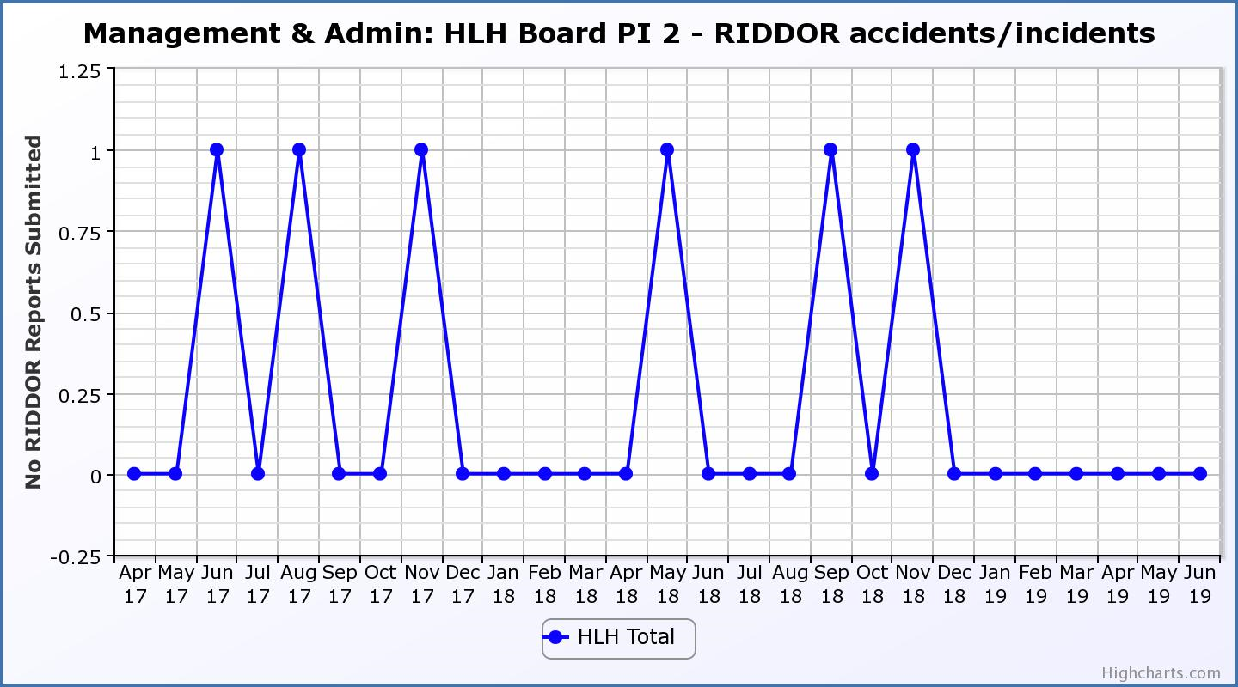

Business Plan Outcome | Performance Indicator | Reporting Frequency | RAG Rating Definition | RAG Rating Q1 19/20 | RAG Rating Q2 19/20 | RAG Rating Q3 19/20 | RAG Rating Q4 19/20 | Summary of Quarter One Performance
2. Implement the Service Delivery Contract with The Highland Council | 3. Delivery of the Service Delivery Contract (SDC) with The Highland Council (THC). | Six-monthly. | - Red = agreement of THC’s CLH Committee that HLH has not met the terms of the SDC.  - Amber = agreement of THC’s CLH Committee that HLH has met the terms of the SDC but has set some improvement targets.  - Green = agreement of THC’s CLH Committee that HLH has met or exceeded the terms of the SDC. |  |  |  |  | NA – this is a six-monthly indicator. It was reported at the 20 June HLH Board meeting that on 29 May 2019 THC’s Care, Learning and Housing (CLH) Committee agreed that HLH had met or exceeded the outcomes expected in the SDC with the Council for the operating period to March 2019 and there were a range of positive contributions from Members on music tuition and the work of HLH.

Business Plan Outcome | Performance Indicator | Reporting Frequency | RAG Rating Definition | RAG Rating Q1 19/20 | RAG Rating Q2 19/20 | RAG Rating Q3 19/20 | RAG Rating Q4 19/20 | Summary of Quarter One Performance
3. Improve customer engagement and satisfaction | 4. Customer engagements. | Quarterly. | - Red = customer numbers are more than 5% lower than the corresponding quarter in the previous year.  - Amber = customer numbers are less than the corresponding quarter in the previous year.  - Green = customer numbers are the same as or have increased compared with the corresponding quarter in the previous year. | Green |  |  |  | Customer engagements increased from 2,046,402 in Q1 2018/19 to 2,295,186 in Q1 2019/20.
Performance Indicator 4 - Customer engagements
The graph below shows a year on year increase in customer numbers.
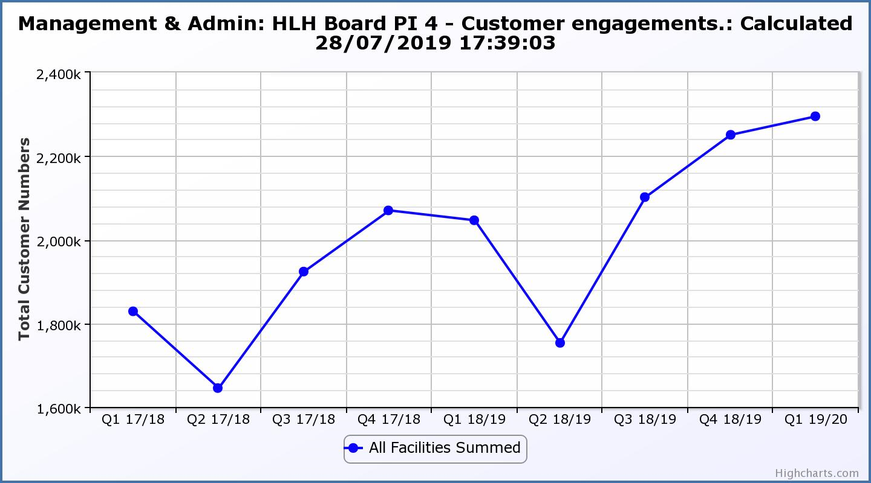

Business Plan Outcome | Performance Indicator | Reporting Frequency | RAG Rating Definition | RAG Rating Q1 19/20 | RAG Rating Q2 19/20 | RAG Rating Q3 19/20 | RAG Rating Q4 19/20 | Summary of Quarter One Performance
3. Improve customer engagement and satisfaction (cont.) | 5. Customer surveys. | Quarterly. | - Red = no surveys have been completed or scheduled.  - Amber = 4 to 8 of the HLH areas of work have completed or scheduled customer surveys.  - Green = all areas of HLH work have completed or scheduled customer surveys. | Green |  |  |  | All areas of work have included customer surveys in their operational plans for 2018/19.

Business Plan Outcome | Performance Indicator | Reporting Frequency | RAG Rating Definition | RAG Rating Q1 19/20 | RAG Rating Q2 19/20 | RAG Rating Q3 19/20 | RAG Rating Q4 19/20 | Summary of Quarter One Performance
3. Improve customer engagement and satisfaction (cont.) | 6. Formal complaints. | Quarterly. | - Red = 41 or more complaints per quarter.  - Amber = 31 to 40 complaints per quarter.  - Green = 30 complaints or fewer per quarter. | Green |  |  |  | There were 18 complaints received during Q1 2019/20.

Performance Indicator 6 - Formal Complaints
The graph below shows the number of complaints which continue to be very low in relation to customer numbers.
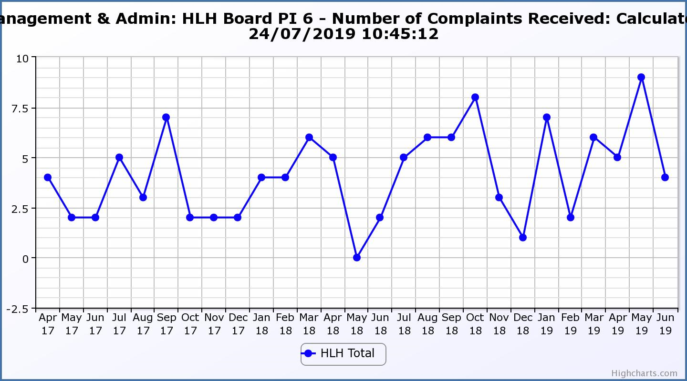
Business Plan Outcome | Performance Indicator | Reporting Frequency | RAG Rating Definition | RAG Rating Q1 19/20 | RAG Rating Q2 19/20 | RAG Rating Q3 19/20 | RAG Rating Q4 19/20 | Summary of Quarter One Performance
4. Improve staff engagement and satisfaction | 7. Staff turnover (resignations as a percentage of posts). | Quarterly. | - Red = more than 2%  - Amber = 1.7 to 2%  - Green = 1.6% or less | Green |  |  |  | The number of resignations per month as a percentage of posts in Q1 was 0.4% in April, 0.4% in May and 0.3% in June. Please see HR report elsewhere on this agenda for further information.

Performance Indicator 7 - Staff Turnover (resignations as a percentage of posts)
The graph below shows resignations as a percentage of the number of posts and resignations have been consistent with previous years and continue to be low (1% equates to 10.6 staff)
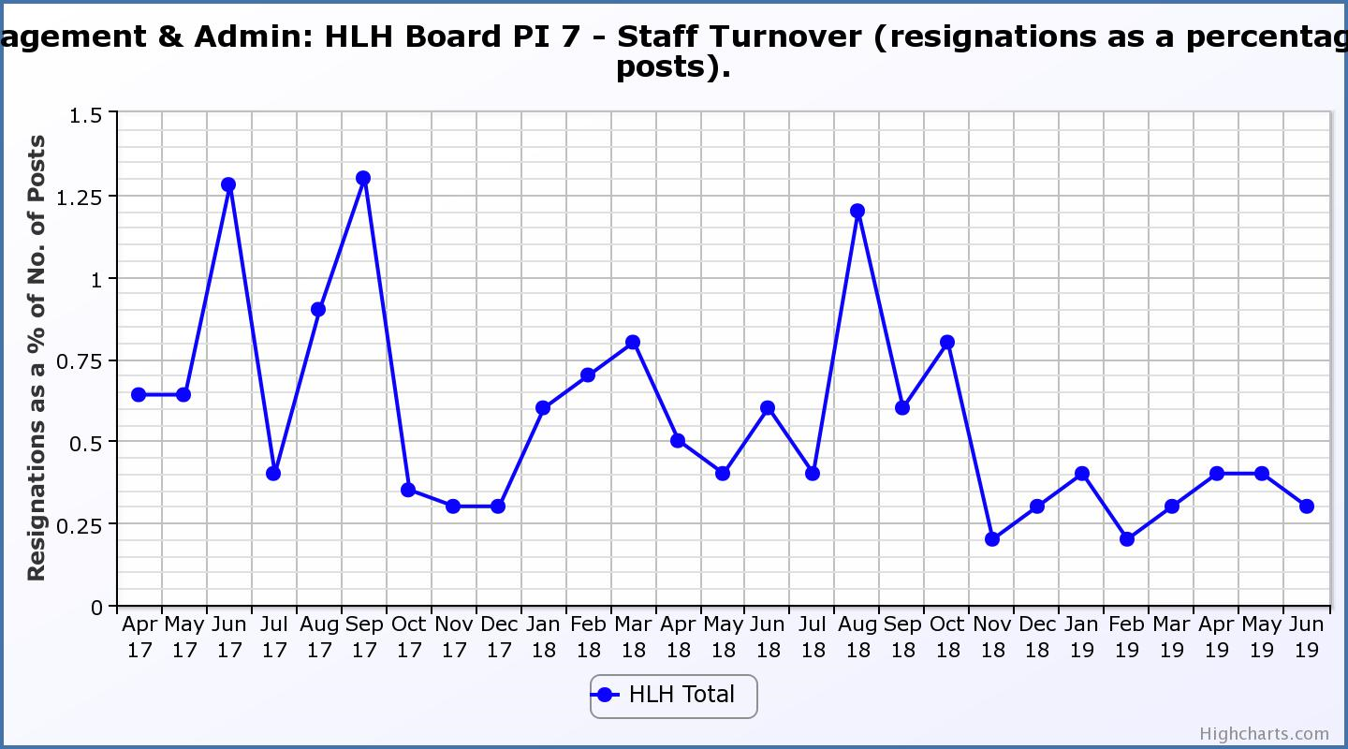
Business Plan Outcome | Performance Indicator | Reporting Frequency | RAG Rating Definition | RAG Rating Q1 19/20 | RAG Rating Q2 19/20 | RAG Rating Q3 19/20 | RAG Rating Q4 19/20 | Summary of Quarter One Performance
4. Improve staff engagement and satisfaction (cont.) | 8. Staff absence rates. | Quarterly. | - Red = absence rate greater than 3.6%.  - Amber = absence rate between 3.4% and 3.6%.  - Green = absence rate 3.3% or less. | Red |  |  |  | The absence rate for Q1 was 4.24%. Please see the HR report elsewhere on this agenda for further information.

Performance Indicator 8 - Staff Absence Rates
The absence rate increased in quarter one of 2019/20. Please see the HR report elsewhere on this agenda for further information.
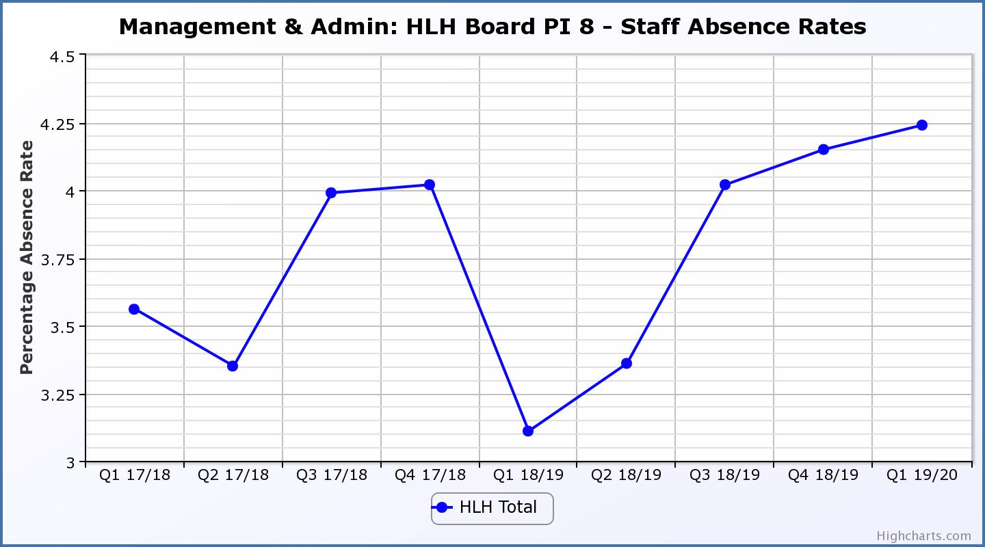

Business Plan Outcome | Performance Indicator | Reporting Frequency | RAG Rating Definition | RAG Rating Q1 19/20 | RAG Rating Q2 19/20 | RAG Rating Q3 19/20 | RAG Rating Q4 19/20 | Summary of Quarter One Performance
5. Enhance the positive company image | 9. Media clippings. | Quarterly | - Red = number of negative press clippings outweigh neutral and positive.  - Amber = number of negative and neutral press clippings outweigh positive.  - Green = number of positive and neutral media clippings outweigh negative. | Green |  |  |  | Media clippings for Q1 2019/20 totalled 104. 92 of these were positive,  10 were neutral and there were 2 which were negative.

Performance Indicator 9 - Media Clippings
The following two graphs show the numbers of positive and neutral media clippings compared with negative. The positive and neutral outweigh the negative.
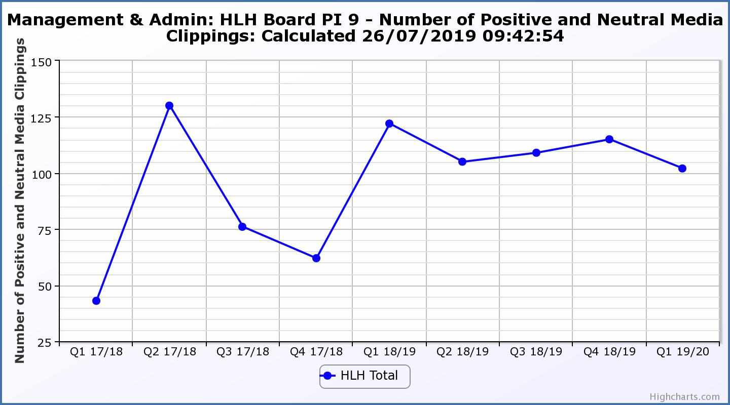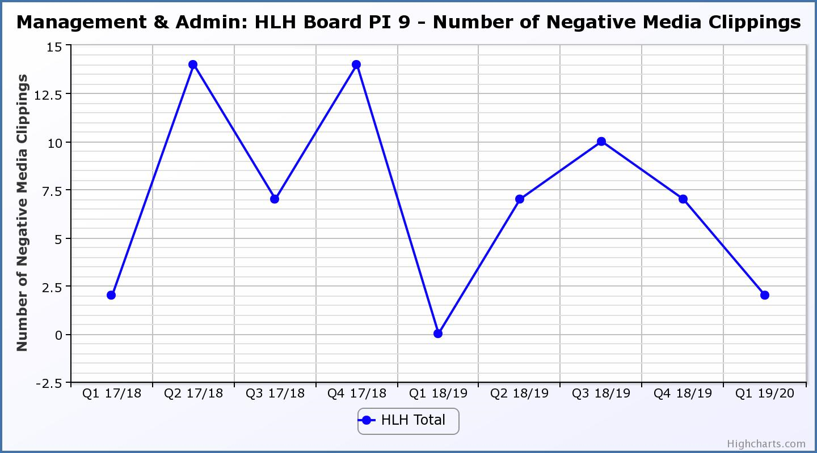
Business Plan Outcome | Performance Indicator | Reporting Frequency | RAG Rating Definition | RAG Rating Q1 19/20 | RAG Rating Q2 19/20 | RAG Rating Q3 19/20 | RAG Rating Q4 19/20 | Summary of Quarter One Performance
6. Be a trusted and effective partner | 10. THC’s annual survey of performance and attitudes. | Annual. | - Red = all HLH areas of work represented receive lower net satisfaction ratings than the previous year.  - Amber = two or more areas of HLH work receive lower net satisfaction ratings than the previous year.  - Green = net satisfaction ratings are maintained or improved for three or more areas of HLH work compared with the previous year. |  |  |  |  | NA – this is an annual indicator.

Business Plan Outcome | Performance Indicator | Reporting Frequency | RAG Rating Definition | RAG Rating Q1 19/20 | RAG Rating Q2 19/20 | RAG Rating Q3 19/20 | RAG Rating Q4 19/20 | Summary of Quarter One Performance
6. Be a trusted and effective partner (cont.) | 11. Partnership work with sportscotland | Annual | - Red = cancellation of Partnership Agreement with sportscotland  - Amber = continuation of current level of partnership work with sportscotland  - Green = Growth in partnership working with sportscotland | Green |  |  |  | A new four year partnership agreement with sportscotland has been signed for the delivery of the active schools, sports hubs and leadership programmes.

Business Plan Outcome | Performance Indicator | Reporting Frequency | RAG* Rating Definition  (*Red/Amber/Green) | RAG Rating Q1 19/20 | RAG Rating Q2 19/20 | RAG Rating Q3 19/20 | RAG Rating Q4 19/20 | Summary of Quarter One Performance
7. Achieve sustainable growth across the organisation | 12. Financial monitoring. | Quarterly. | An assessment of the year end outturn where:  - Red = delivery of services over budget above 2%.  - Amber = delivery of services between break-even and 2% over budget.  - Green = delivery of services within budget. | Green |  |  |  | The variance for the budget up to the end of quarter 1 was £13K and it is projected that the SDC will be delivered within budget for financial year 2019/20. See the Finance Report elsewhere on this agenda for further information.

Performance Indicator 12 - Financial monitoring
See the Finance Report elsewhere on this agenda for further information.
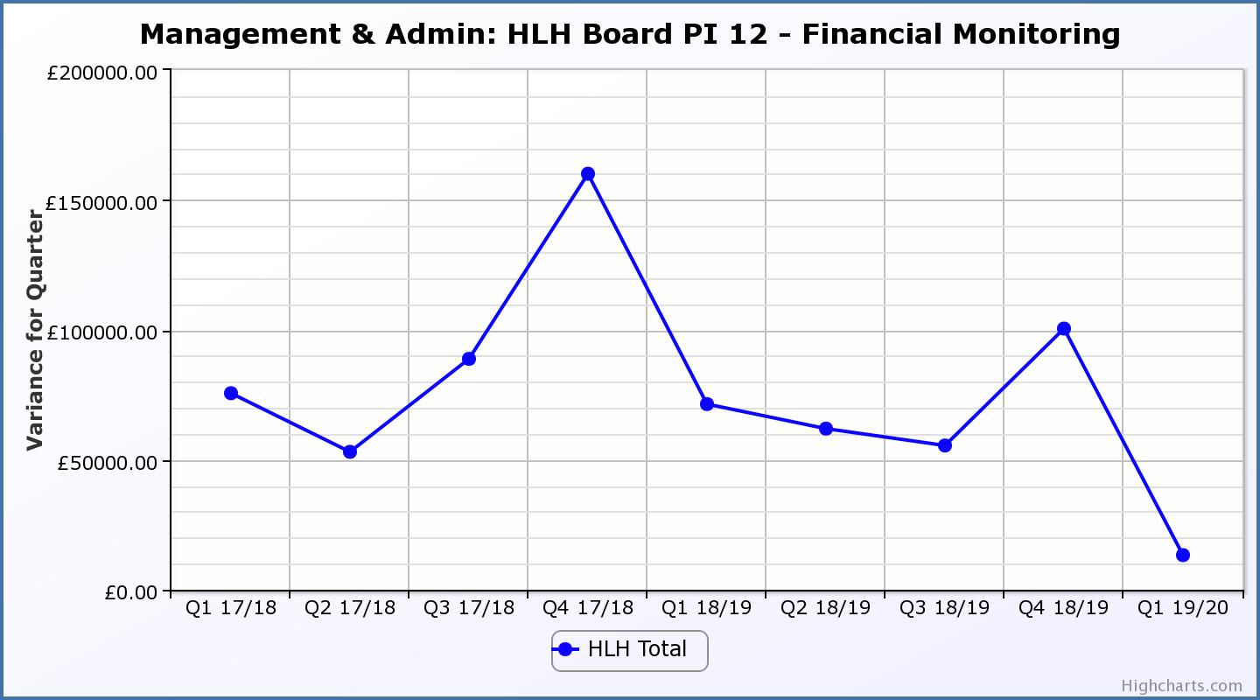
Business Plan Outcome | Performance Indicator | Reporting Frequency | RAG Rating Definition | RAG Rating Q1 19/20 | RAG Rating Q2 19/20 | RAG Rating Q3 19/20 | RAG Rating Q4 19/20 | Summary of Quarter One Performance
7. Achieve sustainable growth across the organisation (cont.) | 13. Number of High Life subscriptions. | Quarterly. | - Red = more than 5% below target.  - Amber = up to 5% below target.  - Green = on or exceeds target. | Green |  |  |  | The number of subscriptions each month during Q1 2019/20 exceeded the target of 20,086 with the average number of subscriptions for the quarter having been 21,652. The target has been set at the level required to achieve the High Life Subscriptions income target.

Performance Indicator 13 - Number of High Life Subscriptions
The trend of the number of High Life Card subscriptions increasing is continuing but is being closely monitored given the amber RAG rating for the cancellation rate.

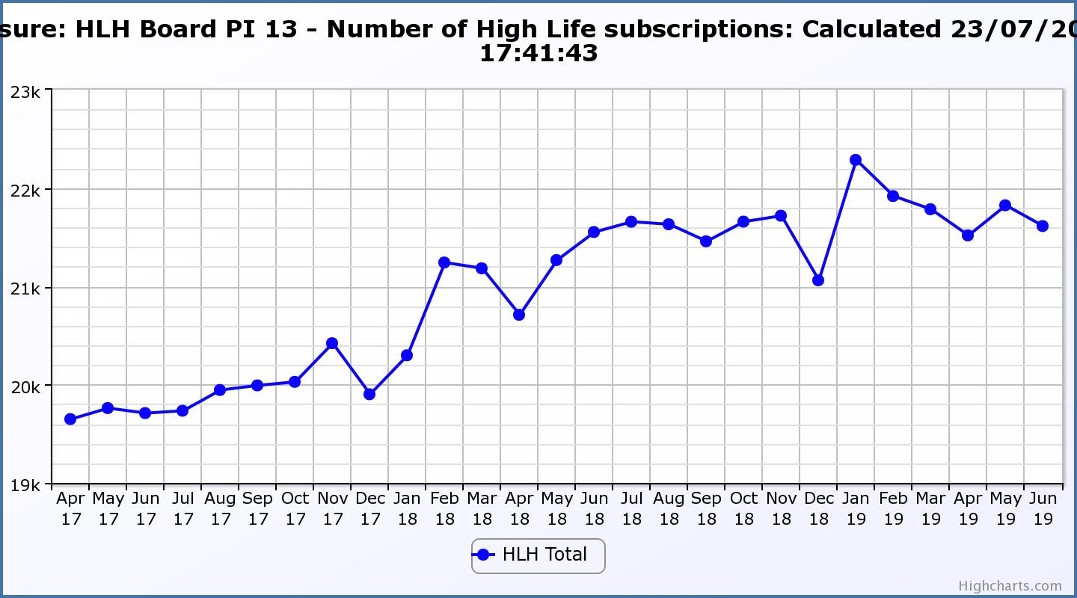
Business Plan Outcome | Performance Indicator | Reporting Frequency | RAG Rating Definition | RAG Rating Q1 19/20 | RAG Rating Q2 19/20 | RAG Rating Q3 19/20 | RAG Rating Q4 19/20 | Summary of Quarter One Performance
7. Achieve sustainable growth across the organisation (cont.) | 14. High Life cancellation rate. | Quarterly. | - Red = cancellation rate above 6% of High Life memberships.  - Amber = cancellation rate is 3% - 6% of High Life memberships.  - Green = cancellation rate is up to 3% of High Life memberships. | Amber |  |  |  | The High Life cancellation rates in Q1 were 3% in April, 3% in May and 3% in June.

Performance Indicator 14 - High Life Cancellation Rate
The overall number of subscriptions continues to increase (as can be seen above). The cancellation rate was 3% each month during quarter four. Please see section three of this report for further information.
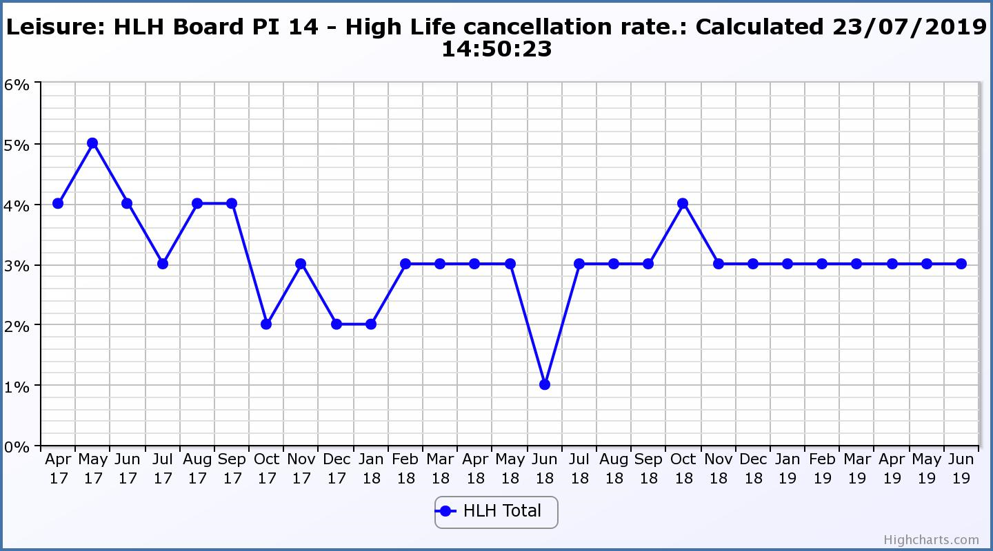
Business Plan Outcome | Performance Indicator | Reporting Frequency | RAG Rating Definition | RAG Rating Q1 19/20 | RAG Rating Q2 19/20 | RAG Rating Q3 19/20 | RAG Rating Q4 19/20 | Summary of Quarter One Performance
8. Develop health and wellbeing across Highland communities | 15. Partnership work with NHSH and other health related organisations. |  | - Red = no partnership work with NHSH etc.  - Amber = Reduction of current level of partnership work with NHSH etc.  - Green = Continuation or growth in partnership working with NHSH etc. | Green |  |  |  | Please see the Health and Wellbeing Update report elsewhere on this agenda for further information.

Business Plan Outcome | Performance Indicator | Reporting Frequency | RAG Rating Definition | RAG Rating Q1 19/20 | RAG Rating Q2 19/20 | RAG Rating Q3 19/20 | RAG Rating Q4 19/20 | Summary of Quarter One Performance
9. Develop and promote the High Life brand | 16. Uptake of HLH card towards the target of 80% of the population. | Annual | - Red = number of card-holders is maintained.  - Amber = number of card-holders is increased by 1-4%.  - Green = number of card-holders is increased by 5% or more. |  |  |  |  | NA – this is an annual indicator.

