HIGH LIFE HIGHLAND  REPORT TO BOARD OF DIRECTORS  20 June 2019 | AGENDA ITEM REPORT No HLH /19

Performance Report - Report by Chief Executive

Summary

The purpose of this report is to present performance information for fourth quarter in the year 2018/19, the period January to March 2019.

It is recommended Directors:-

- comment on the report and agree that the overall health check on the Company for the period is assessed as green;
- note that the delivery of the business plan is assessed as green; and
- note the information provided on the performance indicators for more detailed consideration.

1. | Business Plan Contribution
1.1 | This report supports all the Business Outcomes from the High Life Highland (HLH) Business Plan:  - Sustain a high standard of health and safety, and environmental performance  - Implement the Service Delivery Contract with THC  - Improving customer engagement and satisfaction  - Improving staff engagement and satisfaction  - Enhance the positive charity image  - Be a trusted and effective partner  - Achieve sustainable growth across the organisation  - Develop health and wellbeing across Highland communities  - Develop and promote the High Life brand
2. | Background
2.1 | The performance indicators in this report were set, at the request of the Board, by the Finance and Audit Committee in March 2016. It was agreed then that reporting on the delivery of the business outcomes would be by exception (i.e. reporting where managers had RAG rated the actions “red – no significant progress”).

3. | Summary of Performance
3.1 | Appendix A contains a summary of performance against the performance indicators along with trend information for numeric PIs. There are eleven performance indicators scheduled for assessment at the June 2019 Board meeting. Eight of them have been RAG rated “green”; two amber; and one “red”. The PIs which have been RAG rated amber and red are as follows:  - PI 3 High Life subscription cancellation rate;  - PI 6 Staff absence rate;  - PI 10 Formal complaints.
3.2 | PI 3 High Life Subscription Cancellation Rate - the cancellation rate was 3% each month during January to March 2019 compared with 2% in January and 3% in February and March 2018. At the same time, the overall number of subscriptions continues to be healthy with there having been 21,183 subscriptions in March 2018 and 21,918 in March 2019 so the overall pattern of long term sustained growth has continued.
3.3 | PI 6 Staff absence rate – the absence rate was 4.15%, a slight increase compared to 4.02% in quarter four 2018/19. Please see the HR report elsewhere on this agenda for further information.
3.4 | PI 10 Formal complaints – there were fifteen complaints received during quarter four. Of those one complaint was not upheld, eight were partially upheld, and five were upheld. At the time of writing there was one complaint which was still open which was about gull noise at Ullapool Leisure Centre where the manager was awaiting a response from THC before finally responding to the complainant.
3.5 | The complaints which were upheld or partially upheld were different/isolated and examples include: an overpayment by a customer; a bookings system glitch which could not be replicated; a pool hoist being broken (repair had already been scheduled); a mobile library breakdown (replacement programme has been agreed with THC). Seven of the complaints were at Inverness Leisure, HLH’s busiest site, and although this is a very low number in relation to the number of customer visits the manager has been asked to review them with staff to consider whether there are any learning points to be addressed. All of the complaints were followed up and resolved with the complainants and where appropriate, the staff involved. The overall number of complaints continues to be very low in relation to customer numbers.
4. | Delivery of Business Outcomes
4.1 | The HLH Business Plan 2015-19 identified eight business outcomes and the approach which the charity took to deliver them. The resultant Operational Plans for each of the nine HLH areas of work were RAG rated every quarter. Over the life of the 2015-19 business plan the RAG ratings of the operational plans consistently identified that delivery of the business plan was on target.
4.2 | Reviews of the business outcomes for each of the nine HLH areas of work were carried out at senior management team meetings during quarters three and four 2018/19. The reviews identified that the delivery of the business plan was assessed as green and they noted:  - the outcomes which were complete  - the outcomes which were relevant for carrying forward to the new business plan  - the actions required to deliver the new outcomes in the 2019-24 business plan.
4.3 | This review included the development of new operational plans and the six Principal Managers responsible for each of the nine areas of HLH work will RAG rate the delivery of them quarterly so that reporting on the new business plan can commence from the quarter one 2019/20 performance report to the HLH Board at its August 2019 meeting.
5. | Performance Indicators for More Detailed Consideration
5.1 | The performance indicators scheduled for more detailed consideration in this report are:  - PI 4 - Delivery of the Service Delivery Contract (SDC) with the Highland Council (THC).  - PI 8 - Customer Numbers.  - PI 9 - Media clippings.  - PI 11 - Health and safety audit.  - PI 12 - RIDDOR accidents/incidents.
5.1 | PI 4 delivery of the SDC with THC . On 29 May 2019 THC’s Care, Learning and Housing (CLH) Committee considered the regular six monthly HLH update, covering services delivered during the period under review in this report and which provided:  - information on the performance of HLH  - general updates  - more detailed information on one aspect of the work of HLH.
5.2 | The HLH progress report (which can be seen on THC’s web site: https://www.highland.gov.uk/download/meetings/id/75310/item_20_high_life_highland_progress_report covered: the continued increase in customer engagements and reduced reliance on Council funding; and the routine reporting on the delivery of the Service Delivery Contract with THC. The general updates included information on:  - the new HLH business plan  - the renewed funding agreement with sportscotland  - staff nominations and successes in local and national awards  - the Newton Rooms science, technology, engineering and maths (STEM) partnership project being led by Highlands and Islands Enterprise with HLH, Skills Development Scotland, University of the Highlands and Islands, The Highland Council and NHS Highland  - the new Leisure Link partnership between HLH, Orkney, Western Isles, Argyll and Bute  - the added value which is available to customers who hold the High Life Highland card where 10% to 25% discounts are available from 100 local and national retailers on presentation of their card.
5.3 | This time round the more detailed information on one aspect of the work of HLH was on music tuition and it was contained in a separate report on the agenda (at the request of THC because new national guidance on music tuition has recently been published) and the report can be seen in Appendix B. The Council also asked HLH to provide a case study on Music Tuition for the (external) Best Value Audit of THC.
5.4 | THC’s schools music tuition service transferred to HLH on 1 April 2018 as agreed by the HLH Board at its meeting held on 13 December 2017. Within one year the transfer:  - has achieved a 21% (2,958 to 3,585) growth in customer numbers and a 14% (£8,000 per month) growth in income  - turned round what had been a sharp decline in customer numbers - in 2015/16 pupil numbers were 3,450 and this reduced to 3,100 in 2016/17 and 2,900 in 2017/18  - is a ground breaking and unique situation in Scotland where in many other areas services are facing cuts, and suffering from poor staff morale and low customer confidence.
5.5 | At its meeting on 29 May 2019 THC’s Care, Learning and Housing (CLH) Committee agreed that HLH had met or exceeded the outcomes expected in the SDC with the Council for the operating period to March 2019 and there were a range of positive contributions from Members on music tuition and the work of HLH.
5.6 | PI 8 customer numbers. Customer visits have been increasing year on year since HLH was established in October 2011. As can be seen in the graph below there were 8.4 million customer visits to HLH services last year. The customer number increase was 12% in 2018/19 and 10% in 2017/18.
5.7 | A breakdown of customer numbers by the nine HLH areas of work for 2017/18 and 2018/19 can be seen in the table below. Customer numbers increased across most areas of work. In the three areas of work where there were decreases they were small (from -0.4% to -3.1%). The greatest percentage increases were in:  - adult learning - where there has been a continuing focus on targeted work so the increase is particularly positive  - archives – where attendances at events more than doubled from 4,539 to 10,244 as a result of a proactive focus on this by staff  - libraries – where there has been a 52% (854,275 to 1,298,754) increase in virtual/on-line visits for services such as e-book borrowing (while at the same time, contrary to what is happening in many other areas in Scotland, footfall increased by 3%)  - outdoor activities – had a 14% increase made up of an estimated* 15% increase in the number of countryside ranger customer engagements and an increase in attendances at outdoor sports activities.  2017/18 2018/19 Difference % Change  Adult Learning 13,264 15,536 2,272 17.1%  Archives 797,653 897,752 100,099 12.5%  Arts 5,357 5,193 -164 -3.1%  Leisure 2,782,582 3,014,827 232,245 8.3%  Libraries 3,016,369 3,515,017 498,648 16.5%  Museums 307,795 306,608 -1,187 -0.4%  Music Tuition 0 87,569 NA NA  Outdoor Activities 12,886 14,660 1,774 13.8%  Sport 466,108 454,552 -11,556 -2.5%  Youth Services 78,319 80,730 2,411 3.1%  Total 7,473,890 8,392,444 830,985** 11.1%  *Countryside rangers transferred to HLH on 1 October 2017 so the 2017/18 Outdoor Activities figure was adjusted to allow the percentage increase to be estimated.  ** Music Tuition numbers have been excluded from the total in the table above, when included the percentage increase from 2017/18 to 2018/19 is 12%.
5.8 | PI 9 Media clippings - There is further information on this PI in the Marketing report elsewhere on this agenda.
5.9 | PIs 11 and 12 Health and Safety Audit and RIDDOR accidents/incidents - There is further information on these PIs in the Health and Safety and Environmental Compliance report elsewhere on this agenda.
6. | Customer Service Excellence (CSE) in Libraries
6.1 | HLH uses the Customer Service Excellence (CSE) framework in libraries and over the past four years:  - visits have increased from 2M to 3.5M  - savings of £1M have been made
6.2 | There was an external CSE assessment in May 2019 where:  - the accreditation was renewed;  - 41 areas of good practice were identified (an increase from last year when there were 32)  - 19 areas of sector leading Compliance Plus were identified (there were 17 last year)  - there were no partial compliances.
6.3 | Following the assessment the feedback from the Senior Lead Assessor, HM Cabinet Office, was that with 19 compliance pluses HLH libraries are the highest performing service (of any kind) in the country. This information has been provided to the Council to support it in its Best Value Audit.
6.4 | CSE has been introduced in the following areas of work: archives; arts and museums. Progress will be reviewed over the coming year before an assessment date is fixed.
7. | Implications
7.1 | Resource Implications – there are no additional resource implications arising from this report.
7.2 | Legal Implications - there are no new legal implications arising from this report.
7.3 | Equality Implications – there are no new equality implications arising from this report.
7.3 | Risk Implications – there are no new risk implications arising from this report.

Recommendation

It is recommended Directors:-

- comment on the report and agree that the overall health check on the Company for the period is assessed as green;
- note that the delivery of the business plan is assessed as green; and
- note the information provided on the performance indicators for more detailed consideration.

Designation: Chief Executive

Date: 4 June 2019
Appendix A
HLH Performance Indicators

Business Plan Outcome | Performance Indicator | Reporting Frequency | RAG* Rating Definition  (*Red/Amber/Green) | RAG Rating Q1 18/19 | RAG Rating Q2 18/19 | RAG Rating Q3 18/19 | RAG Rating Q4 18/19 | Summary of Quarter Four Performance
1. To advance sustainable growth and financial sustainability | 1. Financial monitoring. | Quarterly. | An assessment of the year end outturn where:  - Red = delivery of the SDC over budget above 2%.  - Amber = delivery of the SDC between break-even and 2% over budget.  - Green = delivery of SDC within budget. | Green | Green | Green | Green | The variance for the budget up to the end of quarter four was £100,506 and the SDC was, therefore delivered within budget for financial year 2018/19. See the Finance Report elsewhere on this agenda for further information.

Performance Indicator 1 - Financial monitoring, variance to budget per quarter.
See the Finance Report elsewhere on this agenda for further information.
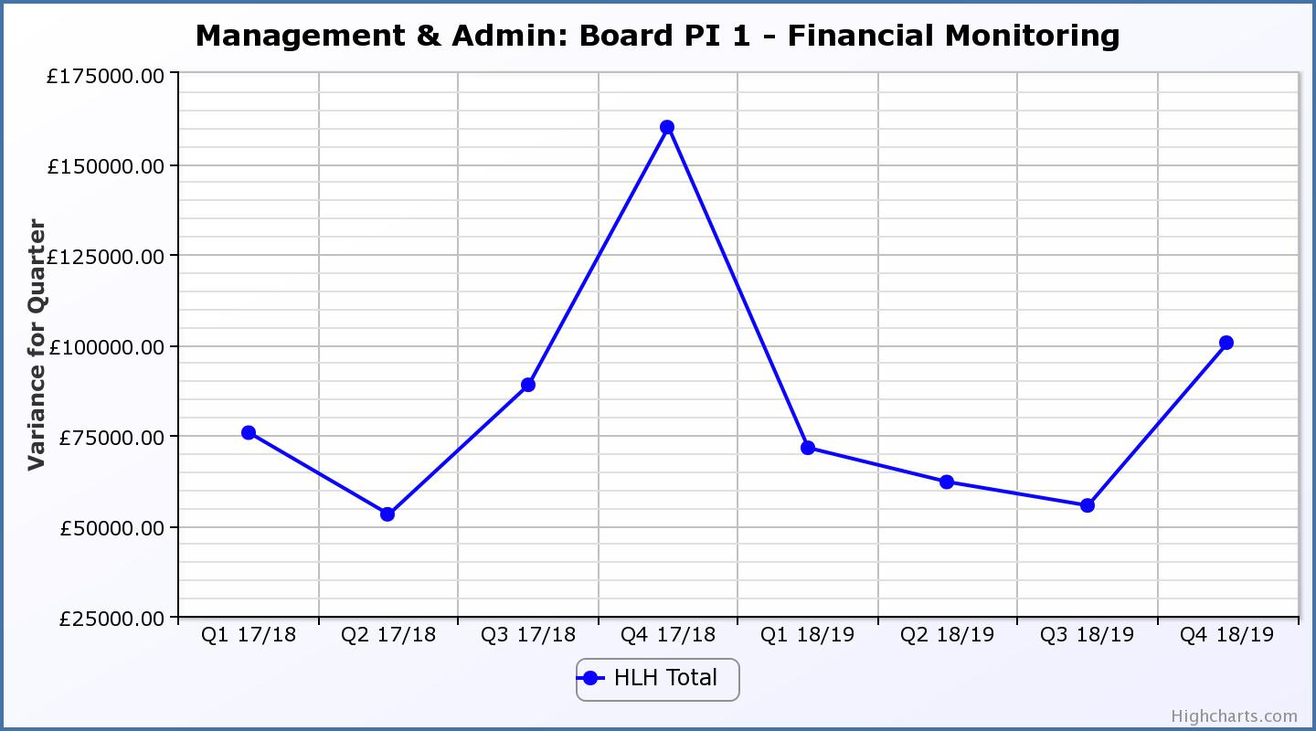

Business Plan Outcome | Performance Indicator | Reporting Frequency | RAG Rating Definition | RAG Rating Q1 18/19 | RAG Rating Q2 18/19 | RAG Rating Q3 18/19 | RAG Rating Q4 18/19 | Summary of Quarter Four Performance
1. To advance sustainable growth and financial sustainability (cont) | 2. Number of High Life subscriptions. | Quarterly. | - Red = more than 5% below target.  - Amber = up to 5% below target.  - Green = on or exceeds target. | Green | Green | Green | Green | The number of subscriptions each month during Q4 exceeded the target of 20,086 with the average number of subscriptions for the quarter having been 21,996. The target has been set at the level required to achieve the High Life Subscriptions income target.

Performance Indicator 2 - Number of High Life Subscriptions
The number of High Life Card subscriptions continues to increase and in January 2019 was the highest they have been at 22,286.

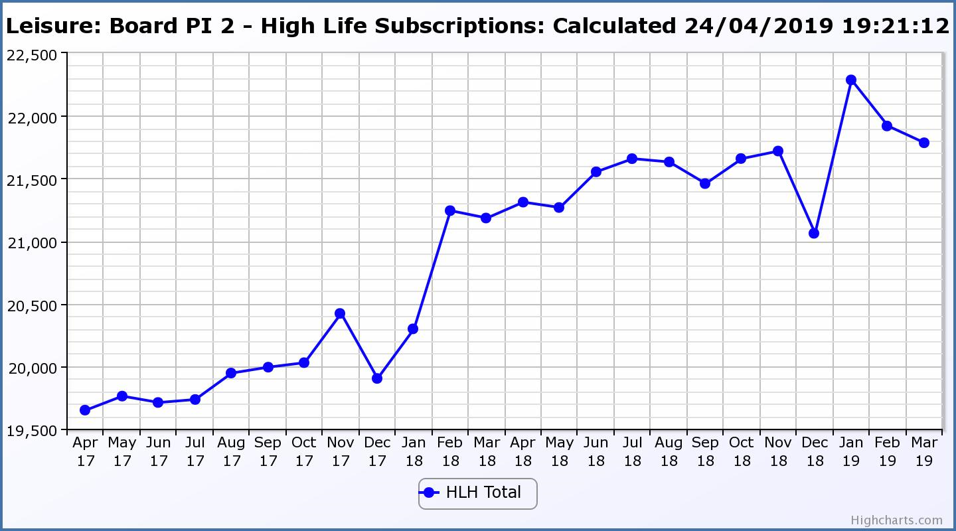

Business Plan Outcome | Performance Indicator | Reporting Frequency | RAG Rating Definition | RAG Rating Q1 18/19 | RAG Rating Q2 18/19 | RAG Rating Q3 18/19 | RAG Rating Q4 18/19 | Summary of Quarter Four Performance
1. To advance sustainable growth and financial sustainability (cont) | 3. High Life cancellation rate. | Quarterly. | - Red = cancellation rate above 6% of High Life memberships.  - Amber = cancellation rate is 3% - 6% of High Life memberships.  - Green = cancellation rate is up to 3% of High Life memberships. | Green | Amber | Amber | Amber | The High Life cancellation rates in Q4 were 3% in January, February and March.  Please see section three of this report for further information.

Performance Indicator 3 - High Life Cancellation Rate
The overall number of subscriptions continues to increase (as can be seen above). The cancellation rate was 3% each month during quarter four. Please see section three of this report for further information.
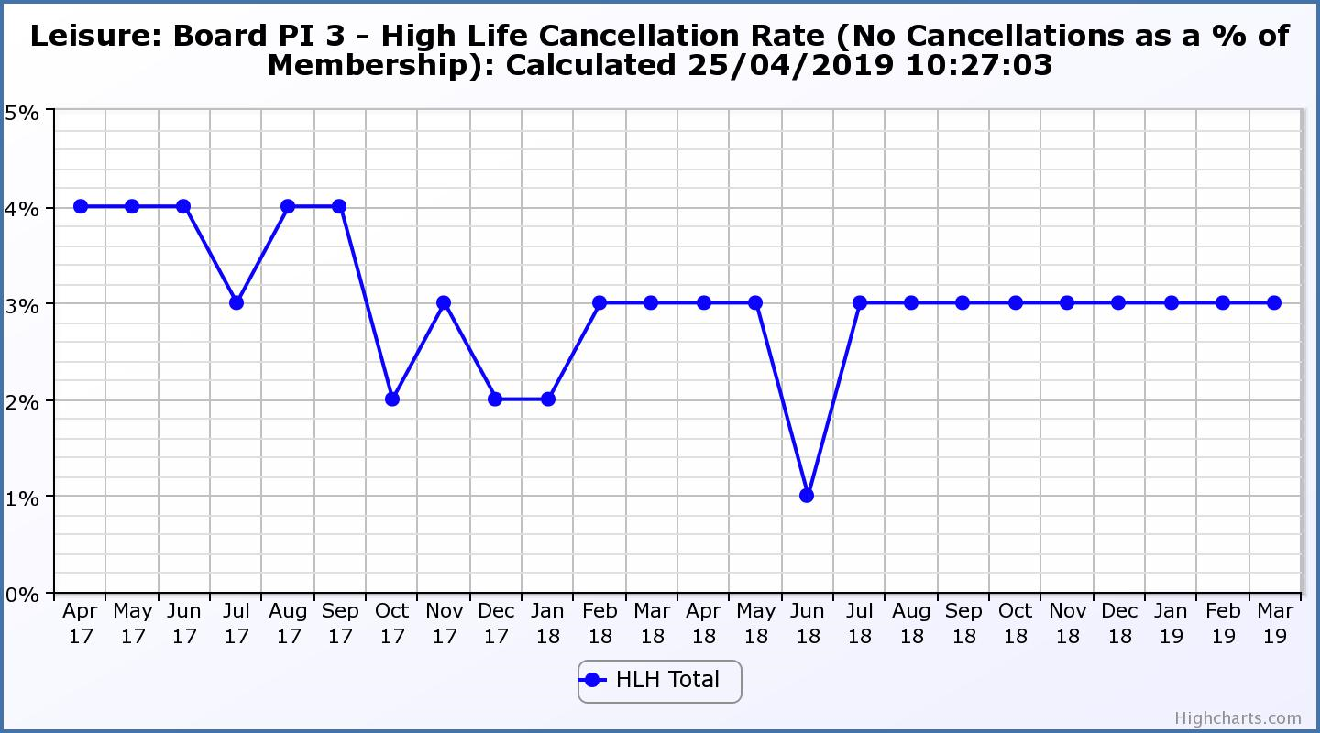

Business Plan Outcome | Performance Indicator | Reporting Frequency | RAG Rating Definition | RAG Rating Q1 18/19 | RAG Rating Q2 18/19 | RAG Rating Q3 18/19 | RAG Rating Q4 18/19 | Summary of Quarter Four Performance
2. Deliver the Service Delivery Contract with THC | 4. Delivery of the Service Delivery Contract (SDC) with The Highland Council (THC). | Six-monthly. | - Red = agreement of THC’s ECAS Committee that HLH has not met the terms of the SDC.  - Amber = agreement of THC’s ECAS Committee that HLH has met the terms of the SDC but has set some improvement targets.  - Green = agreement of THC’s ECAS Committee that HLH has met or exceeded the terms of the SDC. |  | Green |  | Green | At 29 May 2019 meeting THC’s Care, Learning and Housing (CLH) Committee agreed that HLH had met or exceeded the outcomes expected in the SDC with the Council for the operating period to March 2019.  Please see section five of this report for more detail.

Business Plan Outcome | Performance Indicator | Reporting Frequency | RAG Rating Definition | RAG Rating Q1 18/19 | RAG Rating Q2 18/19 | RAG Rating Q3 18/19 | RAG Rating Q4 18/19 | Summary of Quarter Four Performance
3. Improving staff satisfaction | 5. Staff turnover (resignations as a percentage of posts). | Quarterly. | - Red = more than 2%  - Amber = 1.7 to 2%  - Green = 1.6% or less | Green | Green | Green | Green | The number of resignations per month as a percentage of posts in Q4 was 0.4% in January, 0% in February and 0.3% in March.

Performance Indicator 5 - Staff Turnover (resignations as a percentage of posts)
The graph below shows resignations as a percentage of the number of posts and resignations have been consistent with previous years and continue to be low (1% equates to 10.6 staff).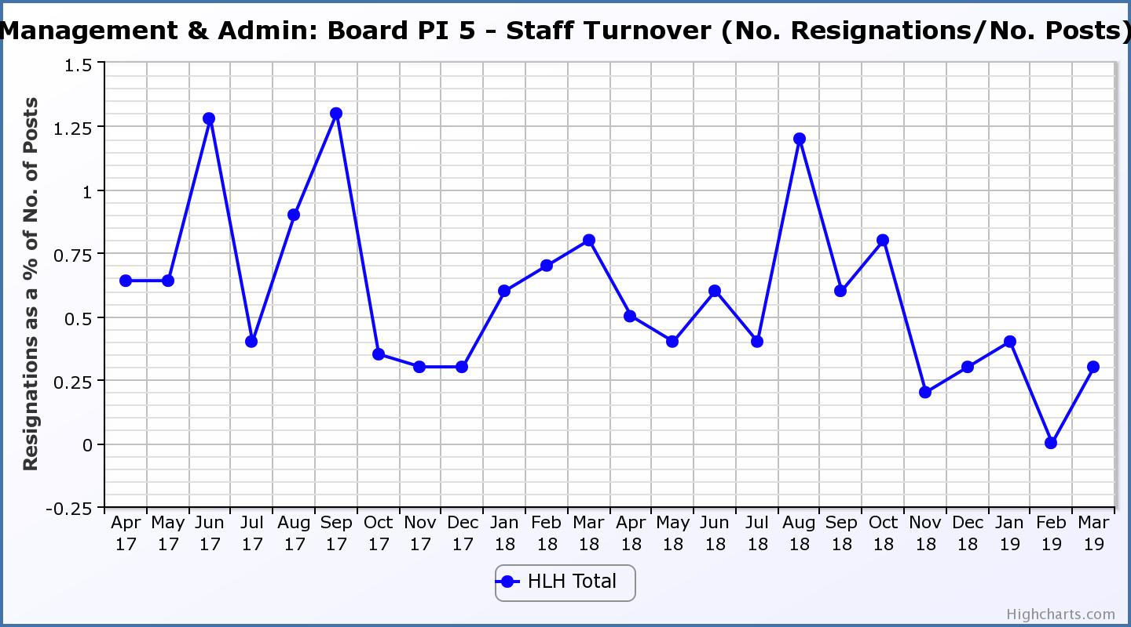
Business Plan Outcome | Performance Indicator | Reporting Frequency | RAG Rating Definition | RAG Rating Q1 18/19 | RAG Rating Q2 18/19 | RAG Rating Q3 18/19 | RAG Rating Q4 18/19 | Summary of Quarter Four Performance
3. Improving staff satisfaction (cont.) | 6. Staff absence rate. | Quarterly. | - Red = absence rate greater than 3.6%.  - Amber = absence rate between 3.4% and 3.6%.  - Green = absence rate 3.3% or less. | Green | Green | Red | Red | The absence rate for Q4 was 4.15%. Please see the HR report elsewhere on this agenda for further information.

Performance Indicator 6 - Staff Absence Rates
The absence rate increased in quarter four of 2018/19. Please see the HR report elsewhere on this agenda for further information.
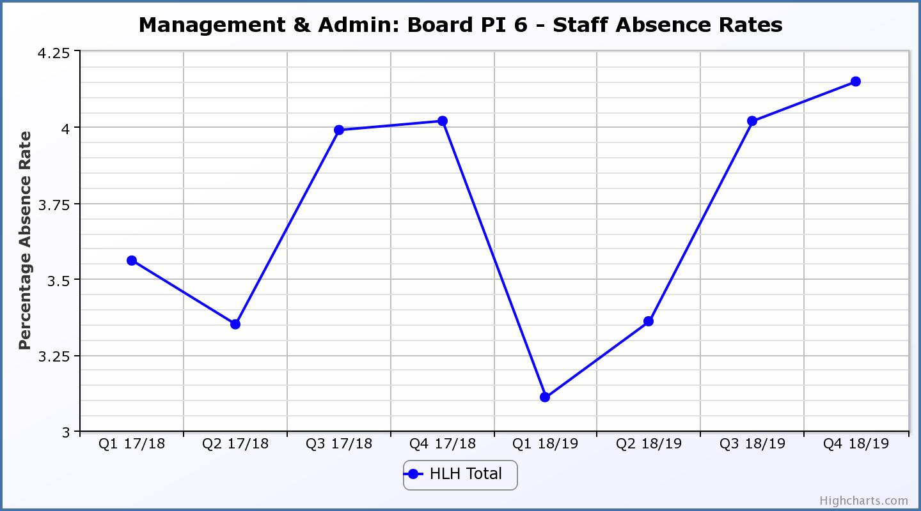

Business Plan Outcome | Performance Indicator | Reporting Frequency | RAG Rating Definition | RAG Rating Q1 18/19 | RAG Rating Q2 18/19 | RAG Rating Q3 18/19 | RAG Rating Q4 18/19 | Summary of Quarter Four Performance
4. Improving customer satisfaction | 7. Customer surveys. | Quarterly. | - Red = no staff surveys have been completed or scheduled.  - Amber = 4 to 8 of the HLH areas of work have completed or scheduled customer surveys.  - Green = all areas of HLH work have completed or scheduled customer surveys. | Green | Green | Green | Green | All areas of work included customer surveys in their operational plans for 2018/19.  This PI was reported on at the 21 March 2019 HLH Board meeting.

Business Plan Outcome | Performance Indicator | Reporting Frequency | RAG Rating Definition | RAG Rating Q1 18/19 | RAG Rating Q2 18/19 | RAG Rating Q3 18/19 | RAG Rating Q4 18/19 | Summary of Quarter Four Performance
4. Improving customer satisfaction (cont) | 8. Customer Numbers. | Quarterly. | - Red = customer numbers are more than 5% lower than the corresponding quarter in the previous year.  - Amber = customer numbers are less than the corresponding quarter in the previous year.  - Green = customer numbers are the same as or have increased compared with the corresponding quarter in the previous year. | Green | Green | Green | Green | Customer numbers increased from 2,089,232 in Q4 2017/18 to 2,281,662 in Q4 2018/19.

Performance Indicator 8 - Customer Numbers
The graph below shows a year on year increase in customer numbers.
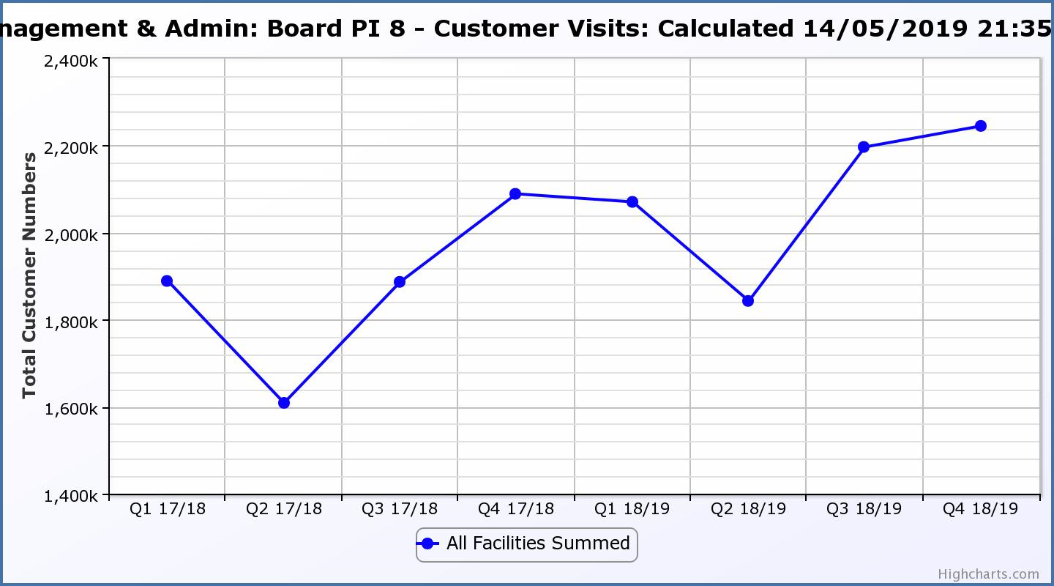

Business Plan Outcome | Performance Indicator | Reporting Frequency | RAG Rating Definition | RAG Rating Q1 18/19 | RAG Rating Q2 18/19 | RAG Rating Q3 18/19 | RAG Rating Q4 18/19 | Summary of Quarter Four Performance
5. A positive company image | 9.Media clippings. | Quarterly | - Red = number of negative press clippings outweigh neutral and positive.  - Amber = number of negative and neutral press clippings outweigh positive.  - Green = number of positive and neutral media clippings outweigh negative. | Green | Green | Green | Green | Media clippings for Q4 2018/19 totalled 122.  78 of these were positive, 37 were neutral and there were 7 which were negative.

Performance Indicator 9 - Media Clippings
The following two graphs show the numbers of positive and neutral media clippings compared with negative. The positive and neutral outweigh the negative.

Business Plan Outcome | Performance Indicator | Reporting Frequency | RAG Rating Definition | RAG Rating Q1 18/19 | RAG Rating Q2 18/19 | RAG Rating Q3 18/19 | RAG Rating Q4 18/19 | Summary of Quarter Four Performance
5. A positive company image (cont.) | 10. Formal complaints. | Quarterly. | - Red = 21 or more complaints per quarter.  - Amber = 11 to 20 complaints per quarter.  - Green = 10 complaints or fewer per quarter. | Green | Amber | Amber | Amber | There were fifteen complaints received during Q4 2018/19. Please see section three of this report for further information.

Performance Indicator 10 - Formal Complaints
The graph below shows the number of complaints which continue to be very low in relation to customer numbers.
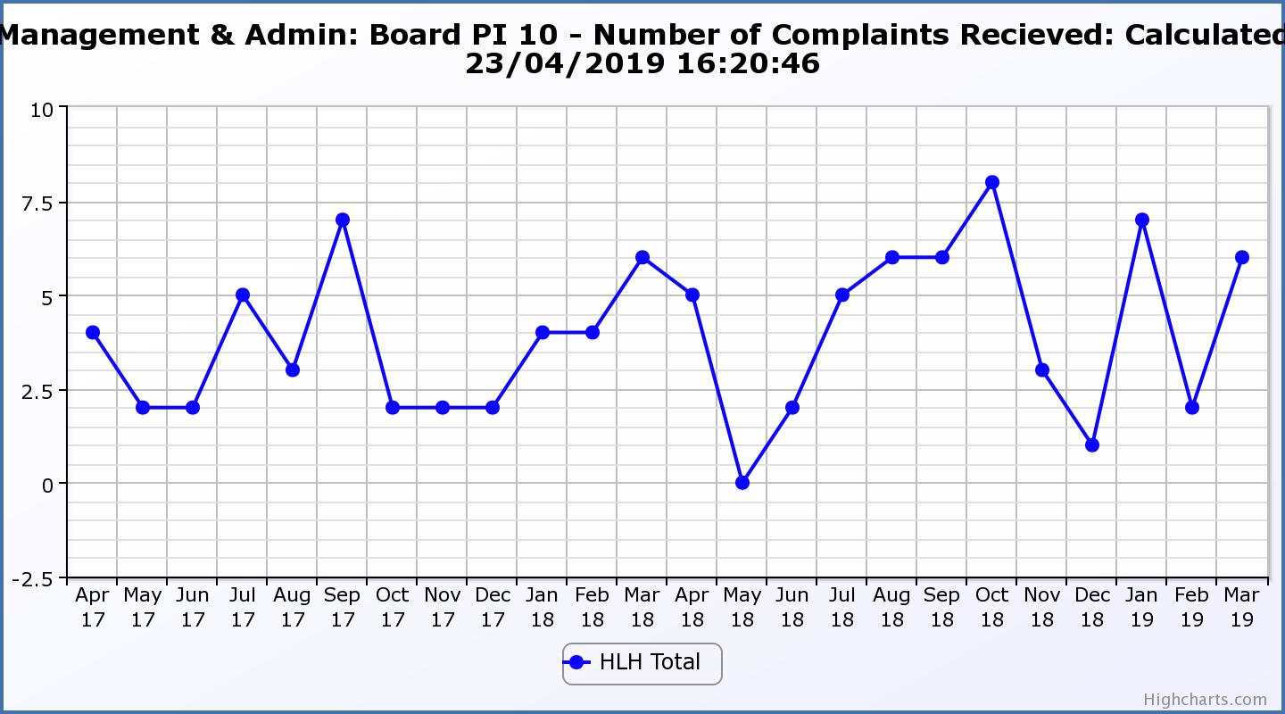
Business Plan Outcome | Performance Indicator | Reporting Frequency | RAG Rating Definition | RAG Rating Q1 18/19 | RAG Rating Q2 18/19 | RAG Rating Q3 18/19 | RAG Rating Q4 18/19 | Summary of Quarter Four Performance
7. Sustain a good health and safety performance | 11. Health and safety audit. | Annual. | - Red = the external audit raises systemic (i.e. applying across multiple sites) H&S issues.  - Amber = the external audit highlights common actions to be addressed across the company.  - Green = the external audit does not raise systemic issues. |  | Green |  |  | The QLM follow-up audit took place in August 2018 and all actions are complete as noted by the Health and Safety and Environmental Compliance Committee at its meeting held in November 2018.  Please see the Annual Health and Safety and Environmental Compliance report elsewhere on this agenda for further information.

Business Plan Outcome | Performance Indicator | Reporting Frequency | RAG Rating Definition | RAG Rating Q1 18/19 | RAG Rating Q2 18/19 | RAG Rating Q3 18/19 | RAG Rating Q4 18/19 | Summary of Quarter Four Performance
7. Sustain a good health and safety performance  (cont) | 12. RIDDOR accidents/incidents. | Quarterly. | - Red = number of RIDDOR reports per quarter is above 20.  - Amber = number of RIDDOR reports per quarter is between 10 and 20  - Green = number of RIDDOR reports per quarter is less than 10. | Green | Green | Green | Green | There were no RIDDOR accidents reported during Q4 2018/19.

Performance Indicator 12 - RIDDOR Accidents
The graph below tracks the number of accidents and incidents reported under the Reporting of Injuries, Diseases and Dangerous Occurrences Regulations (RIDDOR). There were no RIDDOR accidents reported in Q4 2018/19.
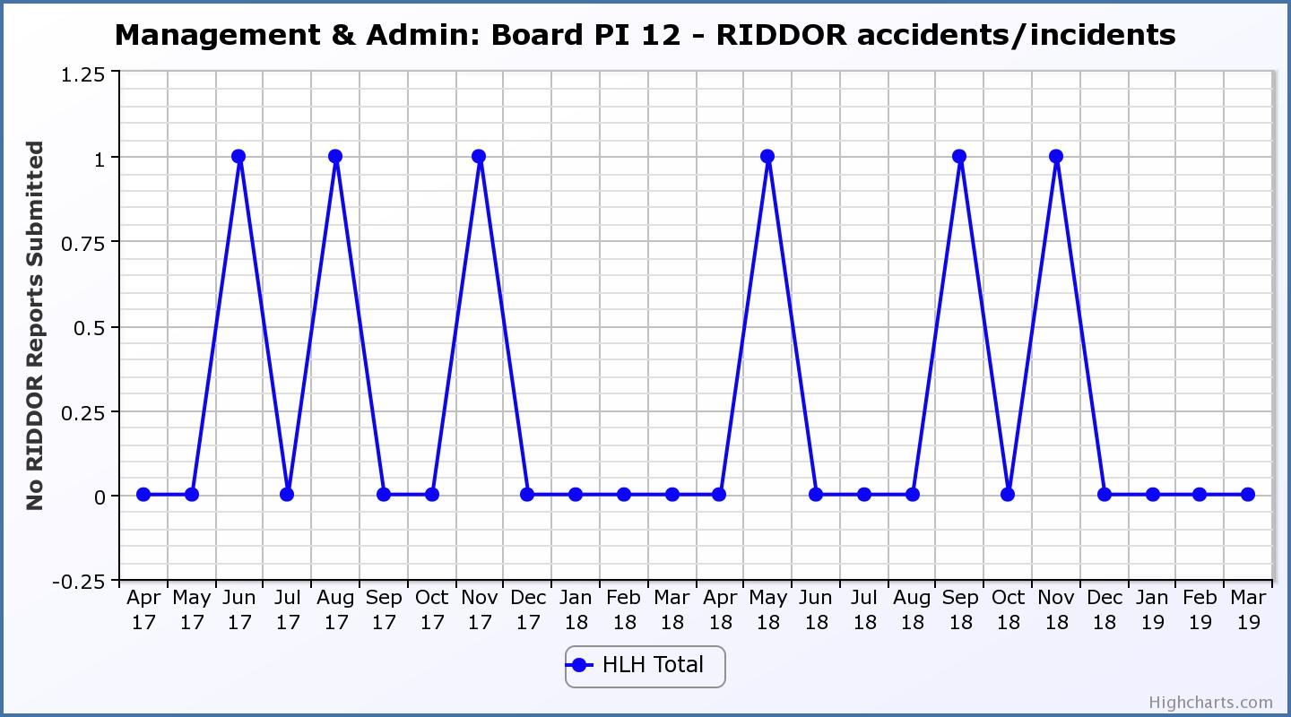
Business Plan Outcome | Performance Indicator | Reporting Frequency | RAG Rating Definition | RAG Rating Q1 18/19 | RAG Rating Q2 18/19 | RAG Rating Q3 18/19 | RAG Rating Q4 18/19 | Summary of Quarter Four Performance
8. A trusted partner | 13. THC’s annual survey of performance and attitudes. | Annual. | - Red = all HLH areas of work represented receive lower net satisfaction ratings than the previous year.  - Amber = two or more areas of HLH work receive lower net satisfaction ratings than the previous year.  - Green = net satisfaction ratings are maintained or improved for three or more areas of HLH work compared with the previous year. |  | Green |  |  | NA

Appendix B

Schools Music Tuition report to THC’s Care, Learning and Housing Committeee meeting held on 29 May 2019.

Agenda Item | 21.
Report No | CLH  43/19

HIGHLAND COUNCIL

Committee: |  | Care, Learning and Housing Committee
Date: |  | 29 May 2019
Report Title: |  | Schools Music Tuition
Report By: |  | Chief Executive of High Life Highland
1. | Purpose/Executive Summary
1.1 | This report provides an update on school music tuition which transferred to High Life Highland (HLH) on 1 April 2018 and information on new national guidance which was published in February 2019.
2. | Recommendations
2.1 | Members are asked to note:  - the successful completion of the transfer of music tuition to HLH;  - early indications of improvement in service delivery since the transfer;  - the joint guidance published in February 2019 by the Convention of Scottish Local Authorities, the Scottish Government and the Music Education Partnership Group; and  - that historically, the service has complied well with the new national guidance and that this approach is being continued by HLH.

3. | Background
3.1 | The school music tuition service (referred to nationally as IMS) transferred to High Life Highland on 1 April 2018 following the consideration of the Council’s Redesign Board at its meeting held on 19 December 2017 and the subsequent approval of the Care, Learning and Housing Committee at its meeting held on 25 January 2018.
3.2 | Immediately following the transfer of the 54 posts associated with the service and following consultation with the tutors involved, HLH established five new instructor posts funded variously from customer charges and external funding. The new posts started in August 2018. The decision to invest in the service was based on evidence from the Redesign review prior to the transfer and follow up discussions with staff that there was unmet demand.
3.3 | At the time of the transfer there were examples where similar services in other areas in Scotland were being considered for cuts or closure and in other areas there were campaigns as well as the national campaigns to maintain services. This led to the development of joint guidance being published by the Convention of Scottish Local Authorities (COSLA), the Scottish Government and the Music Education Partnership Group (MEPG). The Guidance can be seen on the COSLA web site: http://www.cosla.gov.uk/music-instrumental-music-tuition-guidance-2019pdf.
4. | Service Improvements
4.1 | Since the Council transferred its music tuition service to HLH on 1 April 2018 the number of individual pupils receiving lessons increased from 2,958 to 3,585 (an increase of 21%). This has been achieved through a considerable effort and focus on improving the service by:  - adding five new posts - three funded through customer income, one through external (grant) funding and one through the Pupil Equity Fund (PEF) where the five primary schools in the Inverness High School ASG combined some of their PEF funding to create a post  - realignment of provision and small increases to existing part-time staff contracts where demand has been identified  - existing Music Instructors taking on additional pupils  - developing an on-line management and bookings system which makes it easier for parents to access the service, has streamlined administration, and provided staff and managers with more comprehensive statistical information on which to base future service developments  - advertising the service in schools, on-line, through social media and on local radio  - freezing charges at the level set by the Council in the year before the service transferred.
4.2 | In the three years prior to transfer there had been a sharp decline in pupil numbers. In 2015/16 pupil numbers were 3,450 and this reduced to 3,100 in 2016/17 and 2,900 in 2017/18. It is considered that the greatest contributing factor to the decline was the application of 10% price increases two years in a row, but there is evidence from the review that there were other factors such as the uncertainty of the future of the service leading to poor morale (the national uncertainty described above will have contributed to this) reliance on inefficient paper based systems and processes and a lack of focus on and investment in the development and promotion of the service.
4.3 | The associated school groups which have benefited from the additional posts and/or increased contract time are as follows: Grantown; Kingussie; Culloden; Nairn; Inverness Royal Academy; Portree; Plockton; Dingwall; Ullapool.
4.4 | As part of HLH’s business planning for the growth and development of services, the following options for further developing the music tuition service are being explored:  - Evening music lessons for adults and children - this is a new service which has been successfully run in Culloden Library and options/locations for expanding it are being explored  - Including music activities in the School’s Out summer programme  - Widening access to training opportunities (eg. Songs & Games for Little Ones)  - Options for demand led expansion to schools provision are being explored  - Public events which will allow musicians of all ages to come together whilst promoting the schools music service  - Development of an e-newsletter for music tuition parents which will also promote local ‘area’ groups and ensembles as a pathway to Highland Young Musicians groups membership  - An additional (third) pipe band drumming (and drumkit) post, underwritten by Scottish Schools Pipe Band Trust.
4.5 | Highland Young Musicians (the regional orchestras and ensembles) continues to be an important part of the service with c.250 of our young people attending the annual Aviemore Concerts Festival in March 2019. For the first time the event was advertised to the wider public and it attracted higher audience numbers for both of the day’s concerts. Macdonald Aviemore Resort has already committed to continue its generous sponsorship of this event for 2020.
4.6 | Young people from Highland have had continued success at a national level. In 2018/19 three young people gained places in the National Youth Orchestra of Scotland (NYOS) Senior Orchestra following competitive auditions with one also having been accepted for a course with the National Youth Orchestra of Great Britain in Liverpool. Several others began their NYOS experiences in the lower level ensembles (again, after competitive audition). A steady number of pupils from Highland continue to gain places on degree and higher education courses throughout Scotland and England.
5. | New National Guidance
5.1 | While the approach in Highland has been to protect services through growing and developing them, in other parts of Scotland there has been consideration of cuts/reductions in service and significantly increased charges sometimes without consideration being given to alternative approaches. This has led to negative publicity and created a difficult environment for music tuition services across Scotland because of the uncertainty faced by staff and customers. Having been able to break out of this cycle in Highland has meant that staff morale has improved which, in turn, seems to have led to an increased customer confidence in the service.
5.2 | The new guidance was developed in response to the national situation described above and can be seen on the COSLA web site: http://www.cosla.gov.uk/music-instrumental-music-tuition-guidance-2019pdf. The guidance clarifies that Instrumental Music Tuition is additional to music education in schools and asks local authorities to consider:  - providing fees exemptions for school pupils in receipt of free school meals  - providing fees exemptions for school pupils undertaking an SQA course in music  - the balance between the need to apply charges and the impact on those who are charged  - co-producing charging policies with the people likely to be affected by a charging regime, including instrumental music teachers, parents and pupils  - making efforts to ensure that the parents and carers of those who use services for which there is a charge understand the reasons for charging and its contribution to provision.
5.3 | The music tuition service in Highland complies with the guidance in that:  - HLH has continued with the Council’s charges which includes exemption from fees for children of families in receipt of benefits and those undertaking SQA courses  - the music tuition review which was undertaken by the Council in 2018 surveyed current and past customers and held workshops with staff, both of which included questions and discussion on charges  - the peer review included consultation with “Friends of Highland Young Musicians” which is an independent charity which supports the Highland Young Musicians Groups. The discussion included charges and exemptions  - HLH froze charges when the service transferred to it in 2018 and has done so again in financial year 2019/20 so that income can be increased by engaging more people with the service rather than by increasing charges  - The information on music tuition, its benefits and the charges and exemptions which are in place which was previously available in handbook format has been updated and is now much more readily available on-line to customers and prospective customers on the HLH web site
5.4 | There are no immediate actions required to ensure compliance with the national guidance and HLH will continue to develop and improve the service in line with the guidance in so far as funding and resources allow.
5.5 | In November last year, HLH delivered a presentation at a meeting of the (national) Music Education Providers’ Group (MEPG) at the Royal Conservatoire in Glasgow. MEPG includes representatives from local authorities, Creative Scotland, the Scottish Government, university academics, trade unions, national third sector organisations, the Scottish Qualifications Authority etc. and was one of the authors of the new guidance. The purpose of HLH presenting at the meeting was to demonstrate that there are alternatives to cutting services and the approach being taken in Highland was applauded by MEPG.
6. | Charging
6.1 | The national guidance and campaigns which have led to its development have primarily focused on cuts to services and charging. In Highland, charging has always been key to being able to afford the service and when it was transferred to HLH, 53% of the cost of delivering the service was funded from customer income and external funding. In 2019/20 it is estimated that this will be 55%.
6.2 | In addition to freezing charges HLH has continued the Council’s policies of providing music tuition free of charge to pupils of families in receipt of benefits and where pupils are undertaking an SQA exam in music. Both of these exemptions are in step with the national guidance.
6.3 | The percentages of pupils in Highland eligible for free school meals are 12.8% at primary and 11.4% at secondary school level. 10% of the pupils who are customers of the Music Tuition service are exempt from paying fees because they are eligible for free school meals. This, being a very high proportion of those eligible for the benefit, is indicative of the success of the service in reaching financially disadvantaged children and young people. The service is also successful in Scottish terms at reaching financially disadvantaged people where, of the areas which charge for the service, Highland is seventh in Scotland.
6.4 | Using the Scottish Government Scottish Index of Multiple Deprivation (SIMD) analysis tool which allows analysis by SIMD area, the percentage of music tuition pupils is as follows (note that the SIMD is based on geographic area data zones and people who are eligible for income related benefits could live in any data zone).  SIMD Quintile 1 (most deprived) 6%  SIMD Quintile 2 18%  SIMD Quintile 3 33%  SIMD Quintile 4 35%  SIMD Quintile 5 (least deprived) 8%  100%
6.5 | This indicates that whilst there is more to be done to attract pupils from the most deprived data zones, there is a strong foundation of the service engaging with pupils living in data zones which are in SIMD quintiles one and two.
7. | Implications
7.1 | There are no Resource; Legal; Community (Equality, Poverty and Rural); Climate Change/Carbon Clever; Risk; or Gaelic implications for the Council associated with the implementation of the recommendations contained in this report.
Designation: Chief Executive, High Life Highland

Date: 1 May 2019

Author: Ian Murray

Background Papers: None

