HIGH LIFE HIGHLAND  REPORT TO BOARD OF DIRECTORS  20 June 2019 | AGENDA ITEM REPORT No HLH /19

MARKETING AND COMMUNICATIONS UPDATE - Report by Chief Executive

Summary

The purpose of this report is to provide a final update on progress made in implementing the 2015-19 Marketing and Communications Plan and introduce the Marketing, PR and Communications (MPRC) 2019 – 2024 strategy along with the monitoring and reporting process to future board meetings.

It is recommended that Directors note the report and comment on any salient points.

1. | Business Plan Contribution
1.1 | This report supports the highlighted Business Outcomes from the High Life Highland (HLH) Business Plan:  1. Sustain a high standard of health and safety, and environmental performance  2. Implement the Service Delivery Contract with THC  3. Improving customer engagement and satisfaction  4. Improving staff engagement and satisfaction  5. Enhance the positive charity image  6. Be a trusted and effective partner  7. Achieve sustainable growth across the organisation  8. Develop health and wellbeing across Highland communities  9. Develop and promote the High Life brand
2. | Background
2.1 | Directors approved the 2015-2019 Marketing and Communications Plan for HLH on 18 June 2015. Since approval Directors have received an update on the plan on a six-monthly basis. The purpose of this report is to provide a final update on this Marketing and Communications Plan.
3. | Marketing and Communications Plan (2015 - 2019) Update
3.1 | The Marketing and Communications Plan (2015 – 2019) final update is contained in Appendix A.
3.2 | Details of the physical and online collateral created/produced by the MPRC Team since the last Board meeting (November 2018 – March 2019) is included in Appendix B.
3.3 | Media Clippings – ongoing analysis of media referring directly or indirectly to HLH is monitored by the Marketing, PR and Communications team. For the full period since the last update until 31st March 2019, HLH appeared in the press/media 183 times with each assessed and placed into the following categories:  - 176– positive and neutral;  - 7 – negative  The negative aspects of the press coverage has been varied but includes issues mainly outside the control of HLH:  - The Highland Council funding gap (3 articles);  - Isobel Rhind [GROW] project NHS removal of funding (1 article);  - Moray Council Fit Life funding – Moray Leisure taken over by HLH (1 article);  - Criticism of charging for music tuition lessons in schools (1 article);  - The number of new library memberships issued in North East, Highlands & Islands is falling (1 article);
3.4 | Directors should note that HLH has continued to liaise with The Highland Council (THC) Corporate Communications team to issue agreed joint statements where appropriate.
4. | Marketing, PR and Communications Strategy (MPRC) 2019 – 2024
4.1 | Directors will be aware that the 2019 – 2024 MPRC strategy has been developed. The strategy highlights that its over-riding approach will be:  “to know, keep and grow HLH’s customer base”.
4.2 | The objectives of the MPRC strategy are:  - To attract more customers to use the Charity’s services and to encourage them to do so more often  - To increase the amount of income generated  - To positively raise the profile of the Charity and its work.
4.3 | The outcomes from the MPRC strategy are:  - Engagement levels across the Charity’s services will continue to rise each year  - Income earned as a result of marketing campaigns will continue to increase year on year  - More people will be aware of the Charity and the services it provides.
4.4 | In order to deliver upon the objectives and outcomes, the MPRC strategy identifies the follow key business focus areas:  - highlife membership  - Visitor attractions  - Outdoor Activities  - High Life card benefits scheme  - Meetings and Events  - Donations  - E commerce.
4.5 | Throughout the lifespan of the strategy, Directors will be given bi-annual updates on the follow key headings:  - Update on the key priorities (as highlighted in 4.4)  - Press and media coverage  - Online performance analysis  - MPRC collateral  - MPRC campaign analysis  - Key information emerging from the implementation of the MPRC strategy into service operational plans.
5. | Policies Update/Review
5.1 | The Social Media Policy has been reviewed and there are no changes.
6. | GDPR Update
6.1 | Directors will be aware that the General Data Protection Regulations (GDPR) were introduced on 25th May 2018.  High Life Highland has made significant progress in delivering its data protection obligations since the GDPR legal implementation date.
6.2 | An internal working group consisting of key personnel from ICT, MPRC and Business Support was established to take a strategic view with a clear remit to ensure compliance across the organisation.  In addition to GDPR training sessions with the Senior Management Team along with the rollout of guidance and support to all services, the following progress has been made:  • Appointment of a Data Protection Officer  • Creation/updating of Data Retention Schedules  • Creation/updating of Privacy Notices  • Development of an Information Asset Register  • Review of Subject Access Requests processes  • Data Protection Audits undertaken across key services  • Mailing Lists reviewed  • Updating of Data Sharing Agreements with external organisations  • Addition of GDPR section to website.
6.3 | Overall the internal working group is satisfied with progress to date which ensures the Charity is compliant with GDPR.
7. | Implications
7.1  7.2  7.3  7.4 | Resource Implications – the resources associated with the delivery of the Marketing, PR and Communications Strategy (Year 1) have been approved within the 2019/20 budget.  Legal Implications – there are no new legal implications associated with this report.  Equality Implications – there are no new equality issues associated with this report.  Risk Implications – The measures outlined as part of this report indicate HLH is minimising risk of contravening any aspect of the new legislation.

Recommendation

It is recommended that Directors note the report and comment on any salient points.

Designation: Chief Executive

Date: 10 June 2019

Appendix A – Marketing Plan Update

Tactic | Action | Five year reflection / close-off
Branding | Uniform  - Ensure the charity brand and logo is represented across the HLH staff and volunteer uniform range.  - Develop appropriate applications of the brand to any new promotional give-aways. | Over the duration of the marketing plan the HLH brand has being applied consistently across the full range of uniform and appropriately on all promotional material issued by the Marketing, PR and Communications (MPRC) Team.  All promotional/advertising material, where possible ensured full compliance with OSCR’s guidance relating to advising the public of the organisation’s charitable status.
 | Induction and role model behaviour  - Contribute to any updates of the charity induction process as required.  - Demonstrate role model behaviour to peers and staff.  - Develop role model behaviours in teams and as part of staff appraisals.  - Positively challenge individuals and situations where role model behaviour isn’t being displayed.  - Invest time in supporting and developing staff.  - Address poor performance. | Over the duration of the marketing plan role model behaviour has been integrated into operational plans.  Where new staff have taken up or changed post with HLH they have been reminded of the corporate branding guidelines as part of their induction to their role.  Where new facilities/services have been added to HLH e.g. Strathpeffer Pavilion/Music Tuition the MPRC team has met and briefed staff as part the induction/transition process.
 | Site branding  - Identify opportunities to roll out the use of charity branded signage across all HLH facilities.  - Work with the Principal Estates Manager to apply charity branding to sites receiving capital investment. | Site branding has been updated in a number of locations across the charity throughout the period of the plan.  Since the last Board update, corporate branding has been introduced at the following key sites:  - Inverness Botanic Gardens and Nursery donations signage  - Fort William Library signage updated  - Torrin Bunkhouse external signage HLH branding  - Leven Centre HLH branding external signage and internal glass  - Poolewe Swimming pool external and internal HLH branding  - Highland Archive and Registration Centre external branding and signage  - Inverness Leisure – continued phased replacement to HLH branding  - East Caithness Community Facility – HLH branding on entrance doors  - North Coast Leisure Centre HLH branding external and internal  - Dingwall Office signage
 | Marketing toolkit  - Ensure consistent and appropriate use of the marketing toolkit.  - Identify new templates required and apply the brand appropriately. | During the period of the plan, the MPRC Team has ensured consistent and appropriate use of the marketing toolkit across the organisation.  The plan has ensured any new templates were consistent in their application and HLH branding was applied appropriately.
Digital Communications | Website  - Liaise with the ICT team to co-ordinate the development of the new charity website.  - Liaise with all HLH services to agree the functionality and content required for each service.  - Manage the contract with the supplier to ensure that the website is developed on time, within budget and to the specification required.  - Monitor the implementation of the website to ensure that it meets customer needs and arrange for any updates or changes as required.  - Monitor the content management of the website by each service. | Over the duration of the 2015-2019 plan the charity has seen significant changes in the look and feel of the highlifehighland.com suite of websites resulting in increased traffic and engagement with the brand.  During the plan the original provider of website development and support went out of business. This meant alternative arrangements had to be found ‘mid-contract’. Working closely with HLH’s ICT team new suppliers were sourced from companies with previous knowledge of the HLH site which preserved continuity of online services to users.  In addition, new online corporate themes for the charity’s website highlifehighland.com have been developed internally to give a cleaner and fresher look and feel to the site as well as keeping the site fresh, updated and vibrant.  New themes developed since the last update were for :  - Dinosaur Exhibition;  - Staff Health and Wellbeing week
 | Email marketing  - Ensure that all service staff are proactively encouraging customers to give permission for their email addresses to be added to our databases.  - Segment groups of customers relevant to individual promotions.  - Send specific campaign information to segmented customer markets.  - Devise online surveys using ‘Survey Gizmo’ as required to gain customer feedback. (an online survey platform that allows comprehensive reporting and data analysis)  - Analyse the feedback and act on the findings.  - Ensure customers are informed of our response to their feedback.  - Use ‘Mailchimp’ to enable customers to sign up for a range of HLH information.  - Ensure the information is sent to those requesting it. | Over the duration of the plan the email marketing database has performed well and increased from a total audience of c. 29K in 2015 to c.55K across leisure, library, visitor attractions and “School’s Out” (summer programme) databases in 2019.  E-mail databases are used to support promotional campaigns and are tailored to suit the targeted audience or demographic.  GDPR legislation changed during the latter part of the plan and HLH has taken advice from our Data Protection Officer in terms of GDPR and Privacy notices.  Representatives of the MPRC team have played an integral part within the HLH GDPR Group to ensure communication, understanding and compliance.  Since the introduction of the new legislation there has been no significant rise in individuals unsubscribing from the HLH mailing list.  Over the past 12 months to 31st May 2019 975,399 promotional emails have been delivered across the HLH database with 227,598 (27.73%) of those being opened and 33,648 (4.62%) links clicked.  Examples of marketing collateral can be viewed in Appendix B.
 | Social media  - Determine which sites are most beneficial to post to and when to post to them.  - Decide how large the social media presence should be.  - Identify the right metrics to use to measure progress towards social media goals  - Set out how and why to engage current and potential customers online.  - Set up and manage the company’s Facebook presence.  - Set up and manage the company’s Twitter presence.  - Arrange for the integration of a YOUTUBE channel into the website.  - Assess FLICKR, Instagram, Snapchat, Vine and WhatsApp to determine which channel is the most appropriate for HLH customer engagement.  - Set up and manage the use of Trip Advisor in Highland Folk Museum, Inverness Museum and Art Gallery, Inverness Botanic Gardens, Ferrycroft Visitor Centre and Ben Nevis Visitor Centre.  - Devise social media plans for each individual platform.  - Ensure the ongoing adherence to the company’s social media policy by all HLH staff. | The Marketing and Communications plan 2015 – 2019 has seen social media engagement grow over the period.  The main social media platforms in use by HLH are:  - Facebook  - Twitter  - YouTube  - Instagram (Inverness Botanics)  HLH Twitter accounts have been introduced successfully to Sport, Inverness Botanic Gardens and Nursery and Archives and Libraries.  During the plan paid for advertising on social media has been introduced across the charity. This has mainly taken place on Facebook and therefore by default Instagram.  From 31/5/16 until 31/3/19 HLH has developed and produced 70 campaigns; spending £11,674 on Facebook advertising. This has yielded:  - Reach 452,419 (specific ad-placements)  - 3,548,163 impressions (multiple displays of reach)  - Calls to action resulting in 27,536 link clicks.  Examples of marketing collateral can be viewed in Appendix B.
 | Analytics  - Use Google Analytics to monitor the performance of variables such as advertising and campaign performance, audience characteristics and behaviour, sales leads and conversion.  - Use Facebook user insights to monitor the success of campaigns through the following:  - monthly fan size growth;  - the average number of likes or comments;  - unlikes and attrition rate;  - demographics;  - page views;  - mentions.  - Develop the use of Hootsuite Pro to establish who is reading, responding to and reposting HLH social media traffic. | Google Analytics continues to be used across highlifehighland.com and all associated websites.  Facebook Business Manager continues to be used to monitor user behaviours on the Facebook platform.  Examples of the analytics used by HLH will be presented to the Board meeting.
Press and public relations | - Maintain a close working relationship with THC’s Press and Communications team.  - Work with Heads of Service and Principal Managers to identify opportunities to actively place stories and features in publications in support of HLH service activities and achievements.  - Engage and manage the services of a media monitoring company to maintain a library of press and media coverage and to evaluate the success of HLH PR activity. | During the plan a decision was taken to internalise the media monitoring service when the previous contract came to an end.  The monitoring service was taken in house in January 2017 using existing staffing resources to identify any coverage of HLH in the media/press and/or online.  From 1/2/17 until 31/3/19 the following media clippings have been recorded.  - 685 Positive  - 230 Neutral  - 90 Negative  - 493 pages of coverage  The new system continues to monitor:  - Publication;  - Reporter/Journalist;  - Number of clippings;  - Page coverage (in ¼ page equivalent);  - Positive/Negative/Neutral.  During the lifespan of the plan a new weekly media bulletin was introduced where the above information is presented to Senior Management Team.  Since the last update press coverage it is estimated that there has been the equivalent of 99.25 full pages of coverage relating directly or indirectly to HLH.  A member of the MPRC Team has also been made available to attend any meetings held by Principal Managers in order to ensure a consistent message and understanding of projects to/from that particular Service.
Advertising | - Assess advertising opportunities on a case by case basis to ensure that any advertising spend delivers value for money.  - Minimise the use of traditional display advertising that is not carefully targeted or easily measured. | Focusing on the use of cost-effective, targeted advertising using social media to ensure spend achieves value for money has achieved positive results during the plan  Since the last update campaigns have included  - Chief Executive Job advert  Facebook  Impressions 247,172 with a Reach of 125,368 resulting in 2,103 link clicks*  Cost of campaign = £660  LinkedIn  Job Views 332  Click to Apply 18  Cost of campaign = £380  - Music Tuition Evening Classes  Impressions 70,335 with a Reach of 22,100  link clicks 1253  Cost of campaign = £190  - Rangers Walks  Impressions 42,454 with a Reach of 21,087 resulting in 1,448 link clicks  Cost of campaign = £174  Examples of marketing collateral can be viewed in Appendices 2 and 3.  *Impressions = the number of times a post is displayed. Reach = the number of unique people who saw the post/advert. Clicks = the number of people interacting with the post/advert.
Direct marketing and mailing | - Establish databases of key customer groups.  - Maximise on the use of electronic communication to these direct markets.  - Identify occasions that would benefit from door drop marketing.  - Designate the geographic area for the campaign and arrange for leaflets to be delivered. | During the plan – the charity has continue to grow and develop the process of direct marketing with regular e-blast newsletters sent to members along with other communications (generally around the time of highlife card price increases).  No physical direct mail campaigns have been undertaken since the last report. Email marketing is the main direct marketing mailing tool used by the Charity  All campaigns have been supported digitally as part of the digital first ethos.
Events and exhibitions | - Identify key events at which HLH services can be showcased.  - Create, maintain and manage the distribution of an event toolkit that can be used indoors and outside.  - Develop a range of promotional giveaways that can be distributed at events and as part of individual campaigns. | During the plan the numbers of events and exhibitions have increased across the charity from vintage days to book talks, art fairs, concerts and exhibitions.  The MPRC team maintained and managed promotional collateral to be used at events including promotional stands, giveaways, feather flags and pop up banners.  Since the last update the Spa Pavilion was able to utilise their weddings promotional stand at the Scottish wedding fair in Glasgow which to date has resulted in three direct bookings for wedding at the venue therefore demonstrating a positive investment. In addition, the MPRC team provided an IPad preloaded with promotional material along with a Survey Gizmo form to collect customer enquiry data.
Marketing toolkit | - Ensure all HLH staff are using the following marketing toolkit:  - Poster  - Newsletter  - Certificate  - Notice  - Leaflet  - Timetable  - Activity booking form  - Powerpoint slide  - Presentation pack cover  - Identify additional templates that may be required and arrange for their design and addition to the toolkit. | The marketing toolkit has been updated and developed to reflect business, marketing and industry changes during the lifespan of the plan.  All staff have been actively encouraged to use the HLH Marketing Toolkit to ensure consistency in terms of the branding across the charity.  Collateral has been developed and updated using the brand guidelines and toolkit:  Poster and Powerpoint presentation templates have recently been refreshed since the last update and all collateral in the toolkit is reviewed regularly to ensure it is fit for purpose.
Membership marketing and sales promotions | - Develop membership marketing and sales promotions for the following as required:  - New services (for example digital newspapers)  - Pilot initiatives (for example Love to Swim)  - Special projects (for example You Time);  - Existing services (for example researching your family history).  - Maximise on the use of email, social media and direct marketing in each promotion.  - Work with the HIE appointed consultant to design and host a marketing seminar with SMT for the purposes of identifying key actions to develop the High Life membership scheme and to increase sales.  - Update the High Life work streams document to reflect the outcome of the seminar.  - Oversee the implementation of the work streams.  - Review the outcomes and monitor sales levels in response to the actions implemented. | Membership marketing campaigns and sales promotions were developed over the duration of the plan ranging from Love to Swim, Black Friday Move it to Lose it and 200/300 new members promotion.  All of these campaigns had a positive impact on membership or user numbers and were promoted using social media, onsite collateral and email blasts.  During the plan the High Life Highland benefits scheme was launched to add value to the High Life Highland card. Local and national businesses were approached to participate in the scheme across the Highlands.  To date there are +100 businesses providing offers to High Life Highland card holders on production of their card.  Promotions are reviewed and further developed for future campaigns by the HLH Promotions Group which consists of representatives from MPRC, Facilities, ICT and Commercial.
Photography | - Build and manage the bank of high quality photographic images which communicate the charity’s key messages and which will be used to promote HLH services across all media. | The bank of images available to the charity has developed over the period of the plan and images are regularly used to support the communication of key messages and promote HLH services.
Newspapers, television and radio | - Maintain proactive working contact will all local newspapers, radio stations and television stations.  - Identify opportunities to engage with the relevant media contacts as part of individual campaigns or promotions. | The MPRC team continue to work with colleagues across the services to identify press and media opportunities.  All media releases or requests are passed though the MPRC team for approval and newsworthy stories are requested on a regular basis from principal managers and their teams.  The MPRC team liaise with THC Corporate Communications team to issue agreed joint statements where appropriate.  During the plan, Directors have been updated as to the positive, neutral and negative press articles associated with HLH (directly and/or indirectly).
Sponsorship, advertising and contra deals | - Identify opportunities to secure partnerships with third party and commercial organisations to progress sponsorship, advertising and contra deal packages.  - Maintain an overview of the activity of all HLH staff to ensure that they are operating within the company’s policy and guidelines for sponsorship, advertising and contra deals.  - Manage the relationship with the marketing departments of companies with whom sponsorship, advertising and contra deal agreements have been reached to ensure that the terms of the agreements are realised. | Various Sponsorship advertising and contra deals have been sourced during the 2015 - 2019 Marketing and Communications Plan.  Examples are branded Pool cars to reduce travel expenses from BMW and Dicksons of Inverness and sponsorship of the Volunteer and Staff awards.  Examples of advertising contra deals are Inverness Kart Raceway and Landmark Press.  During the plan – HLH introduced the post of Commercial Manager (also allocated to the wide Development Team). The MPRC Team has worked closely with the Commercial Manager where corporate sponsorship/commercial opportunities present.
Print | - Encourage all HLH staff to minimise the use of printed promotional material.  - Identify opportunities to maximise the use of digital communications.  - Work with the Finance Manager and service staff to further reduce the costs of managed print.  - Focus any spend on managed print in support of increasing customer numbers at the company’s visitor attractions and on increasing High Life membership sales. | The plan promoted a strong ‘digital first ethos’ which has been implemented with increasing proactivity across all services throughout the duration of the plan – resulting in print media being kept to an absolute minimum.  Acknowledging the ‘digital first’ position, it is accepted there are occasions in HLH when physical collateral still requires to be printed.  Since the last update HLH has printed information leaflets for Music Tuition, Move It To Lose it record cards, High Life Benefits posters and donations posters.  Examples of marketing collateral can be viewed in Appendix B.
Research | - Identify research that would provide key data to inform the development of specific marketing and sales activities to increase High Life membership sales, increase visitor numbers at HLH tourism centres and enhance service delivery.  - Determine the most appropriate and cost effective method to undertake the research.  - Complete the research, analyse the findings and act on the results.  - Work with the HIE Specialist Advisor to complete the Price Sensitivity analysis of High Life.  - Use the findings of the report to inform future price change recommendations. | Research carried out during the plan has informed campaign decisions, feedback reports were produced and utilised by different forums like the “School’s Out” planning group and the Promotions Group to inform future planning.  The online membership cancellation survey continues to form part of a market-research process to identify the reason(s) that individuals cancel their High Life Memberships.  The information from this system was co-managed by the MPRC Team and the central High Life Team. Additionally, the information was used by the Promotions Group to identify areas of opportunity to promote highlife initiatives across the Highlands.
Inverness Castle Project | - The project’s vision is of Inverness Castle becoming an international quality visitor attraction that celebrates the spirit of the Highlands past, present and future: its creativity, well-being, culture, heritage and natural environment; attract new and returning visitors to the area; is embraced by the people of the Highlands; and inspires all to visit other parts of the Highlands. | HLH is being funded by the Inverness Castle project to supply a project-specific marketing officer to assist the Project Manager with the marketing and communications aspects of the project.  Since the last update this has included:  - Contribution to the overall Inverness Castle Project development, including ongoing development of the marketing and communications plan  - Development of the stakeholder engagement approach, including providing an update on the approach and forward plan to the Project Board and Delivery Group at their meetings on 23 May and 7 June respectively  - Preparation of media releases issued in April and May 2019 respectively, focussing on the continuing rise in visitor numbers to the Inverness Castle Viewpoint and the progress in the plans for the transformation of the North and South towers of the castle  - Liaison with HLH Communications Officer to coordinate press cuttings for Inverness Castle Project;  - Liaison with specific stakeholder groups, including NC500 and the Port of Cromarty Firth Cruise Stakeholder group  - Liaison with the City Region Deal programme manager, including coordination of update reports and communication aspects of the project  - Undertaking ‘learning journeys’ to other councils and visitor attractions as appropriate to inform our approach  - Contributing to the development and submission of an application to the Natural and Cultural Heritage fund for a grant of £750,000 to support the digital approach for the project.

APPENDIX B
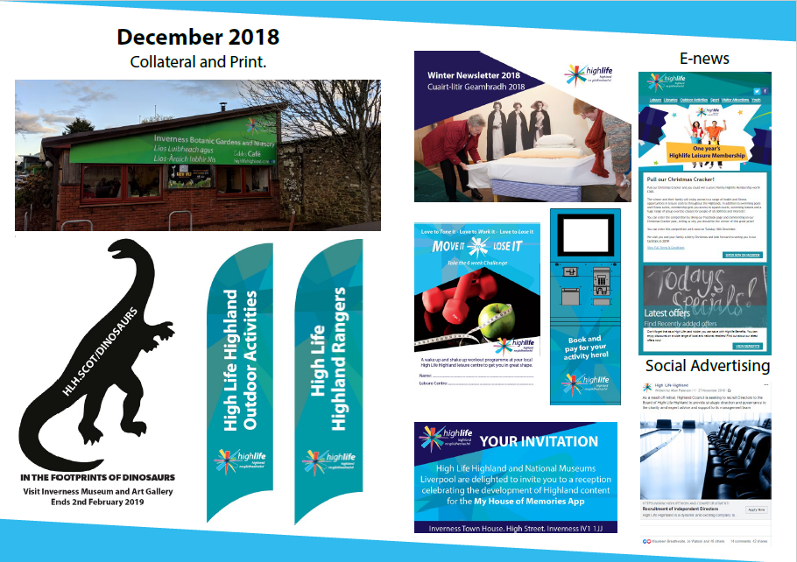
APPENDIX B Cont
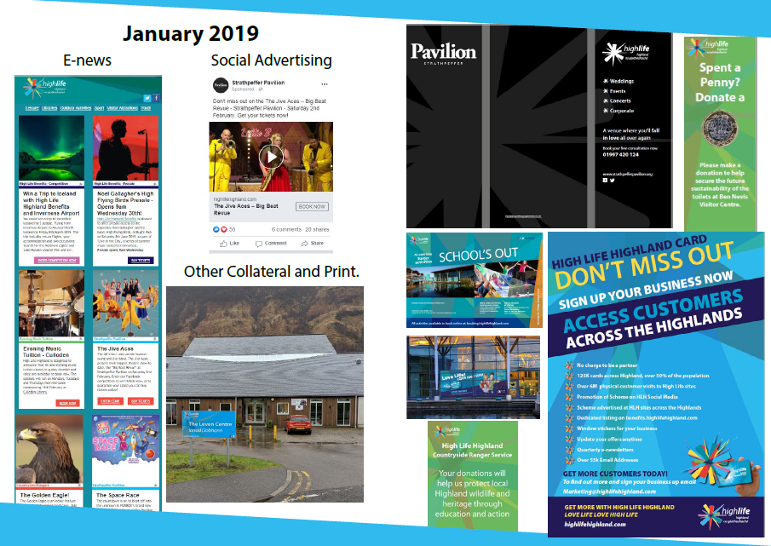
APPENDIX B Cont
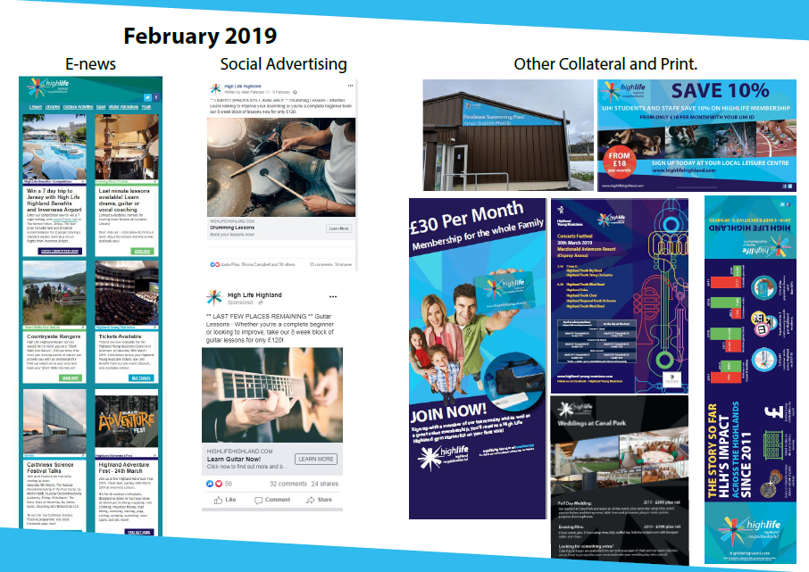
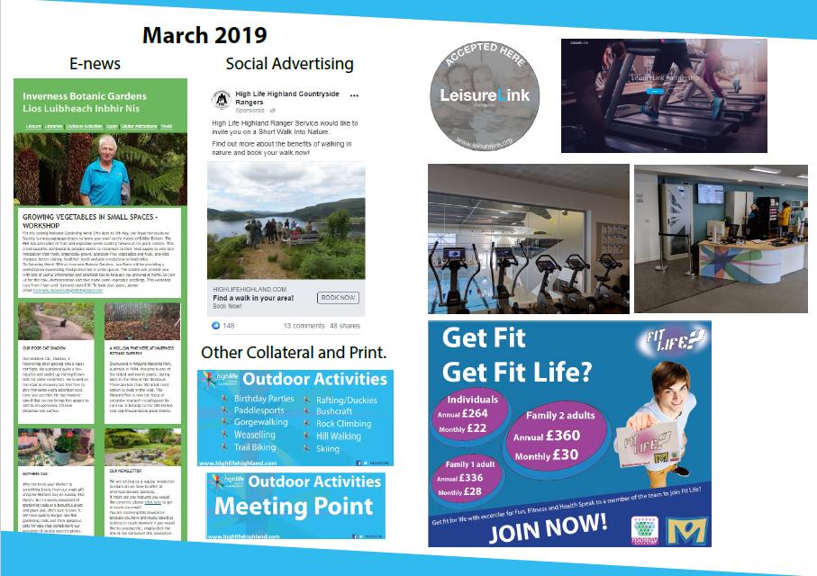
APPENDIX B Cont

