HIGH LIFE HIGHLAND  REPORT TO BOARD OF DIRECTORS  19 March 2019 | AGENDA ITEM REPORT No HLH /18

Performance Report - Report by Chief Executive

Summary

The purpose of this report is to present performance information for the period October to December 2018.

It is recommended Directors:-

- comment on the report and agree that the overall health check on the Company for the period is assessed as green;
- note that the delivery of the business plan is assessed as green; and
- note the information provided on the performance indicator for more detailed consideration.

1. | Business Plan Contribution
1.1 | This report supports all the Business Outcomes from the High Life Highland (HLH) Business Plan:  - To advance sustainable growth and financial sustainability  - Deliver the Service Delivery Contract with THC  - Improving staff satisfaction  - Improving customer satisfaction  - A positive company image  - Services designed around customers and through market opportunities  - Sustain a good health and safety performance  - A trusted partner
2. | Background
2.1 | The performance indicators in this report were set, at the request of the Board, by the Finance and Audit Committee in March 2016. It was agreed then that reporting on the delivery of the business outcomes would be by exception (i.e. reporting where managers had RAG rated the actions “red – no significant progress”).

3. | Summary of Performance
3.1 | Appendix A contains a summary of performance against the performance indicators along with trend information for numeric PIs. There are ten performance indicators scheduled for assessment at the March 2019 Board meeting. Seven of them have been RAG rated “green”; two amber; and one “red”. The PIs which have been RAG rated amber and red are as follows:  - PI 3 High Life subscription cancellation rate;  - PI 6 Staff absence rate;  - PI 10 Formal complaints.
3.2 | PI 3 High Life Subscription Cancellation Rate - the cancellation rate was 3% each month during quarter three. As Directors will be aware from previous reports, the Council pays Macdonald Aviemore Highland Resort (MAHR) to provide public swimming through the HLH leisure access scheme. The contract for the provision of public swimming ceased on 31 March 2018 and was extended to June at which time it came to an end. It re-commenced on 22 November 2018 for one year and the Council has agreed to pay HLH for the lost income associated with this.
3.3 | The three leisure facilities which were affected by the temporary cessation of public swimming at MAHR were: Aviemore Community Centre; The Badenoch Centre, Newtonmore; and the Craig Maclean Centre, Grantown. The number of subscriptions at these three sites was at their lowest in quarter three 2018/19. Subscriptions at all three sites recovered in January 2019 and are now at their highest level ever. Overall, in January, subscription levels were at their highest ever level at 22,286.
3.4 | PI 6 Staff absence rate – the absence rate was 4.02% in quarter three 2018/19. Please see the HR report elsewhere on this agenda for further information.
3.5 | PI 10 Formal complaints – there were twelve complaints received during quarter two. Of those there were five complaints which were not upheld, one which was partially upheld, and six were upheld.
3.6 | The complaints which were upheld or partially upheld related to: gym equipment (IT issues re playing of TV programmes); staff handling of disabled car parking spaces being abused by customers (x2, one of these complaints related to a member of staff from another organisation); cancellation policy; staff; a public access computer; and staff shortages (temporary due to sickness). All of the complaints were followed up and resolved with the complainants and where appropriate, the staff involved. The number of complaints continues to be very low in relation to customer numbers.
4. | Delivery of Business Outcomes
4.1 | The current HLH Business Plan 2015-19 identifies eight business outcomes and the approach which the charity takes to deliver them. The resultant Operational Plans for each of the nine HLH areas of work are RAG rated every quarter.
4.2 | The RAG ratings of the operational plans has identified that delivery of the Business Plan is on target. Five of the nine areas of HLH work RAG rated all of the actions “green – on target” or complete; one area of work RAG rated one action as “amber – some slippage”; two areas of work RAG rated two actions as “amber – some slippage” and one area of work RAG rated three actions as “amber – some slippage”. Directors have agreed that reporting on the delivery of the business outcomes would be by exception (i.e. reporting where managers had RAG rated the actions “red – no significant progress”) and there have been no actions which have been RAG rated “red” in quarter three 2018/19.
5. | Performance Indicator for More Detailed Consideration
5.1 | The performance indicator scheduled for more detailed consideration in this report is PI 7 customer surveys and information is provided below on surveys which have been carried out since this PI was previously reported to the Board (this time last year).
5.2 | The approach taken to date has been for each area of work to design their own surveys and while this has met the specific information requirements of each specialist area it has made charity wide analysis of customer satisfaction difficult. Given this it is recommended that in future all customer surveys which ask about the quality of service provision ask the following standard questions (retaining the flexibility to ask specific questions as required) and that future Board reporting be based on the responses to these questions.  - overall experience of HLH;  - helpfulness of staff; and  - whether respondents would recommend HLH to a friend and why.  It is suggested that the options for responses to the first two questions have a four point scale to “force” positive or negative responses and with the last being a yes/no with a free-text option where customers can explain their responses. (Note that the questions have been kept as simple as possible to encourage people to respond).
5.3 | The remainder of this section provides examples of information which has been obtained from customer surveys over the past year.  Adult Learning – survey of adult learners  - 76% rated their overall experience as excellent.  - 98.9% agreed or strongly agreed that their participation improved their confidence.  - 98.9% agreed or strongly agreed that they had enjoyed themselves.  - 90% said that their participation had helped them to develop friendships and a support network.  Archives – national survey of customers who accessed archives services other than through an in-person visit (telephone, in writing, electronic engagements)  - 100% rated their overall experience (Highland Archive Centre) as good or very good.  - 100% rated the quality of the content as good or very good.  - 100% rated the promptness of the response as good or very good.  Arts – examples of gallery visitors book comments  - “Had a lovely morning”.  - “Mega fun”  - “Cool photography”  - “Enjoyed it very much”  - “We enjoyed dinosaur exhibition”  Leisure Facilities – school’s out programme  - 77% rated their overall experience of the School’s Out programme as excellent of very good.  - 78% were very satisfied or satisfied with the range of activities on offer.  - 93% rated staff as excellent or good.  - 96% said that they would recommend the programme to a friend.  Libraries - HLH Libraries conducted a survey which aimed to assess the reasons why some people were not using their library. Surveys were carried out at leisure centres, community events, and online. Of those surveyed 37% said that they had used their local library within the past 12 months and 63% had not. Those that had not (356 respondents) formed the basis for the non-user sample. Only 11% of non-users said that they did not intend to use libraries in the future and overall, the survey highlighted the importance of promoting the wide range of services which are available in libraries such as activities and events and on-line services.  Museums – Highland Folk Museum visitor survey  - 91% rated the helpfulness and knowledge of staff as outstanding or good.  - 92% rated their overall experience as outstanding or good.  - 90% said that they would recommend the museum.  - 90% said that they would return to the museum.  Music - as part of the peer review prior to the Council transferring the service to HLH a large number of customers were surveyed including past participants, parents, and customers who had discontinued the services and it was considered best to avoid re-surveying customers. There will be a customer survey in 2019/20.  Sport and Outdoor Activities – example of event survey  - 98% enjoyed the event.  - 77% wanted to try out winter sports.  - 76% reported that they would like to take part in similar events in future.  - As a result of the survey a curling class was added to the active schools programme.  Youth Work – participant survey  - 72% rated their overall experience of youth work as excellent or very good.  - 85% reported that it was easy or very easy to get involved in youth work activities.  - 73% of participants reported that being involved with youth work activity helped them to be more confident.  - 69% reported that their involvement with youth work helped them to understand the importance of making good decisions.  - 70% of respondents reported that their involvement in youth work helped them to improve other people’s lives.
6. | Implications
6.1 | Resource Implications – there are no additional resource implications arising from this report.
6.2 | Legal Implications - there are no new legal implications arising from this report.
6.3 | Risk Implications – there are no new risk implications arising from this report.

Recommendation

It is recommended Directors:-

- comment on the report and agree that the overall health check on the Company for the period is assessed as green;
- note that the delivery of the business plan is assessed as green; and
- note the information provided on the performance indicator for more detailed consideration.

Designation: Chief Executive

Date: Draft 27 February 2019
Appendix A
HLH Performance Indicators

Business Plan Outcome | Performance Indicator | Reporting Frequency | RAG* Rating Definition  (*Red/Amber/Green) | RAG Rating Q1 18/19 | RAG Rating Q2 18/19 | RAG Rating Q3 18/19 | RAG Rating Q4 18/19 | Summary of Quarter Two Performance
1. To advance sustainable growth and financial sustainability | 1. Financial monitoring. | Quarterly. | An assessment of the year end outturn where:  - Red = delivery of the SDC over budget above 2%.  - Amber = delivery of the SDC between break-even and 2% over budget.  - Green = delivery of SDC within budget. | Green | Green | Green |  | The variance for the budget up to the end of quarter three was £56K and it is projected that the SDC will be delivered within budget for financial year 2018/19. See the Finance Report elsewhere on this agenda for further information.

Performance Indicator 1 - Financial monitoring, variance to budget per quarter.
See the Finance Report elsewhere on this agenda for further information.
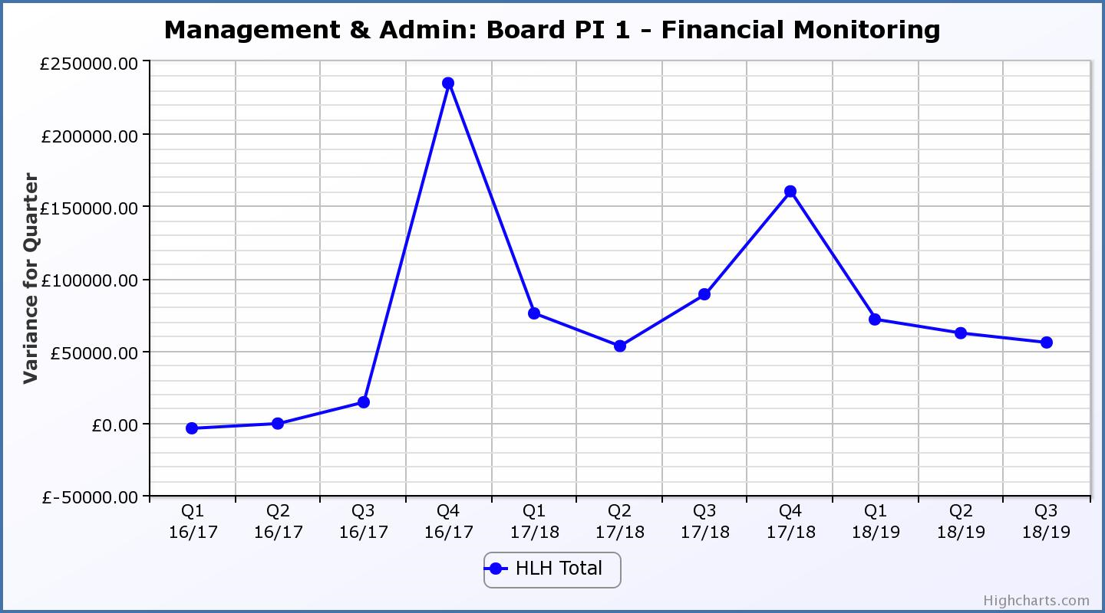

Business Plan Outcome | Performance Indicator | Reporting Frequency | RAG Rating Definition | RAG Rating Q1 18/19 | RAG Rating Q2 18/19 | RAG Rating Q3 18/19 | RAG Rating Q4 18/19 | Summary of Quarter Two Performance
1. To advance sustainable growth and financial sustainability (cont) | 2. Number of High Life subscriptions. | Quarterly. | - Red = more than 5% below target.  - Amber = up to 5% below target.  - Green = on or exceeds target. | Green | Green | Green |  | The number of subscriptions each month during Q3 exceeded the target of 20,086 with the average number of subscriptions for the quarter having been 21,479. The target has been set at the level required to achieve the High Life Subscriptions income target.

Performance Indicator 2 - Number of High Life Subscriptions
The number of High Life Card subscriptions continues to increase and in January 2019 was the highest they have been at 22,286.

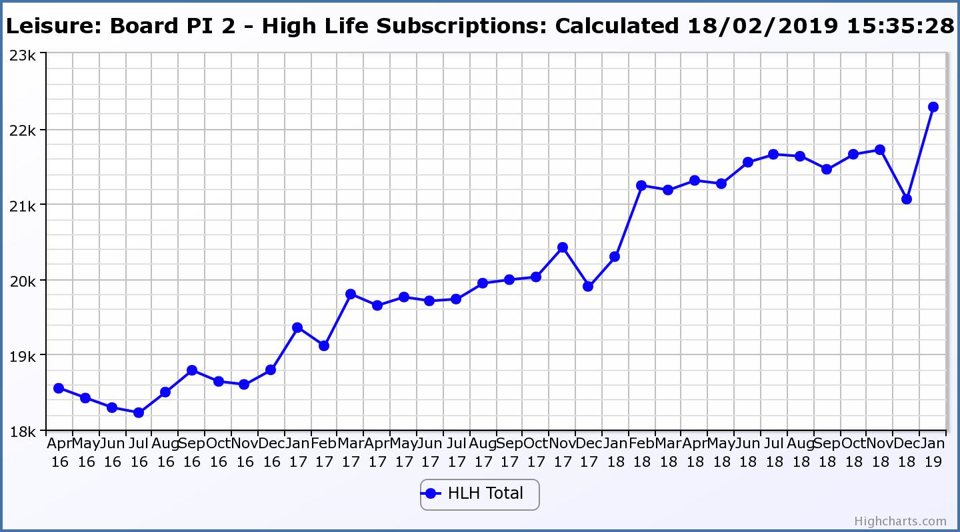

Business Plan Outcome | Performance Indicator | Reporting Frequency | RAG Rating Definition | RAG Rating Q1 18/19 | RAG Rating Q2 18/19 | RAG Rating Q3 18/19 | RAG Rating Q4 18/19 | Summary of Quarter Two Performance
1. To advance sustainable growth and financial sustainability (cont) | 3. High Life cancellation rate. | Quarterly. | - Red = cancellation rate above 6% of High Life memberships.  - Amber = cancellation rate is 3% - 6% of High Life memberships.  - Green = cancellation rate is up to 3% of High Life memberships. | Green | Amber | Amber |  | The High Life cancellation rates in Q3 were 3% in October, November and December.  Please see section three of this report for further information.

Performance Indicator 3 - High Life Cancellation Rate
The overall number of subscriptions has increased with the cancellation rate having been 3% each month during quarter two. Please see section three of this report for further information.
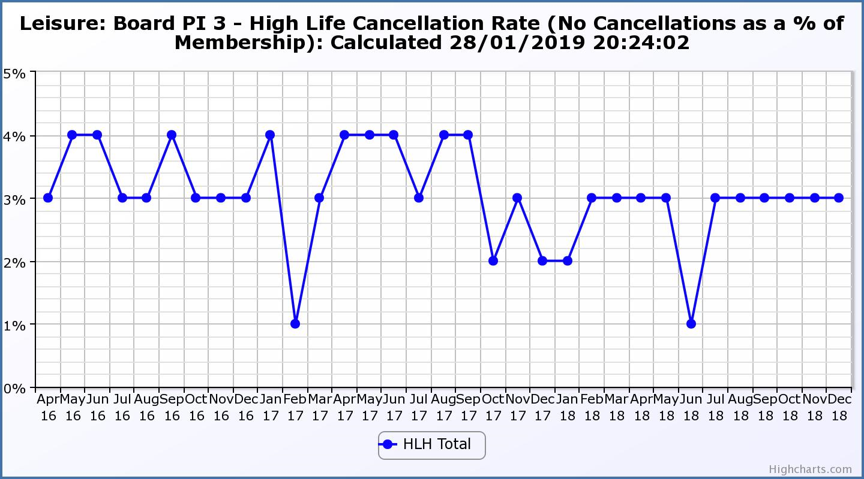

Business Plan Outcome | Performance Indicator | Reporting Frequency | RAG Rating Definition | RAG Rating Q1 18/19 | RAG Rating Q2 18/19 | RAG Rating Q3 18/19 | RAG Rating Q4 18/19 | Summary of Quarter Two Performance
2. Deliver the Service Delivery Contract with THC | 4. Delivery of the Service Delivery Contract (SDC) with The Highland Council (THC). | Six-monthly. | - Red = agreement of THC’s ECAS Committee that HLH has not met the terms of the SDC.  - Amber = agreement of THC’s ECAS Committee that HLH has met the terms of the SDC but has set some improvement targets.  - Green = agreement of THC’s ECAS Committee that HLH has met or exceeded the terms of the SDC. |  | Green |  |  | The next HLH progress report is scheduled for THC’s Care, Learning and Housing Committee meeting in May 2019.

Business Plan Outcome | Performance Indicator | Reporting Frequency | RAG Rating Definition | RAG Rating Q1 18/19 | RAG Rating Q2 18/19 | RAG Rating Q3 18/19 | RAG Rating Q4 18/19 | Summary of Quarter Two Performance
3. Improving staff satisfaction | 5. Staff turnover (resignations as a percentage of posts). | Quarterly. | - Red = more than 2%  - Amber = 1.7 to 2%  - Green = 1.6% or less | Green | Green | Green |  | The number of resignations per month as a percentage of posts in Q3 was 0.8% in October, 0.2% in November and 0.3% in December.

Performance Indicator 5 - Staff Turnover (resignations as a percentage of posts)
The graph below shows resignations as a percentage of the number of posts and resignations have been consistent with previous years and continue to be low (1% equates to 10.6 staff).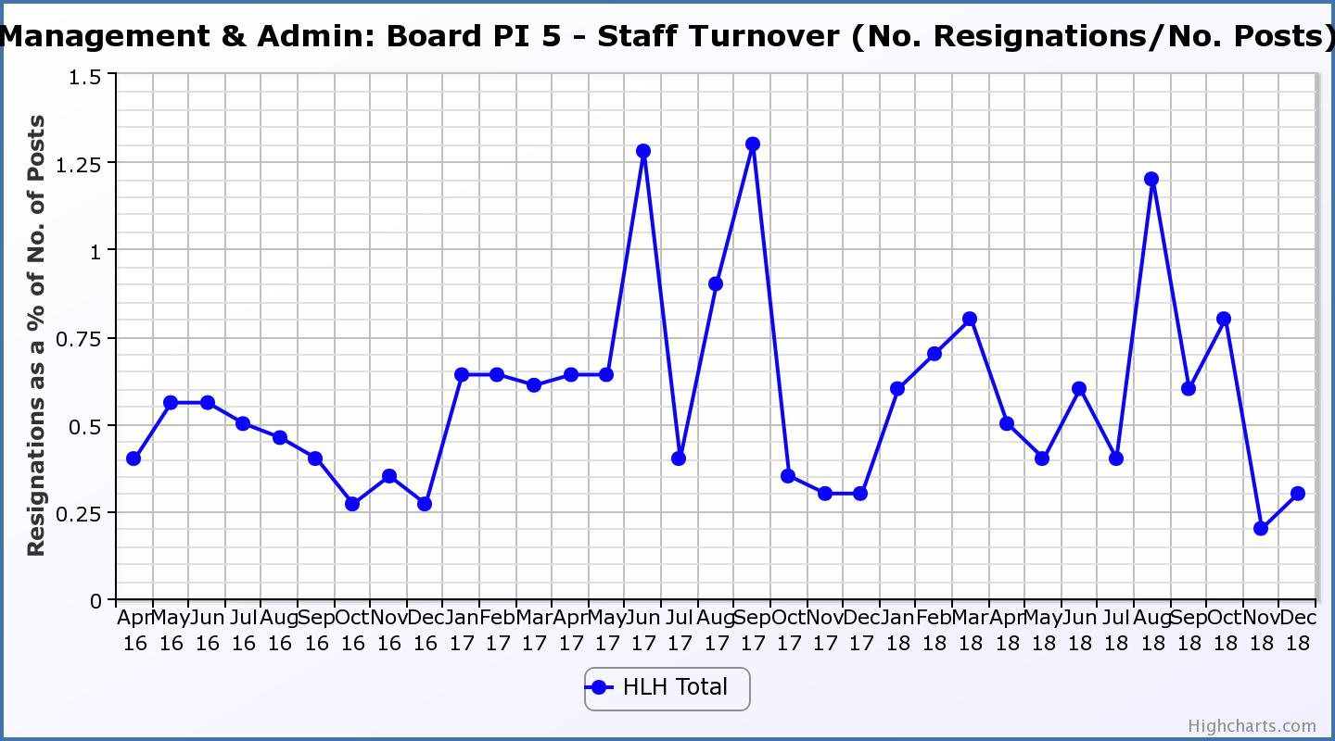
Business Plan Outcome | Performance Indicator | Reporting Frequency | RAG Rating Definition | RAG Rating Q1 18/19 | RAG Rating Q2 18/19 | RAG Rating Q3 18/19 | RAG Rating Q4 18/19 | Summary of Quarter Two Performance
3. Improving staff satisfaction (cont.) | 6. Staff absence rate. | Quarterly. | - Red = absence rate greater than 3.6%.  - Amber = absence rate between 3.4% and 3.6%.  - Green = absence rate 3.3% or less. | Green | Green | Red |  | The absence rate for Q3 was 4.02%. Please see the HR report elsewhere on this agenda for further information.

Performance Indicator 6 - Staff Absence Rates
Following the absence rate increasing in the last two quarters in 2017/18 it decreased in quarters one and two 2018/19. Please see the HR report elsewhere on this agenda for further information. 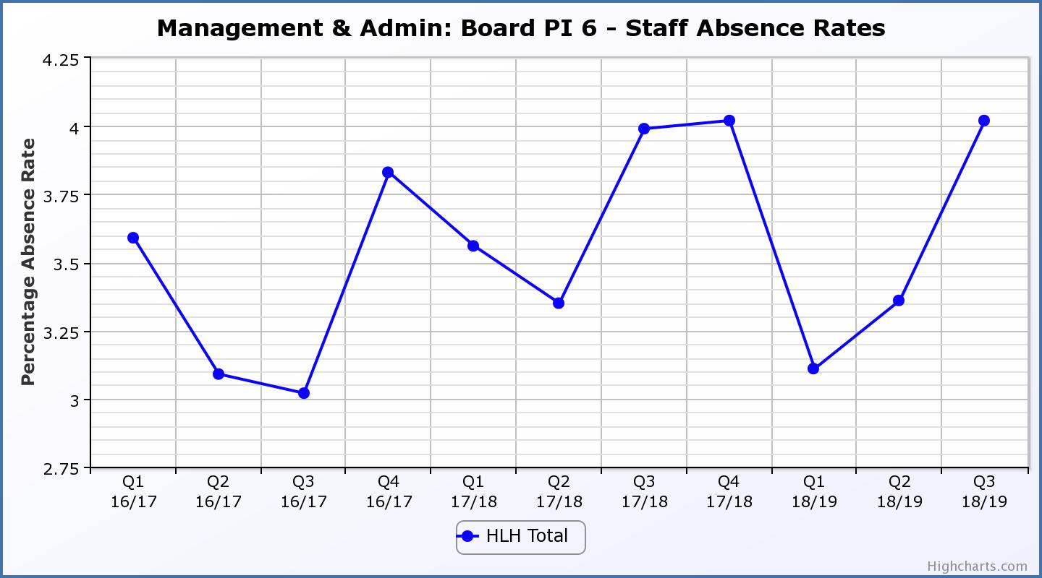

Business Plan Outcome | Performance Indicator | Reporting Frequency | RAG Rating Definition | RAG Rating Q1 18/19 | RAG Rating Q2 18/19 | RAG Rating Q3 18/19 | RAG Rating Q4 18/19 | Summary of Quarter Two Performance
4. Improving customer satisfaction | 7. Customer surveys. | Quarterly. | - Red = no staff surveys have been completed or scheduled.  - Amber = 4 to 8 of the HLH areas of work have completed or scheduled customer surveys.  - Green = all areas of HLH work have completed or scheduled customer surveys. | Green | Green | Green |  | All areas of work included customer surveys in their operational plans for 2018/19.  Please see section five of this report for further information.

Business Plan Outcome | Performance Indicator | Reporting Frequency | RAG Rating Definition | RAG Rating Q1 18/19 | RAG Rating Q2 18/19 | RAG Rating Q3 18/19 | RAG Rating Q4 18/19 | Summary of Quarter Two Performance
4. Improving customer satisfaction (cont) | 8. Customer Numbers. | Quarterly. | - Red = customer numbers are more than 5% lower than the corresponding quarter in the previous year.  - Amber = customer numbers are less than the corresponding quarter in the previous year.  - Green = customer numbers are the same as or have increased compared with the corresponding quarter in the previous year. | Green | Green | Green |  | Customer numbers increased from 1,886,899 in Q3 2017/18 to 2,148,586 in Q3 2018/19.

Performance Indicator 8 - Customer Numbers
The graph below shows a year on year increase in customer numbers.
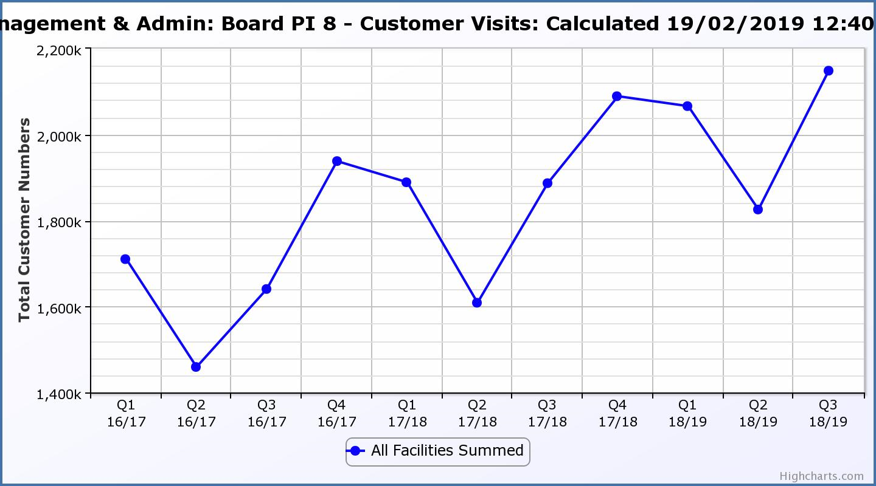

Business Plan Outcome | Performance Indicator | Reporting Frequency | RAG Rating Definition | RAG Rating Q1 18/19 | RAG Rating Q2 18/19 | RAG Rating Q3 18/19 | RAG Rating Q4 18/19 | Summary of Quarter Two Performance
5. A positive company image | 9.Media clippings. | Quarterly | - Red = number of negative press clippings outweigh neutral and positive.  - Amber = number of negative and neutral press clippings outweigh positive.  - Green = number of positive and neutral media clippings outweigh negative. | Green | Green | Green |  | Media clippings for Q3 2018/19 totalled 119. 84 of these were positive,  25 were neutral and there were 10 which were negative.

Performance Indicator 9 - Media Clippings
The following two graphs show the numbers of positive and neutral media clippings compared with negative. The positive and neutral outweigh the negative.

Business Plan Outcome | Performance Indicator | Reporting Frequency | RAG Rating Definition | RAG Rating Q1 18/19 | RAG Rating Q2 18/19 | RAG Rating Q3 18/19 | RAG Rating Q4 18/19 | Summary of Quarter Two Performance
5. A positive company image (cont.) | 10. Formal complaints. | Quarterly. | - Red = 21 or more complaints per quarter.  - Amber = 11 to 20 complaints per quarter.  - Green = 10 complaints or fewer per quarter. | Green | Amber | Amber |  | There were twelve complaints received during Q3 2018/19. Please see section three of this report for further information.

Performance Indicator 10 - Formal Complaints
The graph below shows the number of complaints which continue to be very low in relation to customer numbers.
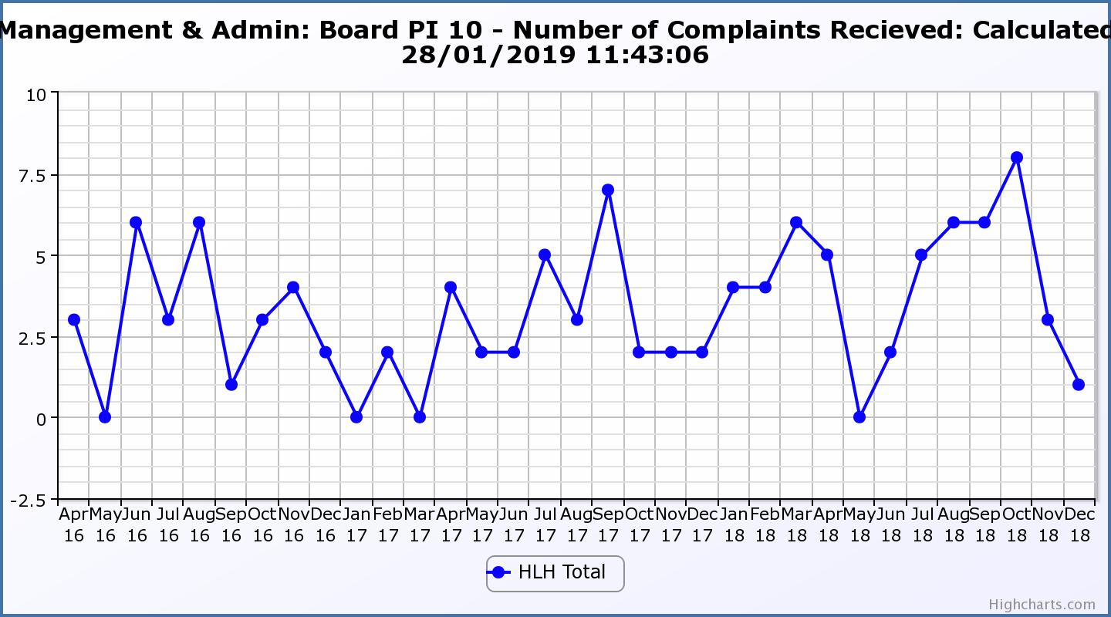
Business Plan Outcome | Performance Indicator | Reporting Frequency | RAG Rating Definition | RAG Rating Q1 18/19 | RAG Rating Q2 18/19 | RAG Rating Q3 18/19 | RAG Rating Q4 18/19 | Summary of Quarter Two Performance
7. Sustain a good health and safety performance | 11. Health and safety audit. | Annual. | - Red = the external audit raises systemic (i.e. applying across multiple sites) H&S issues.  - Amber = the external audit highlights common actions to be addressed across the company.  - Green = the external audit does not raise systemic issues. |  | Green |  |  | The QLM follow-up audit took place in August 2019 and all actions are complete as noted by the Health and Safety and Environmental Compliance Committee at its meeting held in November 2018.

Business Plan Outcome | Performance Indicator | Reporting Frequency | RAG Rating Definition | RAG Rating Q1 18/19 | RAG Rating Q2 18/19 | RAG Rating Q3 18/19 | RAG Rating Q4 18/19 | Summary of Quarter Two Performance
7. Sustain a good health and safety performance  (cont) | 12. RIDDOR accidents/incidents. | Quarterly. | - Red = number of RIDDOR reports per quarter is above 20.  - Amber = number of RIDDOR reports per quarter is between 10 and 20  - Green = number of RIDDOR reports per quarter is less than 10. | Green | Green | Green |  | There was one RIDDOR reported accident during Q3 2018/19.

Performance Indicator 12 - RIDDOR Accidents
The graph below tracks the number of accidents and incidents reported under the RIDDOR regulations. There was one in Q2 2018/19.
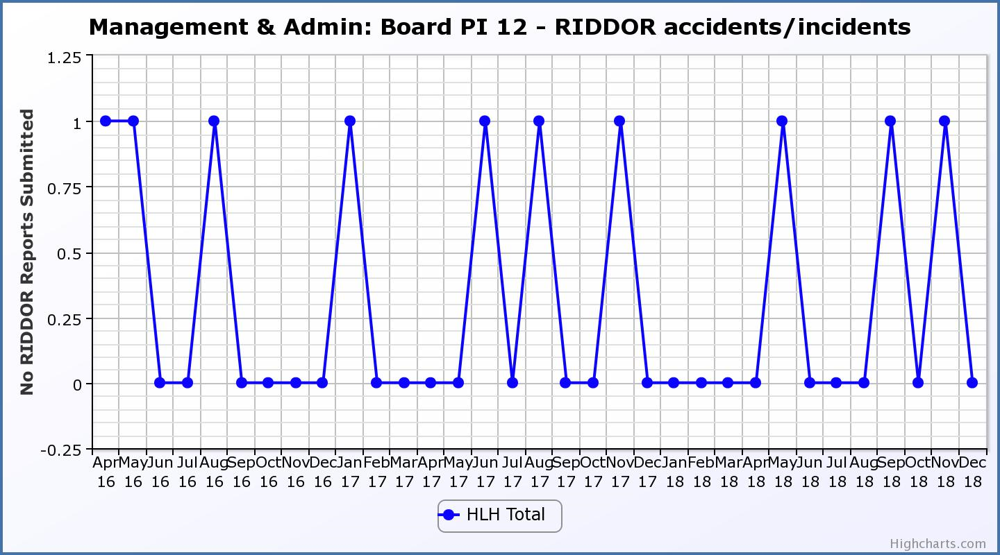
Business Plan Outcome | Performance Indicator | Reporting Frequency | RAG Rating Definition | RAG Rating Q1 18/19 | RAG Rating Q2 18/19 | RAG Rating Q3 18/19 | RAG Rating Q4 18/19 | Summary of Quarter Two Performance
8. A trusted partner | 13. THC’s annual survey of performance and attitudes. | Annual. | - Red = all HLH areas of work represented receive lower net satisfaction ratings than the previous year.  - Amber = two or more areas of HLH work receive lower net satisfaction ratings than the previous year.  - Green = net satisfaction ratings are maintained or improved for three or more areas of HLH work compared with the previous year. |  | Green

