HIGH LIFE HIGHLAND  REPORT TO BOARD OF DIRECTORS  11 December 2018 | AGENDA ITEM REPORT No HLH /18

Performance Report - Report by Chief Executive

Summary

The purpose of this report is to present performance information for the period July to September 2018.

It is recommended Directors:-

- comment on the report and agree that the overall health check on the Company for the period is assessed as green;
- note that the delivery of the business plan is assessed as green;
- note the information provided on the performance indicators for more detailed consideration;
- note that the Health and Safety Policy has been reviewed by the then Health and Safety and Environmental Compliance strategic group and that it was considered to be fit for purpose with no changes required; and
- consider and agree the draft performance indicators for monitoring the delivery of the new High Life Highland Business Plan 2019-24 in Appendix C.

1. | Business Plan Contribution
1.1 | This report supports all the Business Outcomes from the High Life Highland (HLH) Business Plan:  - To advance sustainable growth and financial sustainability  - Deliver the Service Delivery Contract with THC  - Improving staff satisfaction  - Improving customer satisfaction  - A positive company image  - Services designed around customers and through market opportunities  - Sustain a good health and safety performance  - A trusted partner
2. | Background
2.1 | The performance indicators in this report were set, at the request of the Board, by the Finance and Audit Committee in March 2016. It was agreed then that reporting on the delivery of the business outcomes would be by exception (i.e. reporting where managers had RAG rated the actions “red – no significant progress”).

3. | Summary of Performance
3.1 | Appendix A contains a summary of performance against the performance indicators along with trend information for numeric PIs. There are fourteen performance indicators scheduled for assessment at the December 2018 Board meeting. Eleven of them have been RAG rated “green” and two amber. One has not been RAG rated as explained below. The PIs which have been RAG rated amber are as follows:  - PI 3 High Life Subscription Cancellation Rate.  - PI 10 Formal complaints.
3.2 | PI 3 High Life Subscription Cancellation Rate - the cancellation rate was 3% each month during quarter two. As Directors will be aware from previous reports, THC used to pay Macdonald Aviemore Highland Resort (MAHR) to provide public swimming through the HLH leisure access scheme. The contract for the provision of public swimming ceased on 31 March 2018 and was extended to June at which time it came to an end. As a result there was a higher than average level of cancellations at the three facilities in Badenoch and Strathspey during quarter two. The High Life card was reintroduced at MAHR on 22 November 2018 for one year. THC has agreed to pay HLH for the lost income associated with this.
3.3 | PI 10 Formal complaints – there were seventeen complaints received during quarter two. Of those there were five complaints which were upheld, six were partially upheld, and six were not upheld.
3.4 | The complaints which were upheld or partially upheld were mostly to do with miscommunications between staff and customers which were able to be resolved with most of these (six) taking place at Inverness Leisure, the facility with the highest footfall. Of the complaints which have not been upheld, one relates to Strathpeffer Pavilion where there has been a series of complaints on the same topic from a single complainer.
4. | Delivery of Business Outcomes
4.1 | The current HLH Business Plan 2015-19 identifies 8 business outcomes and the approach which the charity takes to deliver them. The resultant Operational Plans for each of the nine HLH areas of work are RAG rated every quarter.
4.2 | The RAG ratings of the operational plans has identified that delivery of the Business Plan is on target. Five of the nine areas of HLH work RAG rated all of the actions “green – on target” or complete; one area of work RAG rated 1 action as “amber – some slippage”; one area of work RAG rated 2 actions as “amber – some slippage”; one area of work RAG rated 3 actions as “amber – some slippage”; and one area of work RAG rated 4 actions as “amber - some slippage”. Directors have agreed that reporting on the delivery of the business outcomes would be by exception (i.e. reporting where managers had RAG rated the actions “red – no significant progress”) and there have been no actions which have been RAG rated “red” in quarter two 2018/19.
5. | Performance Indicators for More Detailed Consideration
5.1 | The performance indicators scheduled for more detailed consideration in this report are:  - PI 4. Delivery of the Service Delivery Contract (SDC) with the Highland Council (THC).  - PI 9. Media clippings (please see further information in the Marketing and Communications Update report elsewhere on this agenda).  - PI 10. Formal complaints (covered in section three above).  - PI 13. THC’s annual survey of performance and attitudes.
5.2 | PI 4. Delivery of the Service Delivery Contract (SDC) with the Highland Council (THC) - at the time of writing, THC’s Care Learning and Housing Committee was scheduled to meet on Wednesday 6 December 2018 and a verbal update will be provided by the HLH Chief Executive at the 11 December 2018 HLH Board Meeting.
5.3 | PI 13. THC’s annual survey of performance and attitudes – the Council’s annual survey surveys the Citizen’s Panel, which in 2018, was made up of 2,634 individuals selected to be representative of the Highland population. Appendix B contains further information from the survey report. In summary, HLH made a positive contribution to the survey results which are an improvement on previous years. HLH’s service areas were in the top 20 out of 46 Council services (top 29 in 2017/18). The table below shows that two services improved their ranking compared with other services, two remained the same and two reduced.  Rank 2017/18 Rank 2018/19  Libraries 1 2  Swimming Pools 4 4  Other sports facilities 10 5  Museums 12 12  Countryside Ranger Service 15 18  Community learning/adult education 29 20
6. | Health and Safety Policy Review
6.1 | The Health and Safety Policy was reviewed by the then Health and Safety Strategic Group at its meeting held on 21 August 2018 and it was considered to be fit for purpose with no changes required. It is recommended that the HLH Board notes that the policy has been reviewed.
7. | Business Plan 2019-24: New Board Performance Indicators
7.1 | The business plan was agreed by the HLH Board at its September 2018 meeting. The Board has previously aligned its performance Indicators (PIs) with its business plan outcomes so that they can be used to assess progress against the business plan. The draft new PIs in Appendix C have been updated to take account of the revised business plan outcomes and it is recommended that the Board consider and agree the performance indicators in Appendix C. The new PIs would be in place from 1 April 2019 and would be considered by the Board from its June 2019 meeting onwards.
8. | Implications
8.1 | Resource Implications – there are no additional resource implications arising from this report.
8.2 | Legal Implications - there are no new legal implications arising from this report.
8.3 | Risk Implications – there are no new risk implications arising from this report.

Recommendation

It is recommended Directors:-

- comment on the report and agree that the overall health check on the Company for the period is assessed as green;
- note that the delivery of the business plan is assessed as green;
- note the information provided on the performance indicators for more detailed consideration;
- note that the Health and Safety Policy has been reviewed by the then Health and Safety and Environmental Compliance strategic group and that it was considered to be fit for purpose with no changes required; and
- consider and agree the draft performance indicators for monitoring the delivery of the new High Life Highland Business Plan 2019-24 in Appendix C.

Designation: Chief Executive

Date: 30 November 2018

Appendix A
HLH Performance Indicators

Business Plan Outcome | Performance Indicator | Reporting Frequency | RAG* Rating Definition  (*Red/Amber/Green) | RAG Rating Q1 18/19 | RAG Rating Q2 18/19 | RAG Rating Q3 18/19 | RAG Rating Q4 18/19 | Summary of Quarter Two Performance
1. To advance sustainable growth and financial sustainability | 1. Financial monitoring. | Quarterly. | An assessment of the year end outturn where:  - Red = delivery of the SDC over budget above 2%.  - Amber = delivery of the SDC between break-even and 2% over budget.  - Green = delivery of SDC within budget. | Green | Green |  |  | The variance for the budget up to the end of quarter two was £62K and it is projected that the SDC will be delivered within budget for financial year 2018/19. See the Finance Report elsewhere on this agenda for further information.

Performance Indicator 1 - Financial monitoring, variance to budget per quarter.
See the Finance Report elsewhere on this agenda for further information.

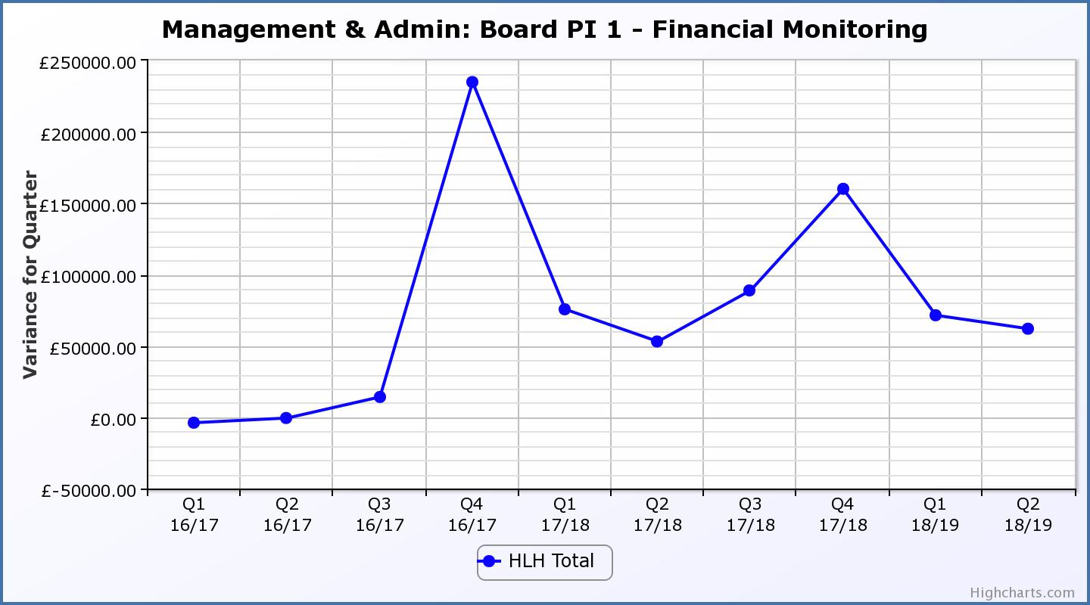
Business Plan Outcome | Performance Indicator | Reporting Frequency | RAG Rating Definition | RAG Rating Q1 18/19 | RAG Rating Q2 18/19 | RAG Rating Q3 18/19 | RAG Rating Q4 18/19 | Summary of Quarter Two Performance
1. To advance sustainable growth and financial sustainability (cont) | 2. Number of High Life subscriptions. | Quarterly. | - Red = more than 5% below target.  - Amber = up to 5% below target.  - Green = on or exceeds target. | Green | Green |  |  | The number of subscriptions each month during Q2 exceeded the target of 20,086 with the average number of subscriptions for the quarter having been 21,582. The target has been set at the level required to achieve the High Life Subscriptions income target.

Performance Indicator 2 - Number of High Life Subscriptions
The number of High Life Card subscriptions continues to increase and the average of 21,582 subscriptions for Q2 2018/19 was the highest they have been.

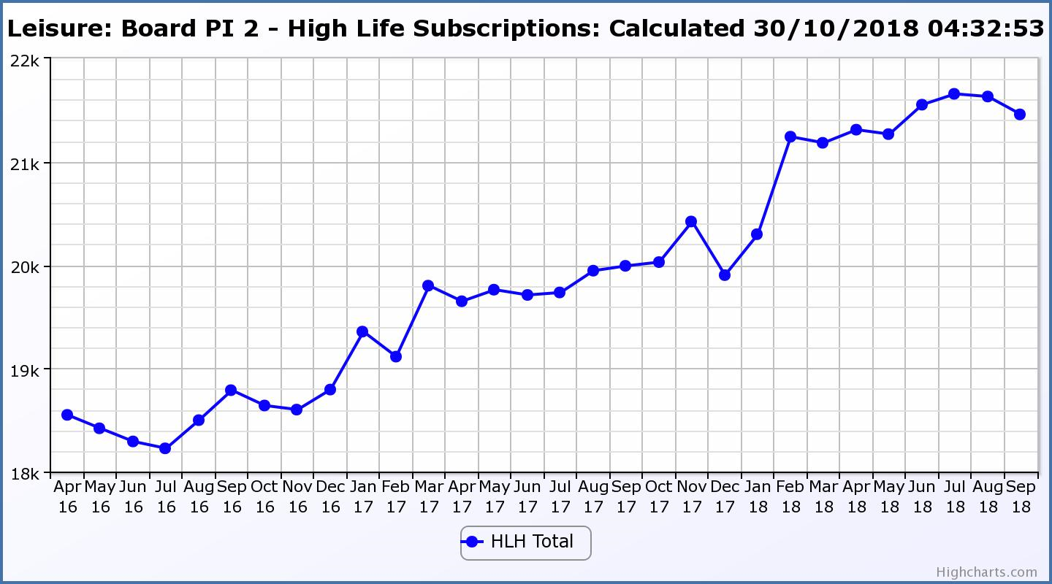

Business Plan Outcome | Performance Indicator | Reporting Frequency | RAG Rating Definition | RAG Rating Q1 18/19 | RAG Rating Q2 18/19 | RAG Rating Q3 18/19 | RAG Rating Q4 18/19 | Summary of Quarter Two Performance
1. To advance sustainable growth and financial sustainability (cont) | 3. High Life cancellation rate. | Quarterly. | - Red = cancellation rate above 6% of High Life memberships.  - Amber = cancellation rate is 3% - 6% of High Life memberships.  - Green = cancellation rate is up to 3% of High Life memberships. | Green | Amber |  |  | The High Life cancellation rates in Q2 were 3% in July, 3% in August and 3% in September.  This was due to the cessation of the agreement between THC and the Macdonald Aviemore Highland Resort for public swimming under the High Life scheme. Please see section three of this report for further information.

Performance Indicator 3 - High Life Cancellation Rate
The overall number of subscriptions has increased with the cancellation rate having been 3% each month during quarter two. Please see section three of this report for further information.
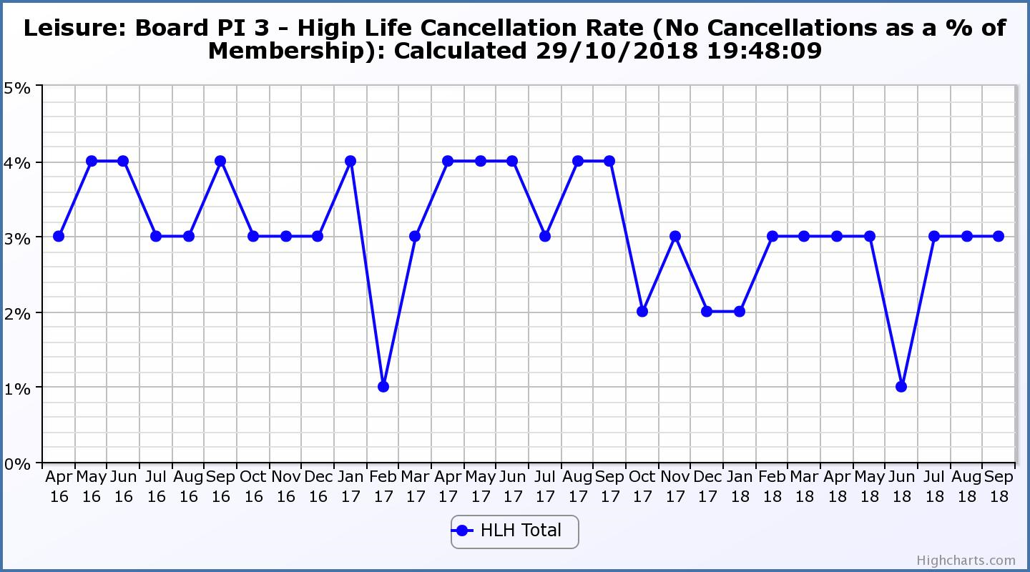

Business Plan Outcome | Performance Indicator | Reporting Frequency | RAG Rating Definition | RAG Rating Q1 18/19 | RAG Rating Q2 18/19 | RAG Rating Q3 18/19 | RAG Rating Q4 18/19 | Summary of Quarter Two Performance
2. Deliver the Service Delivery Contract with THC | 4. Delivery of the Service Delivery Contract (SDC) with The Highland Council (THC). | Six-monthly. | - Red = agreement of THC’s ECAS Committee that HLH has not met the terms of the SDC.  - Amber = agreement of THC’s ECAS Committee that HLH has met the terms of the SDC but has set some improvement targets.  - Green = agreement of THC’s ECAS Committee that HLH has met or exceeded the terms of the SDC. |  | TBC |  |  | The next HLH progress report is scheduled for THC’s Care, Learning and Housing Committee meeting on 6 December 2018 and this PI will be RAG rated following a verbal update from the HLH Chief Executive at the HLH Board meeting on 11 December 2018.

Business Plan Outcome | Performance Indicator | Reporting Frequency | RAG Rating Definition | RAG Rating Q1 18/19 | RAG Rating Q2 18/19 | RAG Rating Q3 18/19 | RAG Rating Q4 18/19 | Summary of Quarter Two Performance
3. Improving staff satisfaction | 5. Staff turnover (resignations as a percentage of posts). | Quarterly. | - Red = more than 2%  - Amber = 1.7 to 2%  - Green = 1.6% or less | Green | Green |  |  | The number of resignations per month as a percentage of posts in Q2 was 0.4% in July, 1.2% in August and 0.6% in September. Please see HR report elsewhere on this agenda for further information.

Performance Indicator 5 - Staff Turnover (resignations as a percentage of posts)
The graph below shows resignations as a percentage of the number of posts and resignations have been consistent with previous years and continue to be low (1% equates to 10.6 staff).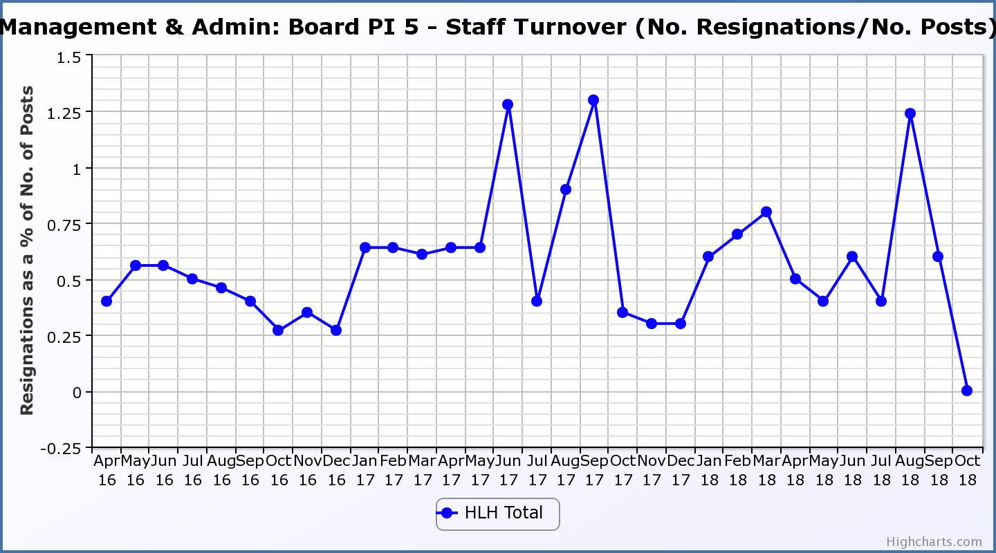
Business Plan Outcome | Performance Indicator | Reporting Frequency | RAG Rating Definition | RAG Rating Q1 18/19 | RAG Rating Q2 18/19 | RAG Rating Q3 18/19 | RAG Rating Q4 18/19 | Summary of Quarter Two Performance
3. Improving staff satisfaction (cont.) | 6. Staff absence rates. | Quarterly. | - Red = absence rate greater than 3.6%.  - Amber = absence rate between 3.4% and 3.6%.  - Green = absence rate 3.3% or less. | Green | Green |  |  | The absence rate for Q2 was 3.36%. Please see the HR report elsewhere on this agenda for further information.

Performance Indicator 6 - Staff Absence Rates
Following the absence rate increasing in the last two quarters in 2017/18 it decreased in quarters one and two 2018/19. Please see the HR report elsewhere on this agenda for further information. 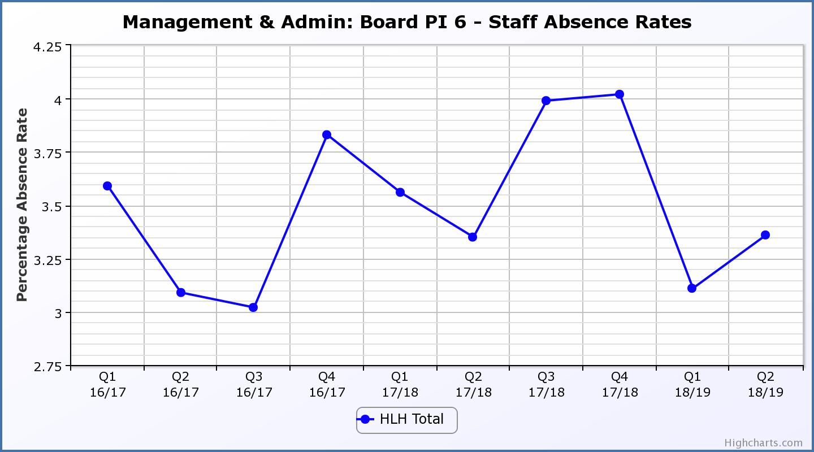

Business Plan Outcome | Performance Indicator | Reporting Frequency | RAG Rating Definition | RAG Rating Q1 18/19 | RAG Rating Q2 18/19 | RAG Rating Q3 18/19 | RAG Rating Q4 18/19 | Summary of Quarter Two Performance
4. Improving customer satisfaction | 7. Customer surveys. | Quarterly. | - Red = no staff surveys have been completed or scheduled.  - Amber = 4 to 8 of the HLH areas of work have completed or scheduled customer surveys.  - Green = all areas of HLH work have completed or scheduled customer surveys. | Green | Green |  |  | All areas of work included customer surveys in their operational plans for 2018/19.

Business Plan Outcome | Performance Indicator | Reporting Frequency | RAG Rating Definition | RAG Rating Q1 18/19 | RAG Rating Q2 18/19 | RAG Rating Q3 18/19 | RAG Rating Q4 18/19 | Summary of Quarter Two Performance
4. Improving customer satisfaction (cont) | 8. Customer Numbers. | Quarterly. | - Red = customer numbers are more than 5% lower than the corresponding quarter in the previous year.  - Amber = customer numbers are less than the corresponding quarter in the previous year.  - Green = customer numbers are the same as or have increased compared with the corresponding quarter in the previous year. | Green | Green |  |  | Customer numbers increased from 1,608,756 in Q2 2017/18 to 1,808,123 in Q2 2018/19.

Performance Indicator 8 - Customer Numbers
The graph below shows a year on year increase in customer numbers.
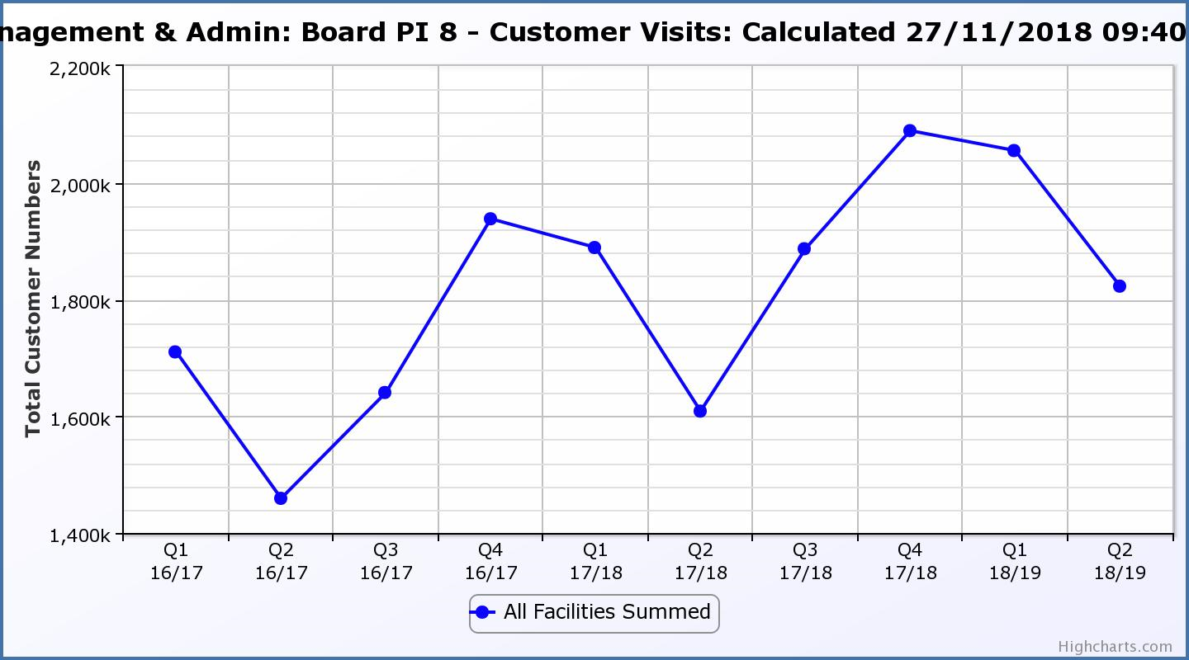

Business Plan Outcome | Performance Indicator | Reporting Frequency | RAG Rating Definition | RAG Rating Q1 18/19 | RAG Rating Q2 18/19 | RAG Rating Q3 18/19 | RAG Rating Q4 18/19 | Summary of Quarter Two Performance
5. A positive company image | 9.Media clippings. | Quarterly | - Red = number of negative press clippings outweigh neutral and positive.  - Amber = number of negative and neutral press clippings outweigh positive.  - Green = number of positive and neutral media clippings outweigh negative. | Green | Green |  |  | Media clippings for Q2 2018/19 totalled 112. 84 of these were positive,  21 were neutral and there were 7 which were negative.

Performance Indicator 9 - Media Clippings
The following two graphs show the numbers of positive and neutral media clippings compared with negative. The positive and neutral outweigh the negative.

Business Plan Outcome | Performance Indicator | Reporting Frequency | RAG Rating Definition | RAG Rating Q1 18/19 | RAG Rating Q2 18/19 | RAG Rating Q3 18/19 | RAG Rating Q4 18/19 | Summary of Quarter Two Performance
5. A positive company image (cont.) | 10. Formal complaints. | Quarterly. | - Red = 21 or more complaints per quarter.  - Amber = 11 to 20 complaints per quarter.  - Green = 10 complaints or fewer per quarter. | Green | Amber |  |  | There were 17 complaints received during Q2 2018/19.

Performance Indicator 10 - Formal Complaints
The graph below shows the number of complaints which continue to be very low in relation to customer numbers.
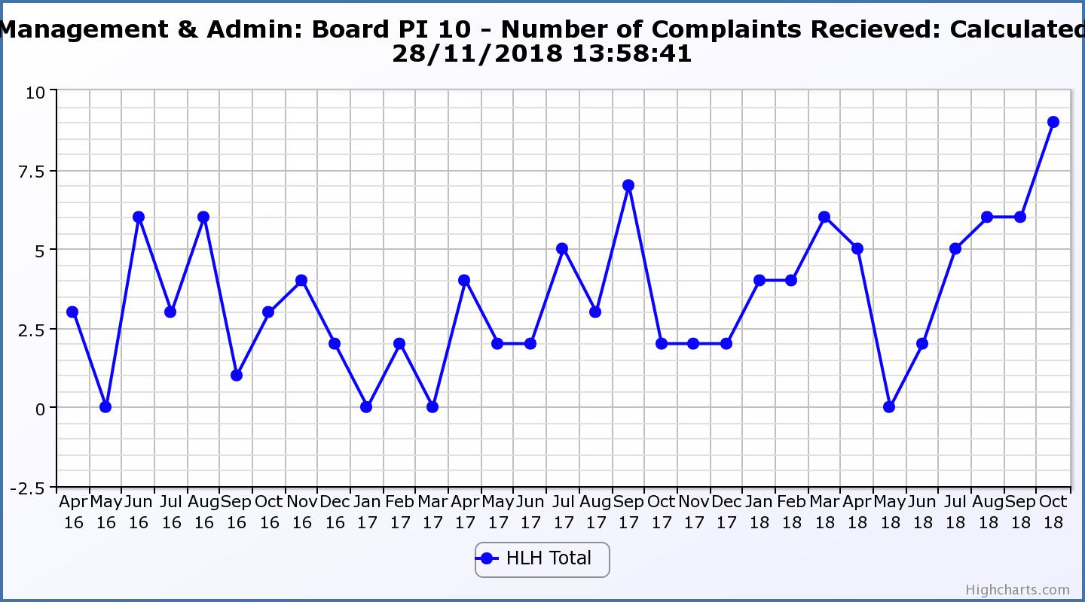
Business Plan Outcome | Performance Indicator | Reporting Frequency | RAG Rating Definition | RAG Rating Q1 18/19 | RAG Rating Q2 18/19 | RAG Rating Q3 18/19 | RAG Rating Q4 18/19 | Summary of Quarter Two Performance
7. Sustain a good health and safety performance | 11. Health and safety audit. | Annual. | - Red = the external audit raises systemic (i.e. applying across multiple sites) H&S issues.  - Amber = the external audit highlights common actions to be addressed across the company.  - Green = the external audit does not raise systemic issues. |  | Green |  |  | The QLM follow-up audit took place in August 2019 and all actions are complete as noted by the Health and Safety and Environmental Compliance Committee at its meeting held in November 2018.

Business Plan Outcome | Performance Indicator | Reporting Frequency | RAG Rating Definition | RAG Rating Q1 18/19 | RAG Rating Q2 18/19 | RAG Rating Q3 18/19 | RAG Rating Q4 18/19 | Summary of Quarter Two Performance
7. Sustain a good health and safety performance  (cont) | 12. RIDDOR accidents/incidents. | Quarterly. | - Red = number of RIDDOR reports per quarter is above 20.  - Amber = number of RIDDOR reports per quarter is between 10 and 20  - Green = number of RIDDOR reports per quarter is less than 10. | Green | Green |  |  | There was one RIDDOR reported accident during Q2 2018/19.

Performance Indicator 12 - RIDDOR Accidents
The graph below tracks the number of accidents and incidents reported under the RIDDOR regulations. There was one in Q2 2018/19.
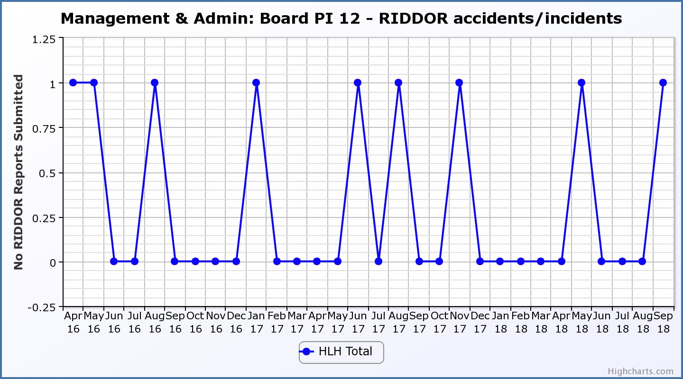
Business Plan Outcome | Performance Indicator | Reporting Frequency | RAG Rating Definition | RAG Rating Q1 18/19 | RAG Rating Q2 18/19 | RAG Rating Q3 18/19 | RAG Rating Q4 18/19 | Summary of Quarter Two Performance
8. A trusted partner | 13. THC’s annual survey of performance and attitudes. | Annual. | - Red = all HLH areas of work represented receive lower net satisfaction ratings than the previous year.  - Amber = two or more areas of HLH work receive lower net satisfaction ratings than the previous year.  - Green = net satisfaction ratings are maintained or improved for three or more areas of HLH work compared with the previous year. |  | Green |  |  | Net satisfaction ratings improved or stayed the same for three areas of HLH work and went down for three areas of HLH work.  Rankings with other Council services were maintained overall with: two areas of work increasing their rankings; two remaining the same; and two going down.

Table 13.1 from THC’s annual Citizen’s panel survey. Appendix B

THC’s annual survey of performance and attitudes surveys the Citizen’s Panel which in 2018 was made up of 2,634 individuals selected to be representative of the Highland population. In 2017 there were 1,152 responses to the survey. The full report can be seen on the Council’s web site: http://www.highland.gov.uk/download/downloads/id/18440/annual_survey_of_performance_and_attitudes_2017.pdf

The 2018 survey assessed satisfaction ratings for 46 Council services. As can be seen in the table below, the survey placed all of the HLH services which form part of the survey in the top 20 (HLH services were in the top 29 in 2017).

The information most relevant to the HLH areas of work are listed below and responses to the survey will reflect on services which are delivered by HLH and also other organisations which deliver the same or similar services:
• libraries;
• swimming pools and other sports facilities (there are some leisure facilities operated by other organisations);
• museums (of the 20 Council funded museums HLH provides the two regional museums);
• community learning/adult education, there are other providers of community learning/adult education) and it is unlikely that he public would consider youth work and some of the adult learning work delivered by HLH to be “community learning” as it is a term which has not been used by HLH.

Table 13.1: Net satisfaction with the services provided by The Council Service
Service | Net satisfaction (%) |  |  |  |  | Respondents using service (2018)
 | 2018 | 2017 | 2016 | 2015 | 2014
Walking routes e.g. Great Glen Way | 80 | 79 | 79 | 83 | 84 | 46%
2. Libraries | 77 | 86 | 77 | 77 | 84 | 58%
Recycling facilities | 76 | 73 | 75 | 76 | 76 | 97%
4. Swimming pools | 76 | 78 | 67 | 72 | 71 | 43%
5. Other sports facilities | 75 | 72 | 72 | 75 | 70 | 40%
Refuse/ bin collection | 74 | 70 | 79 | 78 | 75 | 99%
Council service points | 74 | 56 | 70 | 83 | 73 | 40%
Registrars for births, deaths, & marriages | 73 | 67 | 71 | 74 | 73 | 24%
Public parks and other open spaces | 72 | 80 | 77 | 78 | 80 | 79%
Payment of Council Tax | 72 | 72 | 76 | 83 | 81 | 74%
Pre-school services | 70 | 74 | 76 | 53 | 54 | 16%
12. Museums | 67 | 69 | 72 | 69 | 64 | 47%
Burials and cremations | 65 | 61 | 68 | 66 | 63 | 25%
Street lighting | 64 | 65 | 62 | 68 | 67 | 90%
Council Service Centre | 62 | 50 | 59 | 53 | 58 | 25%
Primary education | 62 | 75 | 77 | 75 | 68 | 23%
Council website | 61 | 57 | 62 | n/a | n/a | 62%
18. Countryside ranger service | 61 | 61 | 64 | 72 | 69 | 27%
School transport | 59 | 46 | 69 | 53 | 54 | 16%
20. Community learning/ adult education | 57 | 37 | 47 | 40 | 51 | 16%
Secondary education | 56 | 50 | 66 | 64 | 61 | 21%
School meals | 56 | 72 | 61 | 64 | 57 | 20%
Services to protect children from harm | 54 | 53 | 59 | 35 | 39 | 16%
Environmental health service | 52 | 53 | 53 | 50 | 52 | 19%
Cycling paths | 52 | 50 | 56 | 47 | 45 | 37%
Gaelic primary education | 50 | 24 | 42 | 20 | 17 | 9%
Breakfast and after school clubs | 47 | 58 | 60 | 23 | 39 | 11%
Gaelic secondary education | 42 | 5 | 25 | 5 | 8 | 8%
Gaelic pre-school services | 41 | 21 | 45 | 15 | 20 | 8%
Grass cutting | 35 | n/a | n/a | n/a | n/a | 85%
Trading standards | 35 | 47 | 48 | 32 | 38 | 15%
Economic development/ Business Gateway | 34 | 20 | 33 | 29 | 30 | 12%
Dealing with flooding | 33 | 37 | 33 | 30 | 34 | 53%
Gaelic community learning/ adult education | 31 | 2 | 23 | 9 | 12 | 9%
Housing information and advice | 30 | 22 | 44 | 17 | 40 | 15%
Care at home services | 29 | 15 | 23 | 4 | 11 | 20%
Street cleaning | 24 | 38 | 35 | 43 | 44 | 92%
Planning applications & building warrants | 21 | 20 | 8 | 21 | 23 | 34%
Planning for future land use (Local Plan) | 19 | 12 | 6 | 13 | 8 | 32%
Advice on benefits | 19 | 28 | 28 | 27 | 35 | 20%
Community occupational therapy | 19 | 38 | 41 | 23 | 39 | 17%
Residential homes for disabled/ elderly people | 9 | 6 | 22 | 0 | 19 | 20%
Services to protect adults at risk from harm | 7 | 18 | 12 | 28 | 36 | 11%
Pavement maintenance | 0 | 18 | 6 | 10 | 15 | 91%
Public toilets | 0 | n/a | n/a | n/a | n/a | 72%
Services to reduce offending | -6 | 15 | -1 | -7 | 15 | 9%
Winter road maintenance | -17 | 13 | -5 | -8 | 17 | 98%
Road repairs and potholes | -81 | -61 | -74 | -65 | -56 | 98%

The graphs below plot the net satisfaction ratings over time and they remain fairly consistent year on year.

HLH Performance Indicators 2019-24 Appendix C

Business Plan Outcome | Performance Indicator | Reporting Frequency | RAG Rating Definition | RAG Rating Q1 19/20 | RAG Rating Q2 19/20 | RAG Rating Q3 19/20 | RAG Rating Q4 19/20 | Summary of Quarter One Performance
1. Sustain a high standard of health and safety and environmental performance | 1. Health and safety audit. | Annual. | - Red = the external audit raises systemic (i.e. applying across multiple sites) H&S issues.  - Amber = the external audit highlights common actions to be addressed across the company.  - Green = the external audit does not raise systemic issues.

Business Plan Outcome | Performance Indicator | Reporting Frequency | RAG Rating Definition | RAG Rating Q1 19/20 | RAG Rating Q2 19/20 | RAG Rating Q3 19/20 | RAG Rating Q4 19/20 | Summary of Quarter One Performance
1. Sustain a high standard of health and safety and environmental performance (cont.) | 2. RIDDOR accidents/incidents. | Quarterly. | - Red = number of RIDDOR reports per quarter is above 20.  - Amber = number of RIDDOR reports per quarter is between 10 and 20  - Green = number of RIDDOR reports per quarter is less than 10.

Business Plan Outcome | Performance Indicator | Reporting Frequency | RAG Rating Definition | RAG Rating Q1 19/20 | RAG Rating Q2 19/20 | RAG Rating Q3 19/20 | RAG Rating Q4 19/20 | Summary of Quarter One Performance
2. Implement the Service Delivery Contract with The Highland Council | 3. Delivery of the Service Delivery Contract (SDC) with The Highland Council (THC). | Six-monthly. | - Red = agreement of THC’s CLH Committee that HLH has not met the terms of the SDC.  - Amber = agreement of THC’s CLH Committee that HLH has met the terms of the SDC but has set some improvement targets.  - Green = agreement of THC’s CLH Committee that HLH has met or exceeded the terms of the SDC.

Business Plan Outcome | Performance Indicator | Reporting Frequency | RAG Rating Definition | RAG Rating Q1 19/20 | RAG Rating Q2 19/20 | RAG Rating Q3 19/20 | RAG Rating Q4 19/20 | Summary of Quarter One Performance
3. Improve customer engagement and satisfaction | 4. Customer engagements. | Quarterly. | - Red = customer numbers are more than 5% lower than the corresponding quarter in the previous year.  - Amber = customer numbers are less than the corresponding quarter in the previous year.  - Green = customer numbers are the same as or have increased compared with the corresponding quarter in the previous year.

Business Plan Outcome | Performance Indicator | Reporting Frequency | RAG Rating Definition | RAG Rating Q1 19/20 | RAG Rating Q2 19/20 | RAG Rating Q3 19/20 | RAG Rating Q4 19/20 | Summary of Quarter One Performance
3. Improve customer engagement and satisfaction (cont.) | 5. Customer surveys. | Quarterly. | - Red = no surveys have been completed or scheduled.  - Amber = 4 to 8 of the HLH areas of work have completed or scheduled customer surveys.  - Green = all areas of HLH work have completed or scheduled customer surveys.

Business Plan Outcome | Performance Indicator | Reporting Frequency | RAG Rating Definition | RAG Rating Q1 19/20 | RAG Rating Q2 19/20 | RAG Rating Q3 19/20 | RAG Rating Q4 19/20 | Summary of Quarter One Performance
3. Improve customer engagement and satisfaction (cont.) | 6. Formal complaints. | Quarterly. | - Red = 41 or more complaints per quarter.  - Amber = 31 to 40 complaints per quarter.  - Green = 30 complaints or fewer per quarter.

Business Plan Outcome | Performance Indicator | Reporting Frequency | RAG Rating Definition | RAG Rating Q1 19/20 | RAG Rating Q2 19/20 | RAG Rating Q3 19/20 | RAG Rating Q4 19/20 | Summary of Quarter One Performance
4. Improve staff engagement and satisfaction | 7. Staff turnover (resignations as a percentage of posts). | Quarterly. | - Red = more than 2%  - Amber = 1.7 to 2%  - Green = 1.6% or less

Business Plan Outcome | Performance Indicator | Reporting Frequency | RAG Rating Definition | RAG Rating Q1 19/20 | RAG Rating Q2 19/20 | RAG Rating Q3 19/20 | RAG Rating Q4 19/20 | Summary of Quarter One Performance
4. Improve staff engagement and satisfaction (cont.) | 8. Staff absence rates. | Quarterly. | - Red = absence rate greater than 3.6%.  - Amber = absence rate between 3.4% and 3.6%.  - Green = absence rate 3.3% or less.

Business Plan Outcome | Performance Indicator | Reporting Frequency | RAG Rating Definition | RAG Rating Q1 19/20 | RAG Rating Q2 19/20 | RAG Rating Q3 19/20 | RAG Rating Q4 19/20 | Summary of Quarter One Performance
5. Enhance the positive company image | 9. Media clippings. | Quarterly | - Red = number of negative press clippings outweigh neutral and positive.  - Amber = number of negative and neutral press clippings outweigh positive.  - Green = number of positive and neutral media clippings outweigh negative.

Business Plan Outcome | Performance Indicator | Reporting Frequency | RAG Rating Definition | RAG Rating Q1 19/20 | RAG Rating Q2 19/20 | RAG Rating Q3 19/20 | RAG Rating Q4 19/20 | Summary of Quarter One Performance
6. Be a trusted and effective partner | 10. THC’s annual survey of performance and attitudes. | Annual. | - Red = all HLH areas of work represented receive lower net satisfaction ratings than the previous year.  - Amber = two or more areas of HLH work receive lower net satisfaction ratings than the previous year.  - Green = net satisfaction ratings are maintained or improved for three or more areas of HLH work compared with the previous year.

Business Plan Outcome | Performance Indicator | Reporting Frequency | RAG Rating Definition | RAG Rating Q1 19/20 | RAG Rating Q2 19/20 | RAG Rating Q3 19/20 | RAG Rating Q4 19/20 | Summary of Quarter One Performance
6. Be a trusted and effective partner (cont.) | 11. Partnership work with sportscotland | Annual | - Red = cancellation of Partnership Agreement with sportscotland  - Amber = continuation of current level of partnership work with sportscotland  - Green = Growth in partnership working with sportscotland

Business Plan Outcome | Performance Indicator | Reporting Frequency | RAG* Rating Definition  (*Red/Amber/Green) | RAG Rating Q1 19/20 | RAG Rating Q2 19/20 | RAG Rating Q3 19/20 | RAG Rating Q4 19/20 | Summary of Quarter One Performance
7. Achieve sustainable growth across the organisation | 12. Financial monitoring. | Quarterly. | An assessment of the year end outturn where:  - Red = delivery of services over budget above 2%.  - Amber = delivery of services between break-even and 2% over budget.  - Green = delivery of services within budget.

Business Plan Outcome | Performance Indicator | Reporting Frequency | RAG Rating Definition | RAG Rating Q1 19/20 | RAG Rating Q2 19/20 | RAG Rating Q3 19/20 | RAG Rating Q4 19/20 | Summary of Quarter One Performance
7. Achieve sustainable growth across the organisation (cont.) | 13. Number of High Life subscriptions. | Quarterly. | - Red = more than 5% below target.  - Amber = up to 5% below target.  - Green = on or exceeds target.

Business Plan Outcome | Performance Indicator | Reporting Frequency | RAG Rating Definition | RAG Rating Q1 19/20 | RAG Rating Q2 19/20 | RAG Rating Q3 19/20 | RAG Rating Q4 19/20 | Summary of Quarter One Performance
7. Achieve sustainable growth across the organisation (cont.) | 14. High Life cancellation rate. | Quarterly. | - Red = cancellation rate above 6% of High Life memberships.  - Amber = cancellation rate is 3% - 6% of High Life memberships.  - Green = cancellation rate is up to 3% of High Life memberships.

Business Plan Outcome | Performance Indicator | Reporting Frequency | RAG Rating Definition | RAG Rating Q1 19/20 | RAG Rating Q2 19/20 | RAG Rating Q3 19/20 | RAG Rating Q4 19/20 | Summary of Quarter One Performance
8. Develop health and wellbeing across Highland communities | 15. Partnership work with NHSH and other health related organisations. |  | - Red = no partnership work with NHSH etc.  - Amber = continuation of current level of partnership work with NHSH etc.  - Green = Growth in partnership working with NHSH etc.

Business Plan Outcome | Performance Indicator | Reporting Frequency | RAG Rating Definition | RAG Rating Q1 19/20 | RAG Rating Q2 19/20 | RAG Rating Q3 19/20 | RAG Rating Q4 19/20 | Summary of Quarter One Performance
9. Develop and promote the High Life brand | 16. Uptake of HLH card towards the target of 80% of the population. | Annual | - Red = number of card-holders is maintained.  - Amber = number of card-holders is increased by 1-4%.  - Green = number of card-holders is increased by 5% or more.

