HIGH LIFE HIGHLAND  REPORT TO BOARD OF DIRECTORS  20 August 2015 | AGENDA ITEM REPORT No HLH /15

Torrin OUtdoor Centre - Report by Chief Executive

Summary

The purpose of this report is to provide Directors with information on the funding required to make improvements to Torrin Outdoor Centre, Skye.

It is recommended that Directors:-

- note that the request to add Torrin Outdoor Centre to the Planned and Cyclical Maintenance Budget has been submitted to THC;
- note that cost of bringing the facility to a fully restored state has been estimated at £450K;
- note the previous decision of incremental growth of outdoor activity provision without significant investment;
- note that a change to the decision in (iii) above would result in a need to adjust the capital priorities agreed at the June HLH Board meeting; and
- agree to continue with the previously agreed course of action with regard to outdoor activities provision at Torrin Outdoor Centre of incremental growth without significant investment.

1. | Business Plan Contribution
1.1 | This report supports the highlighted Business Outcomes from the High Life Highland (HLH) Business Plan:  - To advance sustainable growth and financial sustainability  - Deliver the Service Delivery Contract with THC  - Improving staff satisfaction  - Improving customer satisfaction  - A positive company image  - Services designed around customers and through market opportunities  - Sustain a good health and safety performance  - A trusted partner
2. | Background
2.1 | At its meeting held on 18 June 2015 the HLH Board on considering a report on capital projects in relation to the Torrin outdoor activity centre on Skye agreed:  - to report usage figures and the estimated costs of bringing the centre up to an acceptable standard to the next Board meeting;  - to add the upgrading of the centre to Appendix B; and  - for the Head of Performance to meet with local Councillors to provide them with an update on the centre.
2.2 | The Trading Company explored the option of developing outdoor activities as a means of generating new income as a part of the process of it considering its priorities. In preparation for this a working group of Directors visited Torrin Outdoor Centre and the other two centres. During this visit it was considered that the best use of Torrin Outdoor centre was for group bookings and at its meeting on 24 April 2014 the Trading Company considered a report on outdoor activities and agreed to the principle of controlled/incremental growth of outdoor activity provision without significant investment.
2.3 | The June 2015 Board meeting added Torrin to the planned and cyclical maintenance programme for 2016/17. This has now been submitted to THC.
3. | Usage Figures and Income
3.1 | To illustrate the use of Torrin Outdoor Centre the 2014 bookings can be seen in Appendix A. In 2014 the occupancy rate was 33% and income was £8.5K. Occupancy is calculated on the basis of nights the facility is booked rather than bed-nights because the charge remains the same irrespective of the number of occupants.
3.2 | The table below estimates the income which could be achieved through higher occupancy rates and increasing charges.  *2014 occupancy rate.
  Occupancy | Projected Income based on increasing occupancy and charges
  33%* | £12,180
  40% | £14,944
  50% | £18,679
  60% | £22,415
3.4 | Charges for 2015 were retained at the previous rates set by THC because the majority of bookings had been made prior to the facility transferring to the management of HLH. For 2016 it is planned to increase the charges as follows:  *no additional electricity charge
   | 2015 charge | 2016 charge
  Standard charge (groups of adults) | £90 plus electricity | £120*
  Concession (children and youth groups) | £45 plus electricity | £60*
  “Commercial” | £180 | £240*
4. | Improvement Costs
4.1 | Appendix B contains an architect’s drawing for a refurbishment of the facility. It includes replacing the existing extension to the original building. Cost estimates are in Appendix C and would vary depending on the work undertaken. A full refurbishment of the building including replacing the extension to the building is estimated to cost in the region of £450K.
4.2 | As referred to above, the Board decision at the June 2015 meeting was to place the facility on the Council’s planned and cyclical maintenance programme for 2016. This will be done, subject to agreement with THC, with internal redecoration and new floor coverings being the immediate priority.
4.3 | Should the Board wish to see additional (to the above) improvements it could opt to adopt one or more of the following courses of action:  - seek to allocate a modest sum, say £100K from THC Community Learning and Leisure capital budget. This would have a minimal impact on the overall programme, possibly only delaying one of the other projects. What could be achieved for this amount of funding can be seen in Appendix C.  - seek to allocate a recurring amount of money from THC Community Learning and Leisure capital budget. This would have a similar but on-going impact as the above option.  - seek to allocate the full amount of funding required for a one-off refurbishment. This would have the most impact on the rest of the programme and there would need to be flexibility over the financial year in which the funding was allocated.
4.4 | In making any decision to allocate further funding to Torrin Outdoor Centre, account will have to be taken of the impact of not doing or delaying one or more of the projects already agreed for submission to THC. The reason that the project list was agreed was because of the positive effect they would have on income generation.
4.5 | If a decision is taken to add to HLH’s list of recommended capital projects the following sources of funding would be sought:  - External funding – grant funding has been previously explored using the expertise of THC’s External Funding Manager. There was no funding available to refurbish the building but there may be the ability to attract funding for “add-ons” such as interpretation of the local environment/area and carbon reduction; and  - Additional funding from other THC budgets such as funding for ensuring that the building can be kept wind and watertight; compliance with the Disability Discrimination Act; etc.
5. | Ward 11 - Eilean a' Cheò
5.1 | At the June HLH Board meeting it was agreed that the Head of Performance would meet with local Councillors to provide them with an update. The first available Ward meeting date for this is 5 October 2015 and an update will be provided to them at that meeting.
6. | Implications
6.1 | Resource Implications – There are no direct additional resource implications arising from this report other than the possible delay of other projects in the capital programme.
6.2 | Legal Implications - There are no new legal implications arising from this report.
6.3 | Risk Implications – There are no new risk implications arising from this report.

Recommendation

It is recommended that Directors:-

- note that the request to add Torrin Outdoor Centre to the Planned and Cyclical Maintenance Budget has been submitted to THC;
- note that cost of bringing the facility to a fully restored state has been estimated at £450K;
- note the previous decision of incremental growth of outdoor activity provision without significant investment;
- note that a change to the decision in (iii) above would result in a need to adjust the capital priorities agreed at the June HLH Board meeting; and
- agree to continue with the previously agreed course of action with regard to outdoor activities provision at Torrin Outdoor Centre of incremental growth without significant investment.

Signature:

Designation: Chief Executive

Date: 6 August 2015

Appendix A
Torrin Outdoor Centre Bookings, 2014

Dates |  | No. Nights | Charge/Night | Income excl. electric charges(£)
07-Mar | 09-Mar | 2 | 90 | 180
21-Mar | 23-Mar | 2 | 45 | 90
28-Mar | 30-Mar | 2 | 90 | 180
31-Mar | 01-Apr | 1 | 90 | 90
05-Apr | 19-Apr | 14 | 90 | 1260
25-Apr | 27-Apr | 2 | 90 | 180
30-Apr | 01-May | 1 | 45 | 45
16-May | 18-May | 2 | 90 | 180
23-May | 25-May | 2 | 45 | 90
26-May | 09-Jun | 14 | 45 | 630
06-Jun | 08-Jun | 2 | 45 | 90
10-Jun | 10-Jul | 30 | 53 | 1600
11-Jul | 14-Jul | 3 | 45 | 135
14-Aug | 15-Aug | 1 | 45 | 45
15-Jul | 17-Aug | 33 | 90 | 2970
08-Sep | 12-Sep | 4 | 90 | 360
19-Sep | 21-Sep | 2 | 90 | 180
14-Nov | 16-Nov | 2 | 90 | 180
 |  | 119 |  | 8485

Appendix B
Torrin Outdoor Centre Refurbishment Architect Drawing

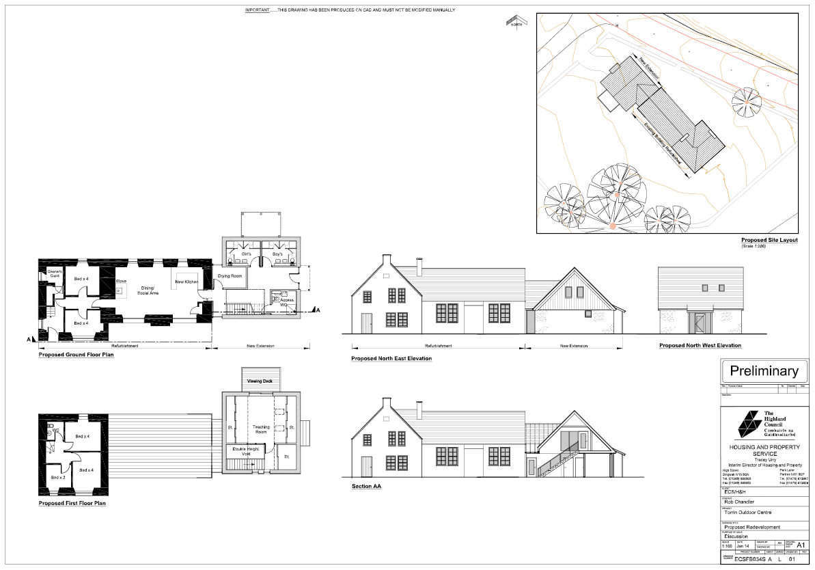

Appendix C
Torrin Outdoor Centre Refurbishment QS Cost Estimates

Description Quantity Units Rate Amount (R) Cost/m2 %
Torrin Outdoor Centre - Redevelopment

Torrin Outdoor Centre - alterations, upgrading and extension

Demolitions |  | 17,546 |  | 3.8
Substructure extension |  | 9,225 |  | 2.0
Superstructure extension |  | 143,093 |  | 31.1
Existing building |  | 80,202 |  | 17.4
External Works |  | 56,280 |  | 12.2
Existing Furniture |  | 400 |  | 0.1
Sub Total |  | 306,746 |  | 66.6
Preliminaries
Percentage allowance | 15.00 | 46,012 |  | 10.0
Sub Total |  | 352,758 |  | 76.6
Contingencies
Percentage allowance | 7.50 | 26,457 |  | 5.7
Sub Total |  | 379,215 |  | 82.3
Location & scale Factor
Percentage allowance | 3.00 | 11,376 |  | 2.5
Sub Total |  | 390,591 |  | 84.8
Other Costs
Professional Fees | 17.00 | 66,401 |  | 14.4
Building Warrant |  | 2,480 |  | 0.5
Planning permission |  | 1,118 |  | 0.3
Sub Total |  | 460,590 |  | 100.0

