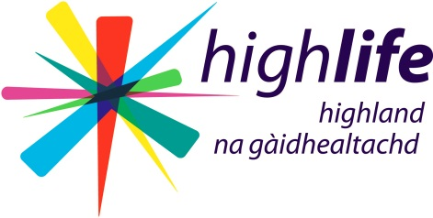
Data Protection Act

ACCESS TO PERSONAL RECORDS

High Life Highland may hold personal information about you. We believe it is very important to work in partnership with you and that you should play a part in what is recorded about you. Information about you may be recorded in several ways – e.g. in a personal file, in a project file, or on a Computer Information Database. Both systems are treated confidentially and are kept in a secure manner.

Under the Data Protection Act 1998 you have rights to be informed and to see what information is held about you.

To ask for personal information held about you please complete a ‘Subject Access Request Form’, available by:

- Requesting one from High Life Highland offices including libraries, community centres and leisure centres.
- Visiting the High Life Highland’s Web Site www.highlifehighland.com and downloading a copy from the ‘Privacy & Cookies’ page.

On receiving your Subject Access Request form, High Life Highland will:
- Acknowledge receipt of your request within 10 days.
- Contact you if any more information or clarification is required in order to respond to your request.
- Respond to your request in writing within 40 days.

Who can get access?
The responsibility for requesting access rests with you. You do not have the right to know what is written about someone else. You can get access if:
- You are an adult, have been, or are receiving, services from the Council.
- You are a child or young person under the age of 16 and you can understand what it means to exercise the right. (a young person aged 12 or over is assumed to be sufficiently mature)
- You are the person who has parental responsibilities or rights over a child or young person and that either the child does not have sufficient understanding, or has authorised the application.
- You are the parent, carer or advocate of an adult who lacks the capacity to understand their rights in relation to access.

What will you get access to?
You will get access to all information held about you within High Life Highland, both manually and computerised. However, there are exemptions, and these are to third party information where the author has refused to consent to access, and where there may be a serious risk of harm.

Each service provided by High Life Highland has a data retention policy and unless there are legal reasons for keeping information, we will destroy personal information within agreed guidelines.

What can you do if you are refused access?
If access has been refused, the reasons will be given to you and an appointment can be made with the appropriate Principal Manager(s) for the service(s) involved to discuss it with them.

If you are still not satisfied then you may appeal to the Information Commissioner or apply to the Court for an order granting access.

