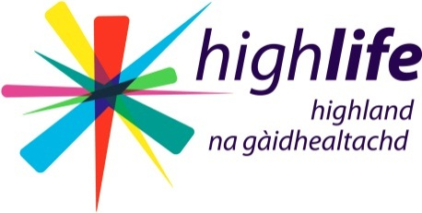
The Data Protection Act 1998 gives any individual, rights to request to be told and see what information is held about them by High Life Highland. The term “Data Subject” refers to the person about whom the information is being requested.

This form should be used wherever possible in making a Subject Access Request. Using this standard form will greatly assist us in meeting a request for information. However, if an individual provides all the information necessary for an officer of High Life Highland to comply with their request other than by completing this form, the request will still be complied with.

There is no charge for making a Subject Access Request. You should receive a written response and copy of any appropriate access documents within 40 days of receipt of this form.

- Details of person requesting the information:
Full Name
Address
Postcode
Date of Birth
Telephone
Email Address

- Please describe the information you seek, together with any other relevant information that will help us to identify the information you require. If you can be specific about a particular High Life Highland Service(s) please tick the appropriate box(es):

High Life Highland Corporate | □ | Libraries | □
Adult Learning | □ | Museums | □
Archives | □ | Outdoor Education | □
Art | □ | Sport | □
Leisure & Community Centres | □ | Youth Services | □
- Are you the Data Subject?
YES □ If you are the Data Subject please supply evidence of your identity, i.e. driving licence, birth certificate (or photocopy). If you prefer you can show your document to a member of High Life Highland staff and they will verify it. [PLEASE NOW SIGN THE DECLARATION AT THE FOOT OF THE PAGE]
NO □ If you are not the Data Subject, are you acting on behalf of the Data Subject with their written authority? If so, that written authority must be enclosed with this request form together with evidence of your identity and that of the Data Subject. [PLEASE NOW COMPLETE QUESTIONS 4 and 5]

For official use only – I confirm I have checked proof of identity:

Name: ____________________________ Position: ______________________________

Signature: _____________________________ Date: ______________________

- Details of the data subject (if different to question 1):
Full Name
Address
Postcode
Date of Birth
Telephone
Email Address

- Please describe your relationship with the Data Subject that leads you to make this request for information on their behalf:

DECLARATION to be completed by all applicants. Please note that any attempt to mislead may result in prosecution.

I _____________________________ , certify that the information given on this Subject Access Request form to High Life Highland is true. I understand that it is necessary for High Life Highland to confirm my/Data Subject’s identity and it may be necessary to obtain more detailed information in order to locate the correct information.
Signature _____________________________________ Date _______________________

Please return the completed form to the ICT Manager, High Life Highland, 12/13 Ardross Street, Inverness, IV3 5NS or by email to ict@highlifehighland.com. Documents which must accompany this application are: (a) evidence of your identity, (b) written authority and evidence of the Data Subject’s identity (if different from (a)).

