Quarter 3 2024/25
The main strategic effort in quarter three was focussed on closing the Service Delivery Plan negotiation with The Highland Council, developing the Strategic ‘Plan on a Page’ and completing the contract move from Restore to Iron Mountain, the new facilities operator at the Nuclear Decommissioning Agency to deliver the public facing archive service at Nucleus: The Nuclear and Caithness Archives. Since Nucleus opened in 2017, the HLH Caithness Archive team had successfully been delivering the archive services under the initial commercial contract.
The new contract, running from January 2025 to June 2029 under Iron Mountain’s leadership, allows HLH to continue supporting the local economy, offering skills development and varied community engagement opportunities including; reminiscence sessions for residents in care and nursing homes; a schools workshop programme in partnership with Wick Voices; and providing a community space for events and exhibitions, all helping HLH make a meaningful impact on the local community.
As an addition to the contract, HLH also supports the conservation of Nuclear Decommissioning Authority records, with HLH’s Senior Conservator providing training and assistance to colleagues working on cleaning and preserving historical records from the civil nuclear industry. These records are transferred to Nucleus from various nuclear sites across the UK for long-term safekeeping.
In response to feedback from the staff survey that some staff felt that HLH was not a successful organisation, the Executive team took the step to increase awards submissions. This led to national recognition from the National Archives, Community Leisure UK and the Green Apple Awards. Successful hosting of the National TRAD Awards at Inverness Leisure led to national recognition in November, December witnessed open days in Invergordon Leisure Centre and a celebration of the 50th anniversary of Dingwall Leisure Centre.
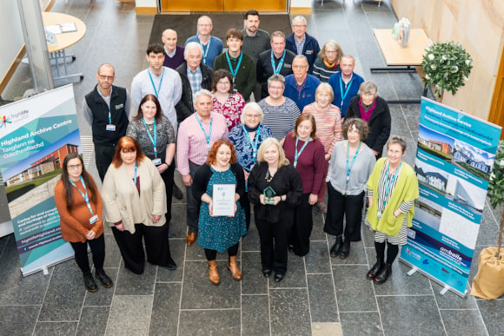
The Highland Archive Team
Not forgetting of course, our i-care awards that took place in November and celebrated the multiple ways that we are making life better across our communities.
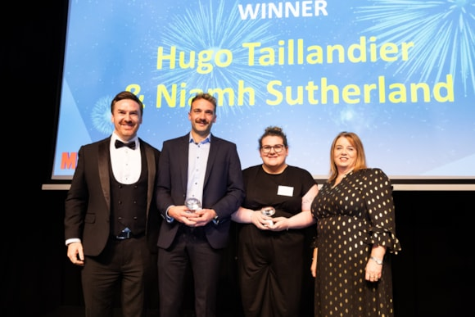
i-care Chair Award winners
Operationally, in addition to hard work in delivering continued growth in revenue and customer engagements, we also launched the Inverness Castle Experience Whisky; approved the new Leisure Management System tender to Gladstone; and maintained our relationships with key stakeholders - both nationally and across the Highlands. Our Young Leaders closed the year on a real positive by supporting MFR Cash for Kids Mission Christmas.
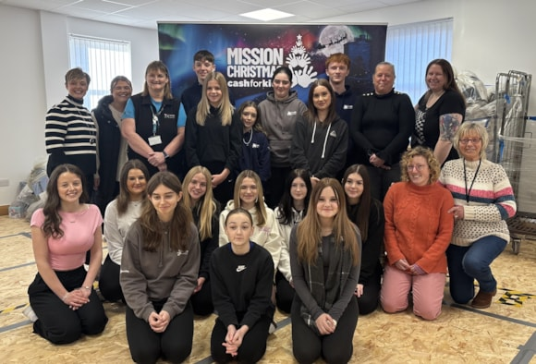
Our MFR Mission Christmas Young Leaders

Since the last board meeting …
The Chief Executive has …
Commenced the annual round of area visits to sites, to meet as many staff as possible, to hear about areas of work and to provide updates on HLH future plans. This started in the North on 26 February 2025 (accompanied by Director Ken Nicol), continued in Lochaber on 13 March with visits to Skye scheduled for 26 March and Easter Ross on 16 May.
Capital Investment
In support of the Highland Council Community, Sports and leisure Facility Strategy and the Highland Investment Programme, HLH has submitted a DRAFT capital programme bid, covering the proposed HLH strategic operational investment needs, for the next 6 years.

Projects cover the whole estate and are not limited to leisure and sports. Whilst it is in the early stages, investment has already been earmarked for community points of delivery (PODs) which will bring investment and improvement initially to the Dingwall and Thurso associated school groups (ASGs) which includes HLH facilities. Alness, Brora, Dornoch, Golspie & Invergordon ASGs are to follow.

Bids are also being considered for the HLH portfolio, in competition with the wider HC estate, for possible investment opportunities from the UK Shared Prosperity Fund (UKSPF). The Highlands has been allocated £3.10M for FY 25/26. Investment outcomes from both the capital and UKSPF funds are likely to be known in late April early May 2025.

Health and Wellbeing - Women’s Wellbeing Cafe
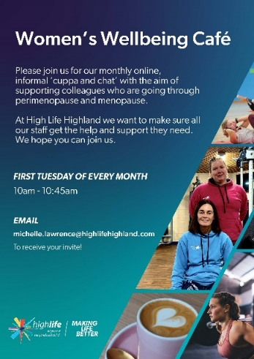
High Life Highland’s Women’s Wellbeing Café opened its virtual doors for the first time on Tuesday 4th February. The aim of this initiative is to support colleagues who are going through perimenopause and menopause and the first cafe proved to be a success with nine attendees joining the informal session. While the group is predominantly aimed at our female colleagues of any age, we realise there are lots of men in the organisation who would like to know how to support wives, sisters, girlfriends, mothers, and friends – so from time to time, these sessions will be open to all members of staff. The virtual cafe will continue to run monthly.
Good News
Diamond for Orlagh
Fortrose Academy pupil and Young Leader Orlagh MacIver was presented with her Diamond Hoodie, marking over 1,000 hours of volunteering with the HLH Young Leadership programme.

World’s Strongest Man and Leadership Programme Ambassador Tom Stoltman presented Orlagh with the hoodie, doing the honours alongside his brother, Britain and Europe’s Strongest Man, Luke Stoltman.

Orlagh (16) has been volunteering in several capacities for the last five years including at the Cromarty Youth Café. She’s been leading multi-sports sessions, arts and craft groups as well as intergenerational gatherings in her local community. She has also been involved in fundraising for the James Support Group and Mikeysline – which helped her achieve her Platinum Hoodie, which she was presented with last summer. Orlagh is also a recipient of an Eric Liddell Award – which recognises individuals who give selflessly to their local communities – resulting in a meeting with The Princess Royal at the awards ceremony in Edinburgh, a moment which she describes as one of her greatest experiences of her volunteering career.

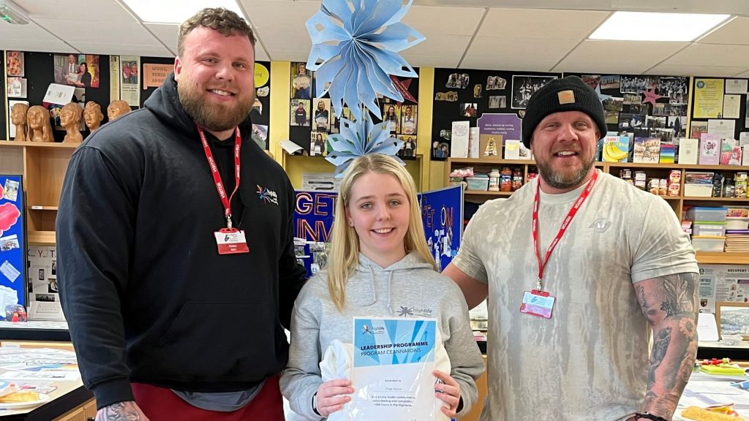
Orlagh with the World’s Strongest Brothers
Final Thought..
Dear Steve
I write with my wholehearted thanks to your truly wonderful staff at Inverness Leisure.
Unfortunately I have had an accident and my body is rejecting my leg. I now have Complex Regional Pain Syndrome as the result of falling on ice in January and breaking my Fibula.
Your team today have been beyond outstanding this morning. I cannot even begin to start on the care, dedication and support I have received today.
A truly phenomenal team from beginning to end which I would like to be commended please.
Very many thanks
Kind regards
Name withheld

