HIGH LIFE HIGHLAND  REPORT TO BOARD OF DIRECTORS  28 AUGUST 2024 | AGENDA ITEM  REPORT No HLH / /24

Quarter ONE Performance Report - Report by Chief Executive

Recommendation

The purpose of this report is to present performance information for the period April to June 2024 (Quarter one).

It is recommended that Directors:

- comment on the report and agree that the overall health check on the charity for that period is rated as amber based on the financial situation and reserves position; and
- note that between the support of THC and the income and efficiency savings made, the position is improving although likely to remain amber until the budget can be balanced and progress can be made towards meeting the 3% reserves policy.

1. | Business Plan Contribution
1.1 | High Life Highland’s (HLH) purpose is Making Life Better. The HLH Business Plan contains eleven Business Outcomes which support the delivery of this purpose, and this report supports the following highlighted outcomes from the Business Plan:  - Seek to continuously improve standards of health and safety.  - Commit to the Scottish Government’s zero carbon targets and maintain the highest standards in environmental compliance.  - Use research and market analysis to develop and improve services to meet customer needs.  - Increase employee satisfaction, engagement and development to improve staff recruitment and retention.  - Improve the financial sustainability of the company.  - Value and strengthen the relationship with THC.  - Develop and deliver the HLH Corporate Programme and seek to attract capital investment.  - Use research and market analysis to develop and deliver proactive marketing and promotion of HLH and its services.  - Initiate and implement an ICT digital transformation strategy across the charity.  - Develop and strengthen relationships with customers, key stakeholders and partners.  - Deliver targeted programmes which support and enhance the physical and mental health and wellbeing of the population and which contribute to the prevention agenda.
2. | Background
2.1 | The implementation of the HLH Business Plan 2022-27 is monitored through a set of performance indicators (PIs) set by the Board to assess the overall performance of the charity. The indicators were set at the HLH Board meeting held on 31 March 2022.
2.2 | At its meeting held on 12 June 2024 the HLH Board AGREED that a more detailed analysis of the pay-as-you-go income be provided. Information on pay as you go income can be seen in section 4 below.
3. | Summary of Performance
3.1 | Appendix A contains a summary of performance against the PIs for Q1 2024/25. Appendix B provides a list of all the PIs along with trend information. Thirteen of the eighteen PIs were scheduled for assessment at the August 2024 HLH Board meeting, of those, seven have been RAG rated green; three amber; and three red.
3.2 | The indicators which have been RAG rated red are travel, financial reserves and social media engagements; the amber ones are financial monitoring, highlife subscriptions and staff attendance rates.
3.3 | PI 4 Travel – This PI has been RAG rated red. During Q1 24/25, travel has exceeded the ceiling set in financial year 2022/23 by 38,142 miles. This is a trend which has continued from the previous financial year when annual travel miles were exceeded by 39,974 (8.5%).
3.4 | Quarter one travel miles can be seen in the table below:
   | Q1 Ceiling | Q1 2024/25 | Difference | % Change
  Adult Learning | 3883 | 4,334 | 451 | 12%
  Archives | 2342 | - | -
  Countryside Rangers | 536 | 987 | 451 | 84%
  Leisure | 18,095 | 20,162 | 2,067 | 11%
  Libraries | 3,239 | 3,813 | 574 | 18%
  Management & Admin | 1283 | 929 | -354 | -28%
  Museums & Galleries | 2,516 | 1,257 | -1,259 | -50%
  Music Tuition | 62,263 | 87,783 | 25,520 | 41%
  Sport | 11,291 | 13,429 | 2,138 | 19%
  Youth Work | 7,364 | 18,198 | 10,834 | 147%
3.5 | The services with increased travel mileage have been asked to review quarter one travel with a view to taking steps to reduce travel for the remainder of the year. Given that this has been a trend carried over from the previous year this will include an assessment on whether services will be impacted as a result of restricting travel to maintain it within the ceiling. As a reminder, post pandemic, a target to reduce travel mileage by 50% was set. At the time, the aim was to consolidate on reduced travel due to restrictions imposed by COVID-19 restrictions.
3.6 | PI 8 Attendance Rates – the attendance rate has been RAG rated amber and has gone down. Early indications are that the focused effort on absence management should be reflected in quarter two, particularly in relation to long-term absences and there is further information on this in the HR report elsewhere on this agenda.
3.7 | PI 9 Financial Monitoring – This indicator has been RAG rated amber and there is further information in the Finance Report elsewhere on this agenda.
3.8 | PI 10 Financial Reserves – This indicator has been RAG rated red. It is anticipated that there will be no reserves by the end of the financial year. This is in the context of additional support and a letter of comfort having been agreed with the Council as part of the current year’s budget and the discussion which is underway in relation to the review of the Service Delivery Contract.
3.9 | PI 11 highlife Subscriptions – This PI has been RAG rated amber as the budget target for Q1 has not been met with income having been £1.962m against a target of £1.963m (0.05%).
3.10 | PI 16 Social media engagements – This PI has been RAG rated red with there having been 34,445 engagements in quarter one 2023/24 and 32,299 in the same quarter this year, a decrease of 6.4%. The level of content delivered via social media channels has been much the same as that in Q1 last year, however, the lead up to the highly popular Get Set For Summer event of June 2023 meant a higher level of engagement – events and festivals Working Group events are now delivered by THC.
3.11 | The new Marketing and Engagement team is increasing its focus on developing engaging video content, storytelling customer success stories and is analysing performance more regularly in order to improve the quality of content to increase engagement.
4. | Performance Indicators for more detailed consideration
4.1 | Each quarter more detailed information is provided on one or more of the performance indicators. The indicators which have been scheduled for more detailed consideration at the August meeting are travel and reserves. Because of the red RAG ratings travel was covered in detail for financial year 2023/24 at the June HLH Board meeting and also above.
4.3 | Due to a better than forecasted year-end outturn, unrestricted, undesignated reserves increased by £50,112 to £245,302 as at 31 March 2024. However, per the agreement with the Highland Council, these reserves will be expended this year with a corresponding reduction in the amount of financial support provided by THC.
4.4 | At the June HLH Board meeting Directors asked whether the balance between highlife leisure subscription and admission prices was right, particularly for visitors, highlighting that this might be affecting income opportunities. The graph below shows income from both sources with highlife income increasing over the period by £836k and admissions income decreasing by £167k. Below that there is a graph showing overall income (which also includes income from lets and coached activities) which is increasing. (Note that the two pandemic years have been omitted from the graphs and the scale of total income graph does not start at zero).
4.5
4.6 | The position on all leisure income categories between 2017/18 and 2023/24 is summarised as follows:
  Income Category | Increase/(Decrease) 2017/18 to 2024/25
  Highlife Income | 835,892
  Admission Charges | (166,547)
  Lettings | 152,404
  Coached Activities | 82,124
  Total | 903,873
4.7 | Given the context is of overall income increasing and most of that having been achieved through subscriptions (the remainder being coached activities and lettings which have both increased) and some of HLH’s admission charges being at the top end of Scottish benchmarking figures, the leisure team will undertake a more in-depth review (particularly of the top-end charges) ahead of the next scheduled price review before coming back with recommendations, as part of the 2025/26 budget processing commencing at Finance and Audit Committee in November 2024.
5. | Implications
5.1 | Resource implications – while this report discusses resources and financial implications, there are no resource implications arising from agreeing the recommendations in this report.
5.2 | Equality implications - there are no new equality implications arising from this report.
5.3 | Legal implications - there are no new legal implications arising from this report.
5.4 | Risk implications - there are no new risk implications arising from this report.

Recommendation

It is recommended that Directors:

- comment on the report and agree that the overall health check on the charity for that period is rated as amber based on the financial situation and reserves position; and
- note that between the support of THC and the income and efficiency savings made, the position is improving although likely to remain amber until the budget can be balanced and progress can be made towards meeting the 3% reserves policy.

Designation: Chief Executive

Date: 19 August 2024

Author: Douglas Wilby, Director of Corporate Performance

Appendix A
HLH Performance Indicators - Summary Q1 2024/25  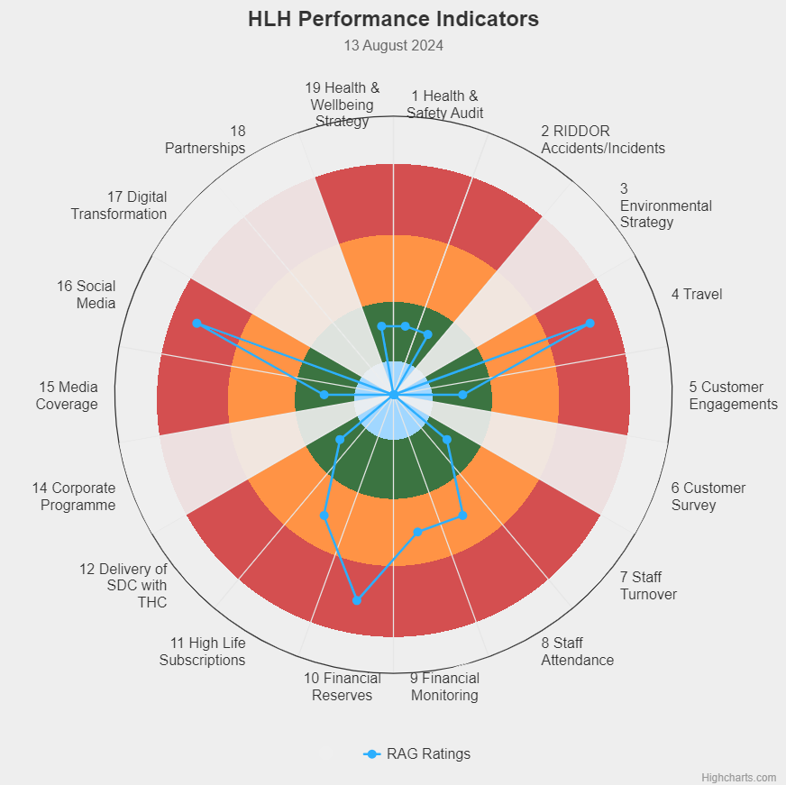 | Eighteen performance indicators (PIs) are used by the High Life Highland Board to assess the overall performance of the charity.  The PIs are RAG rated (allocated a "Red", "Amber" or "Green" status) so that it is easy to se e at a glance how the organisation is performing. Most of the PIs are RAG rated every quarter throughout the year, with some (such as partnership working with NHSH for example) being considered annually so greyed out sectors on this radar diagram mean that the PI is to be considered at a future HLH Board meeting.  (Note, the previous PI, 13, which was the Council’s Citizens Panel survey has discontinued and therefore removed from reporting. Numbering of PIs 14-19 has been retained to avoid costs associated with performance database changes).

Appendix B
HLH Performance Indicators - Detail Q1 2024/25

Business Plan Outcome | Performance Indicator | Reporting Frequency | RAG Rating Definition | RAG Rating Q1 24/25 | RAG Rating Q2 24/25 | RAG Rating Q3 24/25 | RAG Rating Q4 24/25 | Summary of Quarter One Performance
1. Seek to continuously improve standards of health and safety. | 1. External health and safety audit. | Annual. | - Green = the external audit does not raise systemic issues.  - Amber = the external audit highlights common actions to be addressed across the company.  - Red = the external audit raises systemic (i.e., applying across multiple sites) H&S issues. | Green |  |  |  | The annual health and safety report was considered by the HLH Board at is June 2024 meeting.

Business Plan Outcome | Performance Indicator | Reporting Frequency | RAG Rating Definition | RAG Rating Q1 24/25 | RAG Rating Q2 24/25 | RAG Rating Q3 24/25 | RAG Rating Q4 24/25 | Summary of Quarter One Performance
1. Seek to continuously improve standards of health and safety. | 2. RIDDOR accidents/incidents. | Quarterly. | - Red = number of RIDDOR reports per quarter is above 20.  - Amber = number of RIDDOR reports per quarter is between 10 and 20  - Green = number of RIDDOR reports per quarter is less than 10. | Green |  |  |  | No incidents were reported under the RIDDOR regulations during Q1.

Performance Indicator 2 - RIDDOR accidents/incidents
The graph below tracks the number of accidents and incidents reported under the Reporting of Injuries, Diseases and Dangerous Occurrences Regulations (RIDDOR). There were no RIDDOR incidents reported in Q1 2024/25.
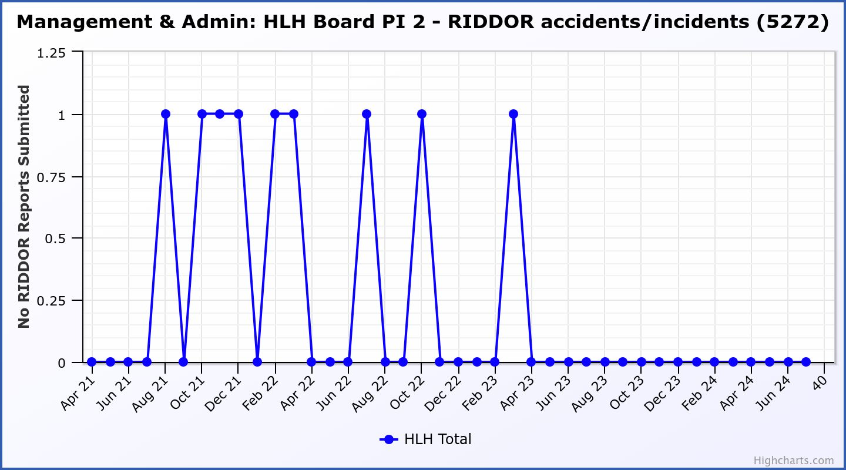

Business Plan Outcome | Performance Indicator | Reporting Frequency | RAG Rating Definition | RAG Rating Q1 24/25 | RAG Rating Q2 24/25 | RAG Rating Q3 24/25 | RAG Rating Q4 24/25 | Summary of Quarter One Performance
2. Commit to the Scottish Government’s zero carbon targets and maintain the highest standards in environmental compliance. | 3. The HLH Environmental strategy will be developed in partnership with the Council as it develops its plans. | . |  | NA |  |  |  | NA - Performance indicators will be identified through the development of these plans and will be aligned with THC’s carbon reduction strategy given the contractual (particularly property) arrangements that there are in place between THC and HLH.

Business Plan Outcome | Performance Indicator | Reporting Frequency | RAG Rating Definition | RAG Rating Q1 24/25 | RAG Rating Q2 24/25 | RAG Rating Q3 24/25 | RAG Rating Q4 24/25 | Summary of Quarter One Performance
2. Commit to the Scottish Government’s zero carbon targets and maintain the highest standards in environmental compliance. | 4. Travel  (Annual ceiling 451,000) | Quarterly. | - Green = 451,000 miles p.a. or less  - Amber = 451,001 to 541,200 miles p.a.  - Red = 541,201 p.a. or more | Red |  |  |  | Travel miles were 150,892 in Q1 2024/25.  There is further detail in section three of this report.

Performance Indicator 4 – Travel Miles
Travel has exceeded the ceiling for Q1 24/25. There is further detail in section three of this report.
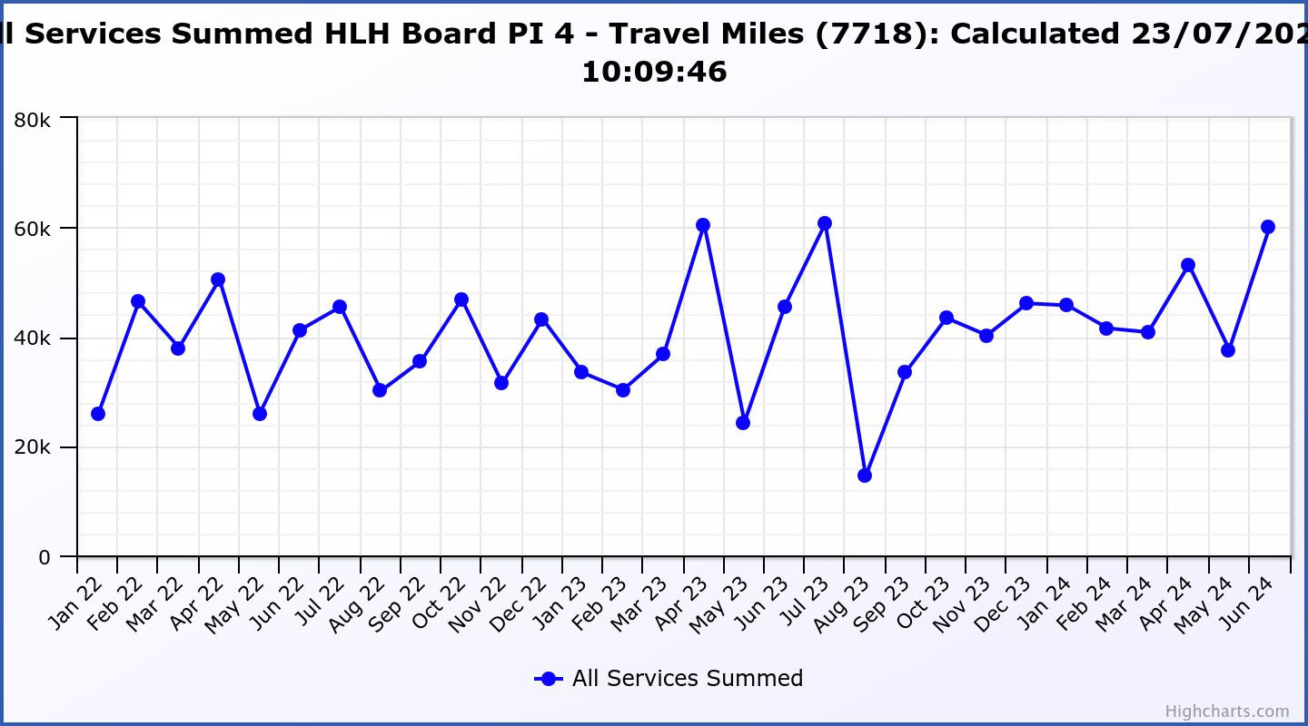

Business Plan Outcome | Performance Indicator | Reporting Frequency | RAG Rating Definition | RAG Rating Q1 24/25 | RAG Rating Q2 24/25 | RAG Rating Q3 24/25 | RAG Rating Q4 24/25 | Summary of Quarter One Performance
3. Use research and market analysis to develop and improve services to meet customer needs. | 5. Customer engagements. | Quarterly. | - Green = customer numbers are the same as or have increased compared with the corresponding quarter in the previous year  - Amber = customer numbers are less than the corresponding quarter in the previous year.  - Red = customer numbers are more than 5% lower than the corresponding quarter in the previous year. | Green |  |  |  | Customer engagements increased from 2,164,346 in Q1 2023/24 to  2,383,303 in Q1 2024/25.
Performance Indicator 5 - Customer engagements
Customer engagements increased to 2,383,303 in Q1 2024/25.

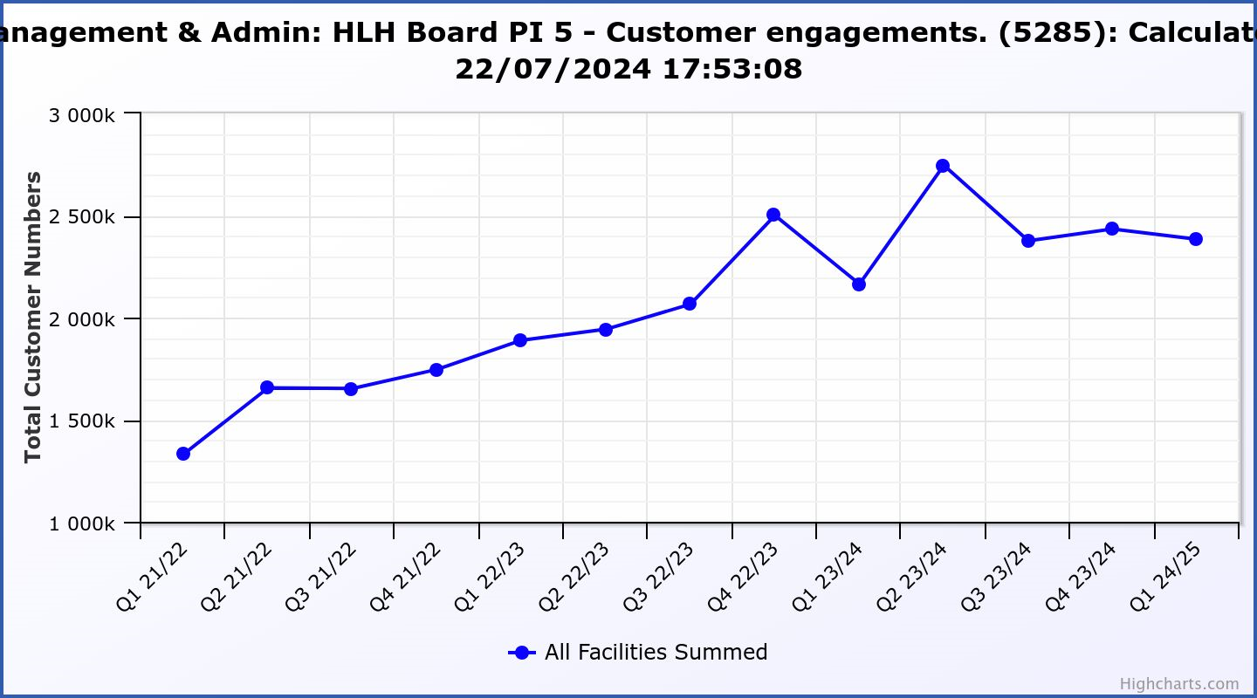
Business Plan Outcome | Performance Indicator | Reporting Frequency | RAG Rating Definition | RAG Rating Q1 24/25 | RAG Rating Q2 24/25 | RAG Rating Q3 24/25 | RAG Rating Q4 24/25 | Summary of Quarter One Performance
3. Use research and market analysis to develop and improve services to meet customer needs. | 6. Charity-wide customer satisfaction survey. | Annually. | - Green = Services delivered by HLH is above average  - Amber = Services delivered by HLH is average  - Red = Services delivered by HLH is below average. | NA |  |  |  | NA

Business Plan Outcome | Performance Indicator | Reporting Frequency | RAG Rating Definition | RAG Rating Q1 24/25 | RAG Rating Q2 24/25 | RAG Rating Q3 24/25 | RAG Rating Q4 24/25 | Summary of Quarter One Performance
4. Increase employee satisfaction, engagement and development to improve staff recruitment and retention. | 7. Staff turnover (resignations as a percentage of posts). | Quarterly. | - Green = 1.6% or less.  - Amber = 1.7 to 2%  - Red = more than 2% | Green |  |  |  | The number of resignations per month as a percentage of posts was 1% in April, 0.8% in May and 1.2% in June. Please see section three of this report for further information.

Performance Indicator 7 - Staff Turnover (resignations as a percentage of posts)
The graph below shows resignations as a percentage of the number of posts (1% equates to 10 staff).

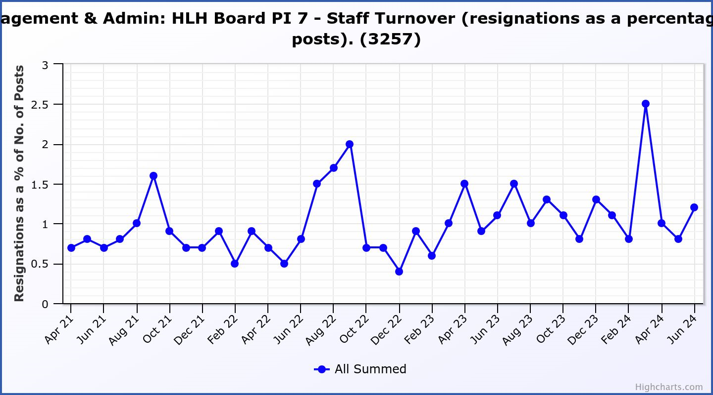

Business Plan Outcome | Performance Indicator | Reporting Frequency | RAG Rating Definition | RAG Rating Q1 24/25 | RAG Rating Q2 24/25 | RAG Rating Q3 24/25 | RAG Rating Q4 24/25 | Summary of Quarter One Performance
4. Increase employee satisfaction, engagement and development to improve staff recruitment and retention. | 8. Staff attendance rates (RAG ratings based on Office for National Statistics for 2020). | Quarterly. | - Green = attendance rate 95.7% or higher.  - Amber = attendance rate 93.7% to 95.6%.  - Red = attendance rate less than 93.7%. | Amber |  |  |  | The attendance rate for Q1 was 94.83 Please see the HR report elsewhere on this agenda for further information.

Performance Indicator 8 - Staff Attendance Rate
Staff attendance rates for Q1 were 94.83%. Please see the HR report elsewhere on this agenda for further information.
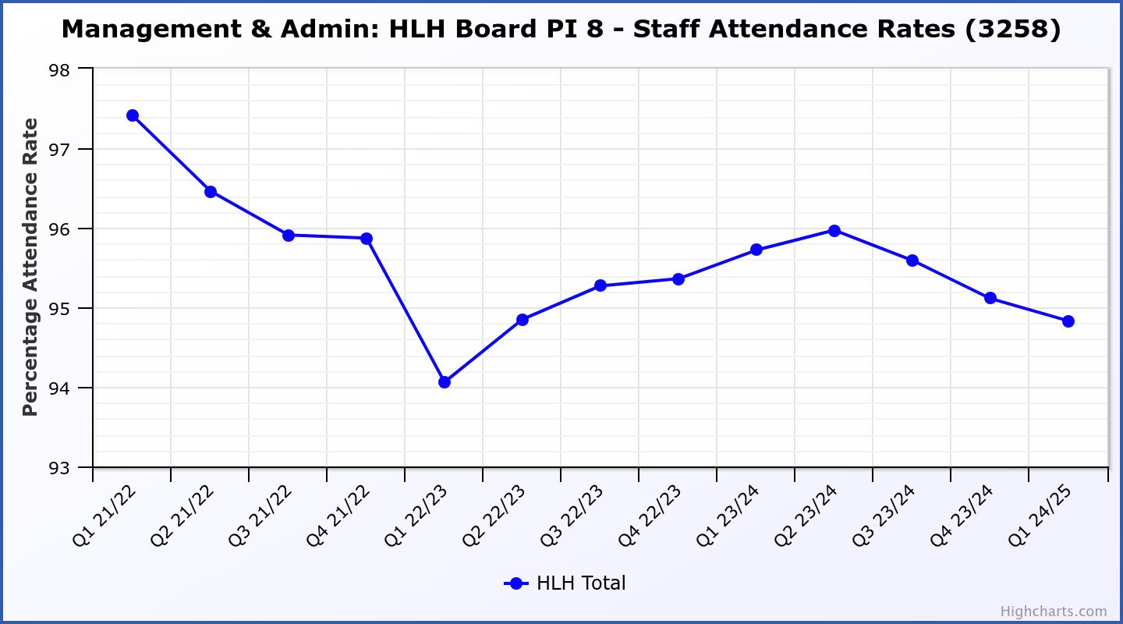

Business Plan Outcome | Performance Indicator | Reporting Frequency | RAG Rating Definition | RAG Rating Q1 24/25 | RAG Rating Q2 24/25 | RAG Rating Q3 24/25 | RAG Rating Q4 24/25 | Summary of Quarter One Performance
5. Improve the financial sustainability of the company | 9. Financial monitoring. | Quarterly. | An assessment of the year end outturn where:  - Green = delivery of services within budget.  - Amber = delivery of services between break-even and 2% over budget.  - Red = delivery of services over budget above 2%. | Amber |  |  |  | There is further information in the Finance Report elsewhere on this agenda.  The 2024/25 budget is forecast to be delivered slightly over budget with a £24k deficit predicted.

Performance Indicator 9 - Financial Monitoring
This graph shows the position at the end of each quarter.
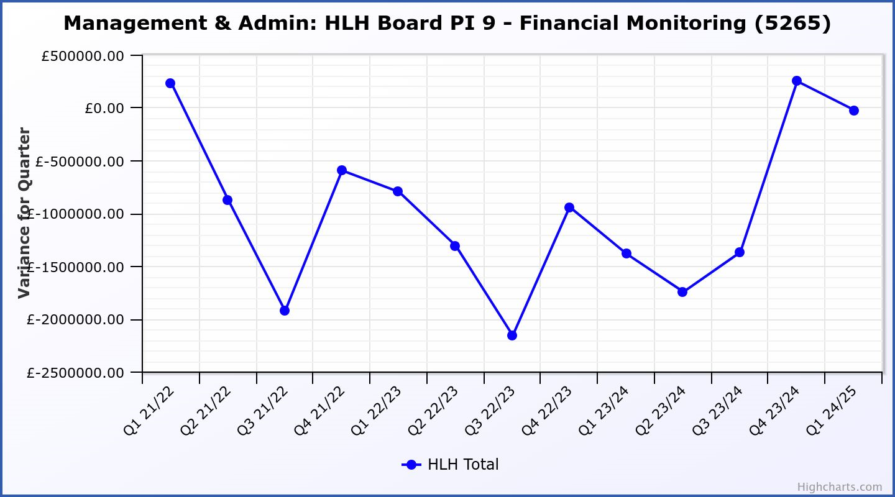

Business Plan Outcome | Performance Indicator | Reporting Frequency | RAG Rating Definition | RAG Rating Q1 24/25 | RAG Rating Q2 24/25 | RAG Rating Q3 24/25 | RAG Rating Q4 24/25 | Summary of Quarter One Performance
5. Improve the financial sustainability of the company | 10. Reserves | Annual. | - Green = meets 3% reserves policy  - Amber = achieves 2% reserves  - Red = fails to achieve 2% reserves policy. | Red |  |  |  | Please see the Finance report elsewhere in this agenda for further information.
Performance Indicator 10 - Financial Reserves

This graph shows the level of uncommitted, unrestricted reserves at the end of each financial year.
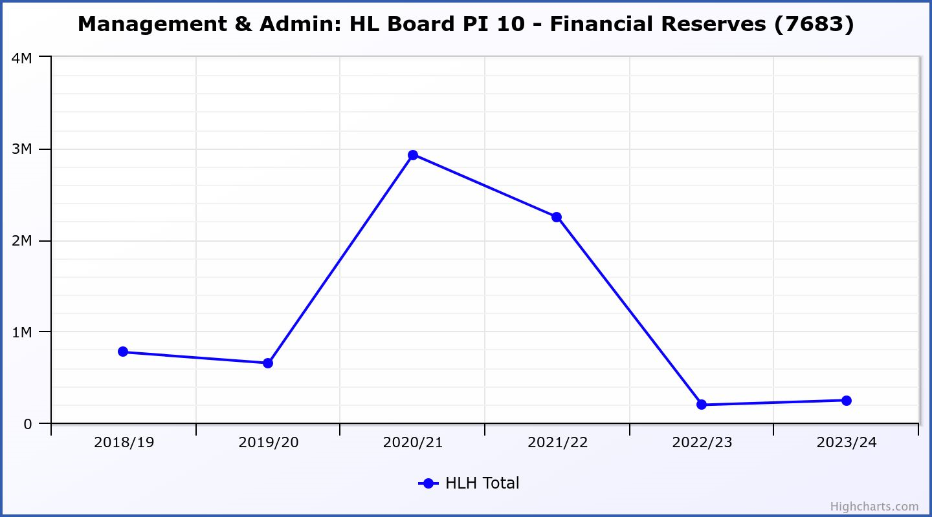

Business Plan Outcome | Performance Indicator | Reporting Frequency | RAG Rating Definition | RAG Rating Q1 24/25 | RAG Rating Q2 24/25 | RAG Rating Q3 24/25 | RAG Rating Q4 24/25 | Summary of Quarter One Performance
5. Improve the financial sustainability of the company | 11. Number of highlife subscriptions (target is the required number to meet the budget). | Quarterly. | - Green= exceeds budgeted income target.  - Amber = risk of budget target not being met.  - Red = budgeted income target unlikely to be met. | Amber |  |  |  | This PI has been RAG rated amber with income of £1.962m against a target of £1.963m.  Please see section three of this report for further information.

Performance Indicator 11 - Number of High Life Subscriptions
These graphs show subscriptions and then subscriptions income against target.

Business Plan Outcome | Performance Indicator | Reporting Frequency | RAG Rating Definition | RAG Rating Q1 24/25 | RAG Rating Q2 24/25 | RAG Rating Q3 24/25 | RAG Rating Q4 24/25 | Summary of Quarter One Performance
6. Value and strengthen the relationship with THC. | 12. Delivery of the Service Delivery Contract (SDC) with The Highland Council (THC). | Six-monthly. | - Green = agreement of THC’s Education Committee that HLH has met or exceeded the terms of the SDC.  - Amber = agreement of THC’s Education Committee that HLH has met the terms of the SDC but has set some improvement targets.  - Red = agreement of THC’s Education Committee that HLH has not met the terms of the SDC. | Green |  |  |  | The Council’s Education Committee considered the HLH Progress Report at its meeting held on 30 May 2024. The Committee noted that HLH continues to deliver the Public Service Obligations on behalf of the Council as set out in the Service Delivery Contract.

Business Plan Outcome | Performance Indicator | Reporting Frequency | RAG* Rating Definition  (*Red/Amber/Green) | RAG Rating Q1 24/25 | RAG Rating Q2 24/25 | RAG Rating Q3 24/25 | RAG Rating Q4 24/25 | Summary of Quarter One Performance
7. Develop and deliver the HLH Corporate Programme and seek to attract capital investment. | 14.The HLH corporate programme covers investment; business process improvement; capital and asset management plans and plans will be developed as this area of work is developed. | NA | Should additional performance indicators be identified through the development of these plans they will be added in future. | NA |  |  |  | NA

Business Plan Outcome | Performance Indicator | Reporting Frequency | RAG Rating Definition | RAG Rating Q1 24/25 | RAG Rating Q2 24/25 | RAG Rating Q3 24/25 | RAG Rating Q4 24/25 | Summary of Quarter One Performance
8. Use research and market analysis to develop and deliver proactive marketing and promotion of HLH and its services. | 15. Media coverage from proactively issued media releases | Quarterly. | - Green = Positive coverage 95%+  - Amber = Positive coverage 90% - 95%  - Red = Positive coverage 90%- | Green |  |  |  | In April 2024, we welcomed our new Media and Content Officer into post. There were 36 proactively issued media releases in Q1 of 2024/25 with 53 re-issues across media publications. Most re-issues have been through local media outlets including HNM titles and WHFP. BBC, Herald, Daily Express and Scottish Field are among some of the more widely distributed publications that have picked up on some HLH press.  Proactively issued media releases have been RAG rated Green with all media releases being reported on positively.

Performance Indicator 11 - Number of High Life Subscriptions
This graph shows the positive media coverage from proactively issued press releases. Press coverage in general is also monitored and for quarter one 2024/25 there were 2 which were neutral (Queen’s Park track upgrade, and Mobile Libraries) and 2 which were negative (School’s Out booking system, and opposition to Barclays Bank room hire at Spectrum Centre).
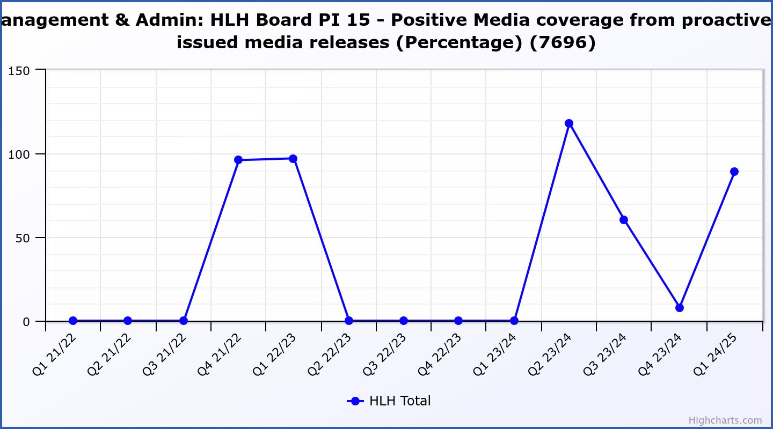

Business Plan Outcome | Performance Indicator | Reporting Frequency | RAG Rating Definition | RAG Rating Q1 24/25 | RAG Rating Q2 24/25 | RAG Rating Q3 24/25 | RAG Rating Q4 24/25 | Summary of Quarter One Performance
8. Use research and market analysis to develop and deliver proactive marketing and promotion of HLH and its services. | 16. On-line engagement through social media channels. |  | - Green = 5% increase compared with the same period last year.  - Amber = no increase to 4.9% lower compared with the same period last year.  - Red = more than 5% lower or less compared with the same period last year. | Red |  |  |  | Social media engagements were 32,299 in Q1 24/25, a small decrease of 6.4% compared to the 34,445 engagements in the same period last year 23/24. The level of content delivered via social media channels has been similar to Q1 last year, however, the lead up to the highly popular Get Set For Summer event of June 2023 meant a higher level of engagement – events and festivals are now delivered by the Council.  The new M&E Team increasing its focus on strategically developing engaging video content, storytelling customer success stories and is analysing performance more regularly in order to improve the quality of content

Performance Indicator 16 - On-line engagement through social media channels.

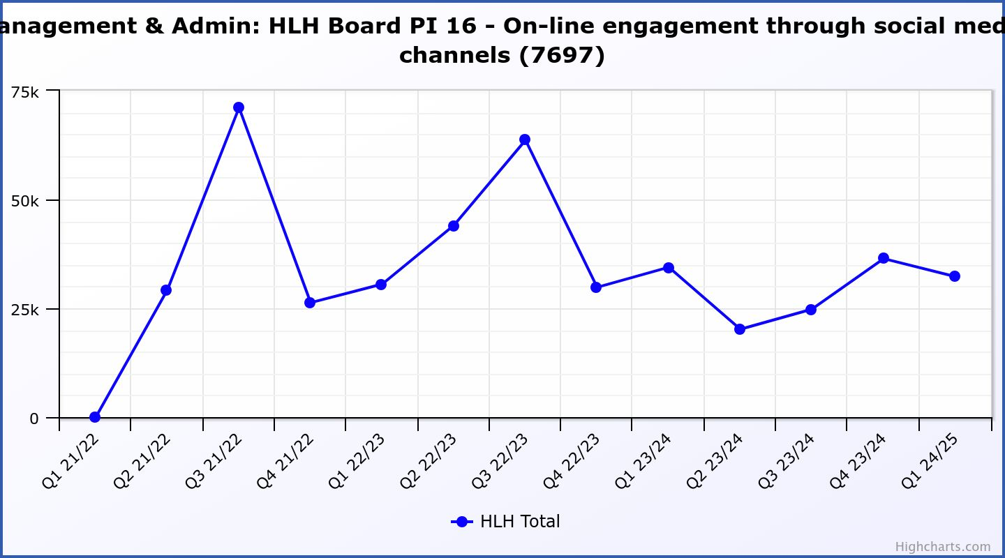

Business Plan Outcome | Performance Indicator | Reporting Frequency | RAG Rating Definition | RAG Rating Q1 24/25 | RAG Rating Q2 24/25 | RAG Rating Q3 24/25 | RAG Rating Q4 24/25 | Summary of Quarter One Performance
9. Initiate and implement an ICT digital transformation strategy across the charity | 17. The HLH digital transformation strategy is yet to be developed. |  | Should performance indicators be identified through the development of these plans they will be added in future. | NA |  |  |  | See note below.

There was a presentation to the HLH Board on the development of a digital strategy at its 26 March 2024 meeting to set the context for the strategy and seek Director input. It is expected that a draft strategy will be available for the consideration of the HLH Board at its March 2025 meeting. The graphic below outlines some of the components of the current and future work. The new finance system is in place; procurement of a leisure management system is subject to board approval at this meeting and the tender specification for the new web site is being developed with a target for board approval of the procurement at its December 2024 meeting.

Business Plan Outcome | Performance Indicator | Reporting Frequency | RAG Rating Definition | RAG Rating Q1 24/25 | RAG Rating Q2 24/25 | RAG Rating Q3 24/25 | RAG Rating Q4 24/25 | Summary of Quarter One Performance
10. Develop and strengthen relationships with customers, key stakeholders and partners | New approach to customer survey as per Business Outcome 3 above.  Same as PI 6 - Charity-wide customer satisfaction survey | Quarterly | - | NA |  |  |  | NA

Business Plan Outcome | Performance Indicator | Reporting Frequency | RAG Rating Definition | RAG Rating Q1 24/25 | RAG Rating Q2 24/25 | RAG Rating Q3 24/25 | RAG Rating Q4 24/25 | Summary of Quarter One Performance
10. Develop and strengthen relationships with customers, key stakeholders and partners | 18. Partnership work with sportscotland and other sports related organisations, NHS Highland and other health related organisations (including Memoranda of Understanding) etc. | Annual | - Green = Growth in partnership working  - Amber = continuation of current level of partnership work  - Red = cancellation of Partnership Agreements | NA |  |  |  | NA

Business Plan Outcome | Performance Indicator | Reporting Frequency | RAG Rating Definition | RAG Rating Q1 24/25 | RAG Rating Q2 24/25 | RAG Rating Q3 24/25 | RAG Rating Q4 24/25 | Summary of Quarter One Performance
11. Deliver targeted programmes which support and enhance the physical and mental health and wellbeing of the population and which contribute to the prevention agenda. | 19. An assessment of the RAG rating of the Health and Wellbeing Strategy action plan. |  | - Green = 80% or more of the actions are RAG rated green  - Amber = 60% to 79% of actions are green.  - Red = 59% or less are rated green. | Green |  |  |  | The Health and Wellbeing update report can be seen elsewhere on this agenda.

