HIGH LIFE HIGHLAND  REPORT TO BOARD OF DIRECTORS  12 JUNE 2024 | AGENDA ITEM  REPORT No HLH / /24

Quarter FOUR Performance Report - Report by Chief Executive

Recommendation

The purpose of this report is to present performance information for the period January to March 2024 (Quarter 4).

It is recommended that Directors:

- comment on the report and agree that the overall health check on the charity for that period is rated as amber based on the financial situation and reserves position; and
- note that between the support of THC and the income and efficiency savings made, the position is improving although likely to remain amber until the budget can be balanced and progress can be made towards meeting the 3% reserves policy.

1. | Business Plan Contribution
1.1 | High Life Highland’s (HLH) purpose is Making Life Better. The HLH Business Plan contains eleven Business Outcomes which support the delivery of this purpose, and this report supports the following highlighted outcomes from the Business Plan:  - Seek to continuously improve standards of health and safety.  - Commit to the Scottish Government’s zero carbon targets and maintain the highest standards in environmental compliance.  - Use research and market analysis to develop and improve services to meet customer needs.  - Increase employee satisfaction, engagement and development to improve staff recruitment and retention.  - Improve the financial sustainability of the company.  - Value and strengthen the relationship with THC.  - Develop and deliver the HLH Corporate Programme and seek to attract capital investment.  - Use research and market analysis to develop and deliver proactive marketing and promotion of HLH and its services.  - Initiate and implement an ICT digital transformation strategy across the charity.  - Develop and strengthen relationships with customers, key stakeholders and partners.  - Deliver targeted programmes which support and enhance the physical and mental health and wellbeing of the population and which contribute to the prevention agenda.
2. | Background
2.1 | The implementation of the HLH Business Plan 2022-27 is monitored through a set of performance indicators (PIs) set by the Board to assess the overall performance of the charity. The indicators were set at the HLH Board meeting held on 31 March 2022.
3. | Summary of Performance
3.1 | Appendix A contains a summary of performance against the PIs for Q4 2023/24. Appendix B provides a list of all the PIs along with trend information. Twelve of the eighteen PIs were scheduled for assessment at the June 2024 HLH Board meeting, of those, eight have been RAG rated green; three amber; and one red.
3.2 | The indicator which has been RAG rated red is Financial Reserves; the amber ones are travel, staff attendance rates, and highlife subscriptions.
3.3 | PI 4 Travel - during 2023/24, travel has exceeded the ceiling set in financial year 2022/23 by 39,974. The tables below detail the travel by each of the HLH areas of work 2023/24. The travel miles exceeded the ceiling for: adult learning; archives; leisure; management and admin; music tuition; sport and youth work with other areas of work containing travel within the agreed levels. Services are working to manage this as per the information in Appendix C.
  Q1-Q4 | Adult Learning | Archives | Countryside Rangers | Leisure | Libraries | Management & Admin
  Ceiling set in 2022-23 | 15,428 | 2,564 | 1,939 | 68,253 | 12,926 | 3,460
  2023-24 | 18,735 | 3,031 | 1,038 | 76,673 | 10,799 | 3,741
  Difference | 3,307 | 467 | 901 | 8,420 | 2,127 | 281
  % Change | 19% | 17% | 60% | 12% | 18% | 8%
  Q1-Q4 | Museums & Galleries | Music Tuition | Sport Development | Youth Work | Total
  Ceiling set in 2022-23 | 9,475 | 249,051 | 38,932 | 23,108 | 425,579
  2023-24 | 4,707 | 275,436 | 41,017 | 55,747 | 490,974
  Difference | 4,768 | 26,385 | 2,085 | 32,639 | 65,395
  % Change | 67% | 10% | 5% | 82% | 14%
3.4 | PI 8 Absence/Attendance Rates - RAG ratings were updated following the March 2024 HLH Board Meeting as agreed based on the most recent Office for National Statistics figure. There is further analysis of this in the HR Report elsewhere on this agenda.
3.5 | PI 10 Financial Reserves – there were no reserves by the end of the financial year. This is being addressed through budget planning which includes discussion with the Council as part of the review of the Service Delivery Contract and there is a briefing elsewhere on this agenda covering the review.
3.6 | PI 11 highlife Subscriptions – there has been an improvement in this PI since the previous HLH Board meeting with a good performance in quarter four. Income was only 1% (£21k) short of the budget leading to an improved amber Rag rating. Between December 2023 and April 2024 this year subscriptions increased by 853.
3.7 | While outside of the reporting period, in April, subscriptions fell short of the number needed to achieve the budget (£11k shortfall) and at the time of writing looked to be continuing at the same level again in May. While this is a small amount in the context of the overall budget it is, nevertheless, important to address it because of the potential cumulative effect over the year.
3.8 | The team has recorded an increase in cancellations made by customers without using the HLH online portal which is likely to be partly as a result of how easily this can be done via on-line banking etc. While the work reported to the Board during recent meetings on new subscriptions through promotions and corporate subscriptions continues, and there are no real differences in the cancellation level and reasons for cancellation compared with historic levels, a short-term project group with staff from leisure and marketing has been established to consider work on retention. The group will also review the exit survey and the cancellation process including taking account of potential new legislation to make it easier for customers to cancel recurring payments.
3.9 | To support the leisure team with improving the customer journey, customer experience and enhance membership growth and development opportunities, the charity has engaged with an industry-leading expert to deliver training. The trainer has an excellent reputation for delivering effective training, learning and coaching within the leisure sector, and in particular around membership sales/development, whilst understanding the specific challenges faced by the sector.
3.10 | 7. Staff turnover (resignations as a percentage of posts). The HLH Board selected this as an indicator of staff satisfaction and the number of resignations increased above want would be considered normal levels in March 2024. The following indicates that staff satisfaction levels are good:  - As reported in the HR Report elsewhere on this agenda the resignations are spread across a number of sites and areas of HLH work so there are no apparent pockets of dissatisfaction;  - there is an overall context of positive feedback reported in the Colleague Survey report elsewhere on this agenda; and  - the information reported at the March 2024 HLH Board on the Exit Survey did not raise any issues of concern.
4. | Performance Indicators for more detailed consideration
4.1 | Each quarter more detailed information is provided on one or more of the performance indicators. The indicators which have been scheduled for more detailed consideration at the June meeting are:  - PI 1. External Health and Safety Audit;  - PI 2. RIDDOR accidents/incidents;  - PI 5 - Customer engagements; and  - PI 12 - Delivery of the Service Delivery Contact (SDC) with The Highland Council (THC).
4.2 | PI 1. External Health and Safety Audit and PI 2. RIDDOR accidents/incidents are both covered in the Annual Health and Safety Report elsewhere on this agenda.
4.3 | PI 5 - Customer engagements. Customer engagements have recovered beyond pre-pandemic levels and within that there has been a shift towards digital engagements. The graph below shows total customer engagements, this is made up of physical attendances and on-line engagements (recorded in accordance with the Local Government Benchmarking Framework) and as can be seen, customer engagements last financial year exceeded the pre-pandemic year at almost 10 million.
4.4 | Appendix D shows a breakdown of total customer engagements for each of the HLH areas of work. While this is a positive picture, there is still work to be done to increase both customer numbers and income and at the most recent wider management team meeting there were service workshops which focused on the growth of customer numbers and income with a view to regaining in-person customer engagements.
4.5 | The overall number of in-person engagements are also recovering with physical visits in 2023/24 numbering almost 5 million. The graph below allows comparison with pre-pandemic in-person customer visits.
4.6 | Appendix E shows a breakdown of in-person customer engagements for each of the HLH areas of work.
4.7 | PI 12. Delivery of the Service Delivery Contract (SDC) with The Highland Council (THC). The Council’s Education Committee considered the HLH Progress Report at its 30 May 2024 meeting and the report can be seen on the Council’s web site here. The report included information on HLH’s performance indicators; how HLH contributes to THC’s corporate plan and new Delivery Plan 2024-27 as well as providing a focus on income growth and development (setting some of the context for the review of the Service Delivery Contract). The committee noted that HLH continues to deliver Public Service Obligations on behalf of the Highland Council as set out in the Service Delivery Contract and were positive about the performance of HLH in communities.
5. | Implications
5.1 | Resource implications – while this report discusses resources and financial implications, there are no resource implications arising from agreeing the recommendations in this report.
5.2 | Equality implications - there are no new equality implications arising from this report.
5.3 | Legal implications - there are no new legal implications arising from this report.
5.4 | Risk implications - there are no new risk implications arising from this report.

Recommendation

It is recommended that Directors:

- comment on the report and agree that the overall health check on the charity for that period is rated as amber based on the financial situation and reserves position; and
- note that between the support of THC and the income and efficiency savings made, the position is improving although likely to remain amber until the budget can be balanced and progress can be made towards meeting the 3% reserves policy.

Designation: Chief Executive

Date: 30 May 2024

Author: Douglas Wilby, Director of Corporate Performance

Appendix A
HLH Performance Indicators - Summary Q4 2023/24  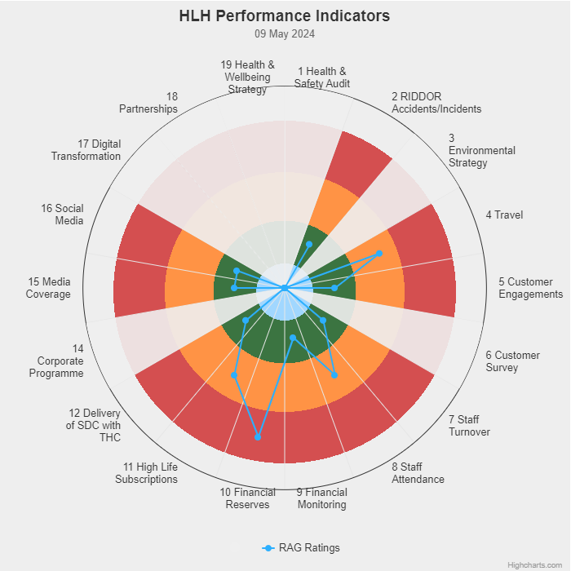 | Eighteen performance indicators (PIs) are used by the High Life Highland Board to assess the overall performance of the charity.  The PIs are RAG rated (allocated a "Red", "Amber" or "Green" status) so that it is easy to se e at a glance how the organisation is performing. Most of the PIs are RAG rated every quarter throughout the year, with some (such as partnership working with NHSH for example) being considered annually so greyed out sectors on this radar diagram mean that the PI is to be considered at a future HLH Board meeting.  (Note, the previous PI, 13, which was the Council’s Citizens Panel survey has discontinued and therefore removed from reporting. Numbering of PIs 14-19 has been retained to avoid costs associated with performance database changes).

Appendix B
HLH Performance Indicators - Detail Q4 2023/24

Business Plan Outcome | Performance Indicator | Reporting Frequency | RAG Rating Definition | RAG Rating Q1 23/24 | RAG Rating Q2 23/24 | RAG Rating Q3 23/24 | RAG Rating Q4 23/24 | Summary of Quarter Four Performance
1. Seek to continuously improve standards of health and safety. | 1. External health and safety audit. | Annual. | - Green = the external audit does not raise systemic issues.  - Amber = the external audit highlights common actions to be addressed across the company.  - Red = the external audit raises systemic (i.e., applying across multiple sites) H&S issues. | NA | NA | NA | Green | The annual health and safety report was considered for recommendation to the HLH Board at the meeting of the Health and Safety and Environmental Compliance meeting held on 22 May 2024 and can be seen in the separate report elsewhere on this agenda.

Business Plan Outcome | Performance Indicator | Reporting Frequency | RAG Rating Definition | RAG Rating Q1 23/24 | RAG Rating Q2 23/24 | RAG Rating Q3 23/24 | RAG Rating Q4 23/24 | Summary of Quarter Four Performance
1. Seek to continuously improve standards of health and safety. | 2. RIDDOR accidents/incidents. | Quarterly. | - Red = number of RIDDOR reports per quarter is above 20.  - Amber = number of RIDDOR reports per quarter is between 10 and 20  - Green = number of RIDDOR reports per quarter is less than 10. | Green | Green | Green | Green | No incidents were reported under the RIDDOR regulations during Q4.

Performance Indicator 2 - RIDDOR accidents/incidents
The graph below tracks the number of accidents and incidents reported under the Reporting of Injuries, Diseases and Dangerous Occurrences Regulations (RIDDOR). There were no RIDDOR incidents reported in Q4 2023/24.
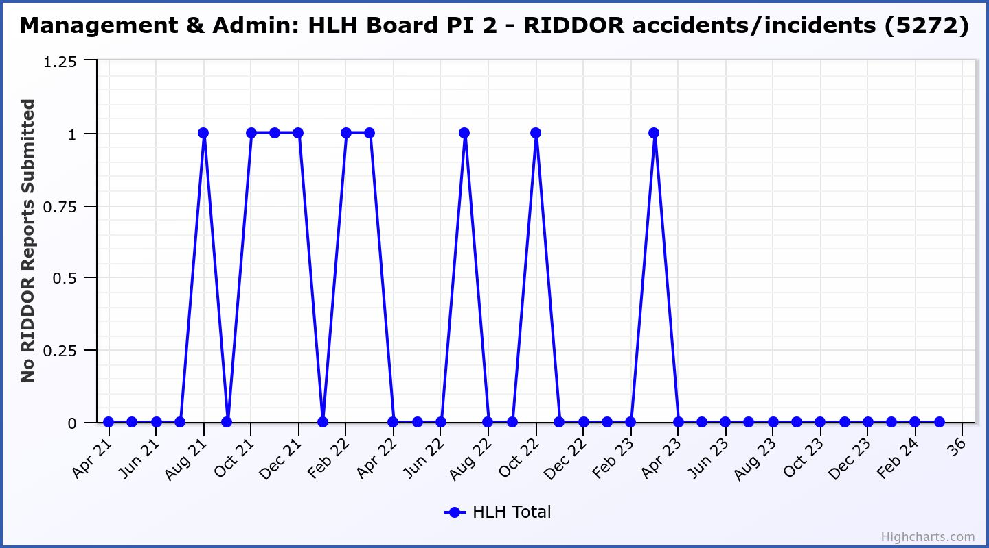

Business Plan Outcome | Performance Indicator | Reporting Frequency | RAG Rating Definition | RAG Rating Q1 23/24 | RAG Rating Q2 23/24 | RAG Rating Q3 23/24 | RAG Rating Q4 23/24 | Summary of Quarter Four Performance
2. Commit to the Scottish Government’s zero carbon targets and maintain the highest standards in environmental compliance. | 3. The HLH Environmental strategy will be developed in partnership with the Council as it develops its plans. | . |  | NA | NA | NA | NA | NA - Performance indicators will be identified through the development of these plans and will be aligned with THC’s carbon reduction strategy given the contractual (particularly property) arrangements that there are in place between THC and HLH.

Business Plan Outcome | Performance Indicator | Reporting Frequency | RAG Rating Definition | RAG Rating Q1 23/24 | RAG Rating Q2 23/24 | RAG Rating Q3 23/24 | RAG Rating Q4 23/24 | Summary of Quarter Four Performance
2. Commit to the Scottish Government’s zero carbon targets and maintain the highest standards in environmental compliance. | 4. Travel  (Quarterly ceiling 112,750. Annual ceiling 451,000) | Quarterly. | - Green = 451,000 miles p.a. or less  - Amber = 451,001 to 541,200 miles p.a.  - Red = 541,201 p.a. or more | Amber | Green | Amber | Amber | Travel miles were 128,081 in Q4 and for financial year 2023/24 were 490,974. (RAG rating provided on Q4 column is for the full financial year).  There is further detail in section three of this report.

Performance Indicator 4 – Travel Miles
Travel has exceeded the ceiling set by 39,974 for 2023/24. There is further detail in section three of this report.
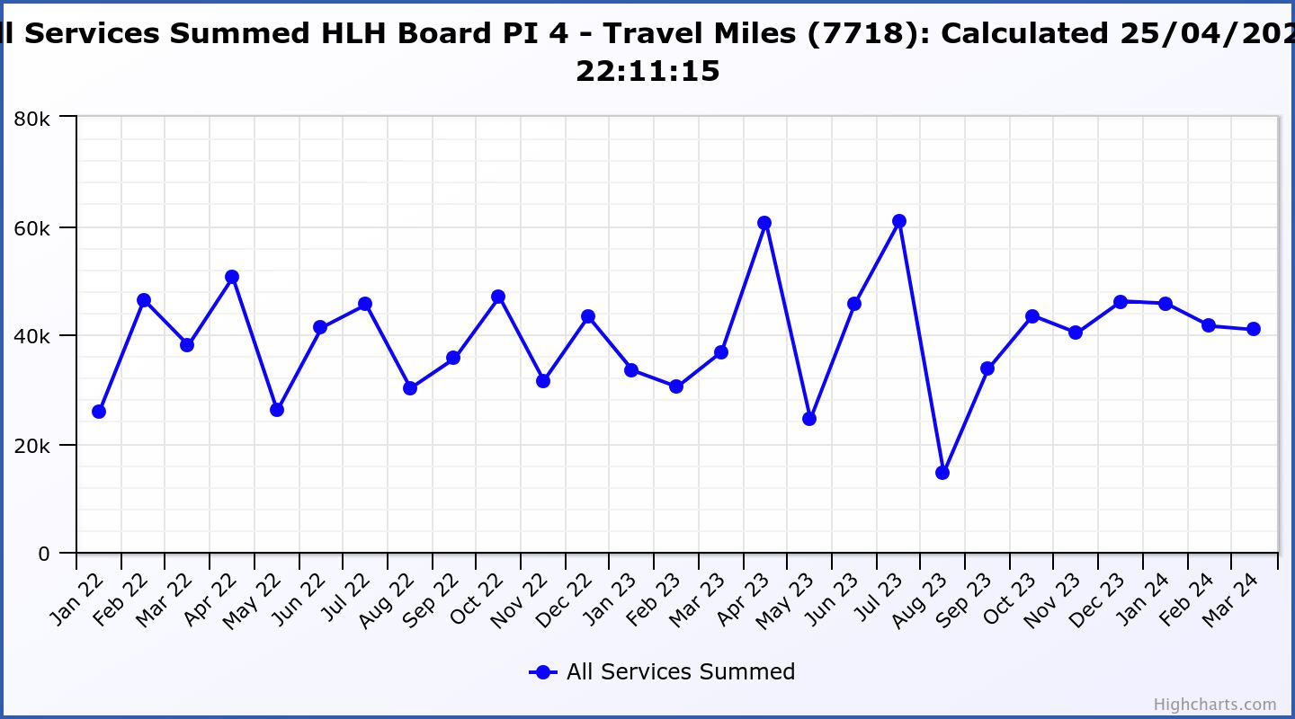

Business Plan Outcome | Performance Indicator | Reporting Frequency | RAG Rating Definition | RAG Rating Q1 23/24 | RAG Rating Q2 23/24 | RAG Rating Q3 23/24 | RAG Rating Q4 23/24 | Summary of Quarter Four Performance
3. Use research and market analysis to develop and improve services to meet customer needs. | 5. Customer engagements. | Quarterly. | - Green = customer numbers are the same as or have increased compared with the corresponding quarter in the previous year  - Amber = customer numbers are less than the corresponding quarter in the previous year.  - Red = customer numbers are more than 5% lower than the corresponding quarter in the previous year. | Green | Green | Green | Green | Customer engagements increased from 2,500,042 in Q4 2022/23 to  2,502,813 in Q4 2023/24.
Performance Indicator 5 - Customer engagements
Customer engagements reached their highest level ever in 2023/24.
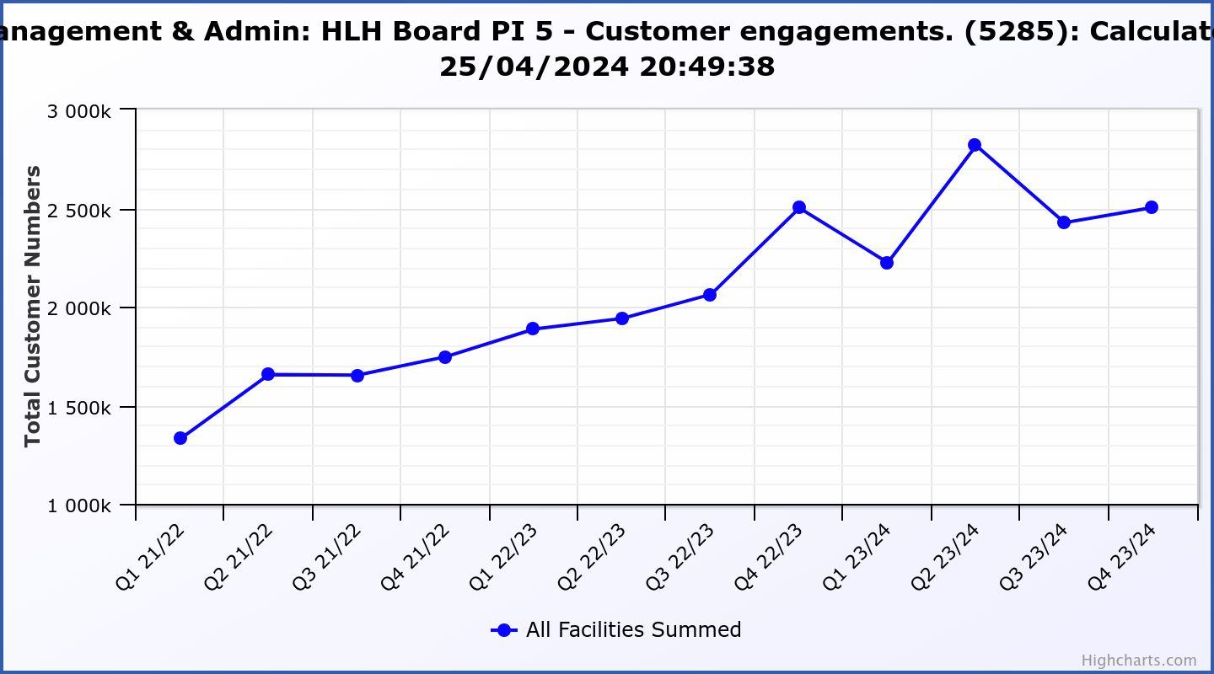
Business Plan Outcome | Performance Indicator | Reporting Frequency | RAG Rating Definition | RAG Rating Q1 23/24 | RAG Rating Q2 23/24 | RAG Rating Q3 23/24 | RAG Rating Q4 23/24 | Summary of Quarter Four Performance
3. Use research and market analysis to develop and improve services to meet customer needs. | 6. Charity-wide customer satisfaction survey. | Annually. | - Green = Services delivered by HLH is above average  - Amber = Services delivered by HLH is average  - Red = Services delivered by HLH is below average. | Green | NA | NA | NA | This was reported to the HLH Board as part of the Q1 reporting where 95% of respondents rated their overall experience of HLH/ staff as excellent or good and 95% said that they would recommend HLH.

Business Plan Outcome | Performance Indicator | Reporting Frequency | RAG Rating Definition | RAG Rating Q1 23/24 | RAG Rating Q2 23/24 | RAG Rating Q3 23/24 | RAG Rating Q4 23/24 | Summary of Quarter Four Performance
4. Increase employee satisfaction, engagement and development to improve staff recruitment and retention. | 7. Staff turnover (resignations as a percentage of posts). | Quarterly. | - Green = 1.6% or less.  - Amber = 1.7 to 2%  - Red = more than 2% | Green | Green | Green | January Green | The number of resignations per month as a percentage of posts was 1.1% in January, 0.8% in February and 2.5% in March. Please see section three of this report for further information.
February
Green

 |  |  |  |  |  |  | March Red

Performance Indicator 7 - Staff Turnover (resignations as a percentage of posts)
The graph below shows resignations as a percentage of the number of posts (1% equates to 10 staff).

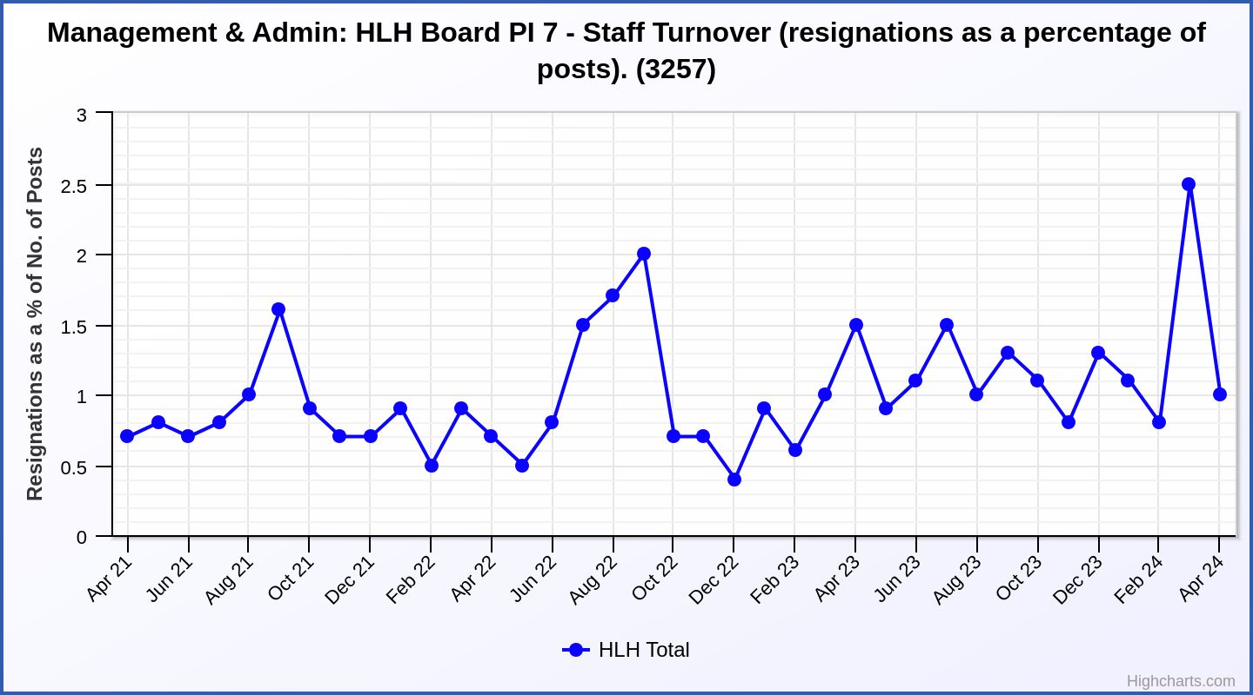

Business Plan Outcome | Performance Indicator | Reporting Frequency | RAG Rating Definition | RAG Rating Q1 23/24 | RAG Rating Q2 23/24 | RAG Rating Q3 23/24 | RAG Rating Q4 23/24 | Summary of Quarter Four Performance
4. Increase employee satisfaction, engagement and development to improve staff recruitment and retention. | 8. Staff attendance rates (RAG ratings based on Office for National Statistics for 2020). | Quarterly. | - Green = attendance rate 95.7% or higher.  - Amber = attendance rate 93.7% to 95.6%.  - Red = attendance rate less than 93.7%. | Red (previous rating) | Red (previous rating) | Red (previous rating) | Amber | The attendance rate for Q4 was 95.11%. Please see the HR report elsewhere on this agenda for further information.

RAG ratings updated following March 2024 HLH Board Meeting as agreed based most recent Office for National Statistics figure.
Most recent ONS report “Sickness absence in the UK labour market: 2022” released 26 April 2023: “Caring Leisure And Other Service Occupations 4.3%”

(Previous RAG rating definitions were as follows: Green = attendance rate 98% or higher. Amber = attendance rate between 97% and 98%. Red = attendance rate less than 97%).
Performance Indicator 8 - Staff Attendance Rate
Staff attendance rates for Q4 were 95.11%. Please see the HR report elsewhere on this agenda for further information.
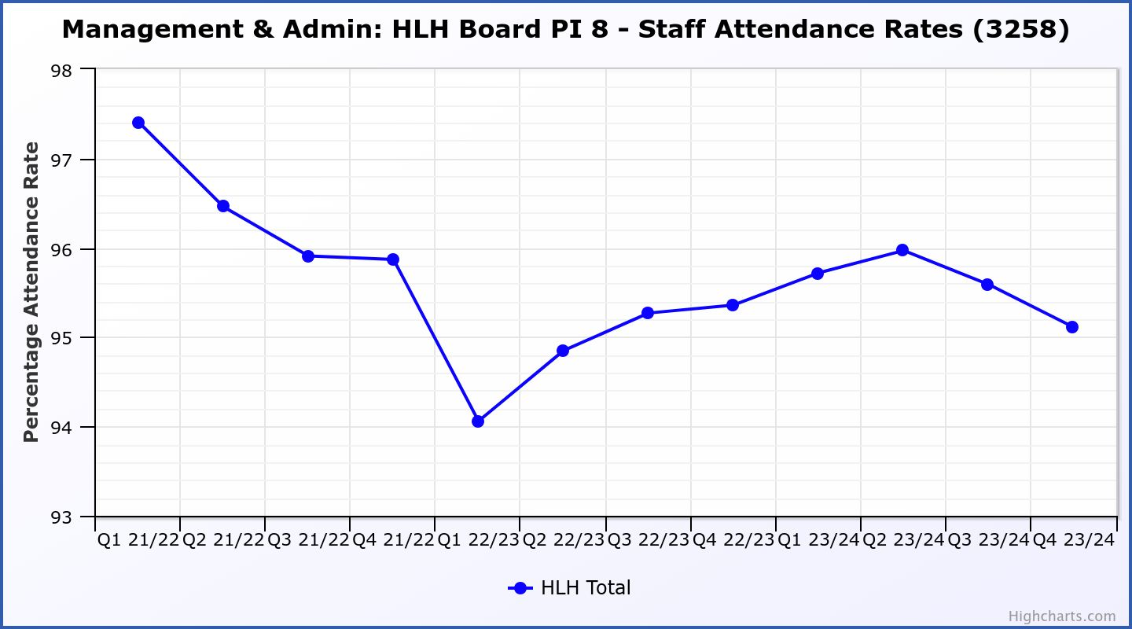

Business Plan Outcome | Performance Indicator | Reporting Frequency | RAG Rating Definition | RAG Rating Q1 23/24 | RAG Rating Q2 23/24 | RAG Rating Q3 23/24 | RAG Rating Q4 23/24 | Summary of Quarter Four Performance
5. Improve the financial sustainability of the company | 9. Financial monitoring. | Quarterly. | An assessment of the year end outturn where:  - Green = delivery of services within budget.  - Amber = delivery of services between break-even and 2% over budget.  - Red = delivery of services over budget above 2%. | Amber | Amber | Amber | Green | There is further information in the Finance Report elsewhere on this agenda.  The budget was delivered within the additional funding agreed with the Council.

Performance Indicator 9 - Financial Monitoring
This graph shows the position at the end of each quarter.
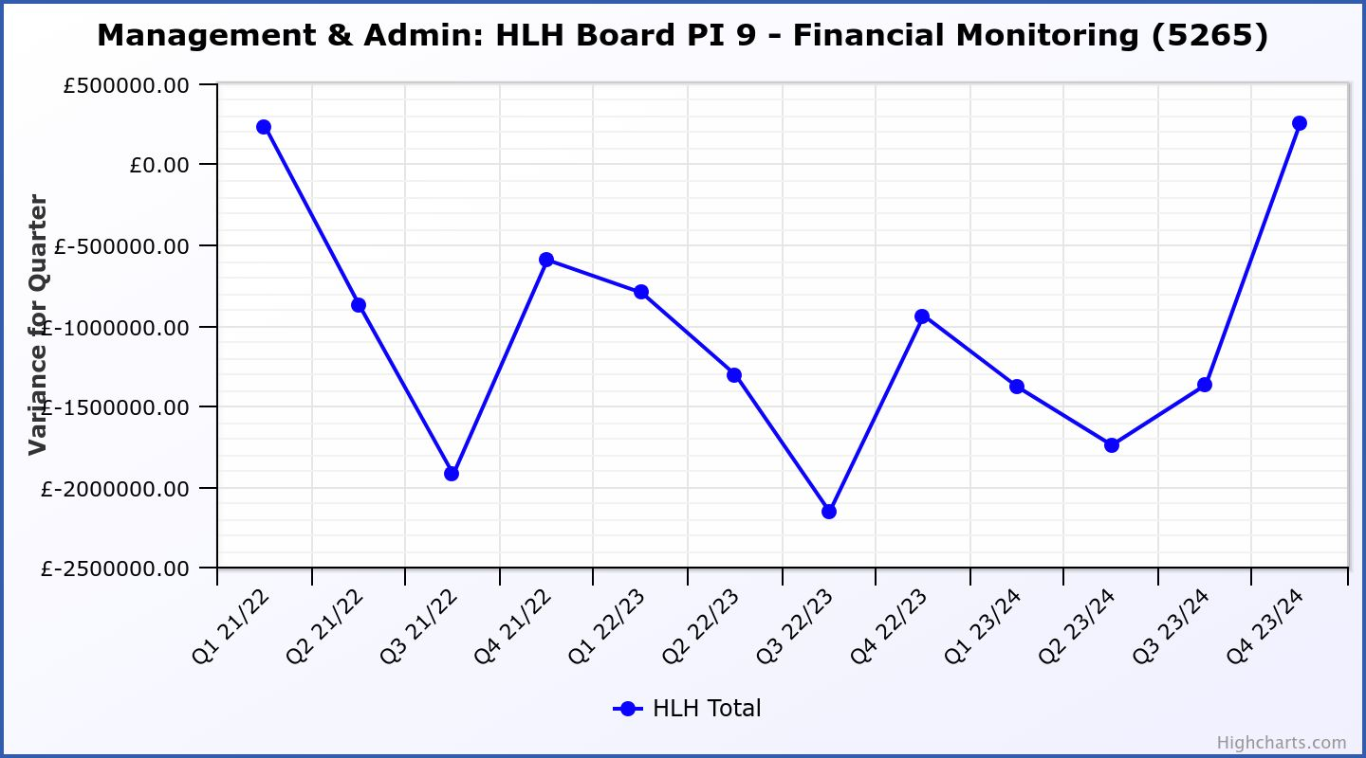

Business Plan Outcome | Performance Indicator | Reporting Frequency | RAG Rating Definition | RAG Rating Q1 23/24 | RAG Rating Q2 23/24 | RAG Rating Q3 23/24 | RAG Rating Q4 23/24 | Summary of Quarter Four Performance
5. Improve the financial sustainability of the company | 10. Reserves | Annual. | - Green = meets 3% reserves policy  - Amber = achieves 2% reserves  - Red = fails to achieve 2% reserves policy. | Red | Red | Red | Red | Uncommitted reserves are 0.1% at the end of 2023/24 and, therefore, RAG rated red.  Please see the Finance report elsewhere in this agenda for further information.
Performance Indicator 10 - Financial Reserves

This graph shows the level of uncommitted, unrestricted reserves at the end of each financial year.
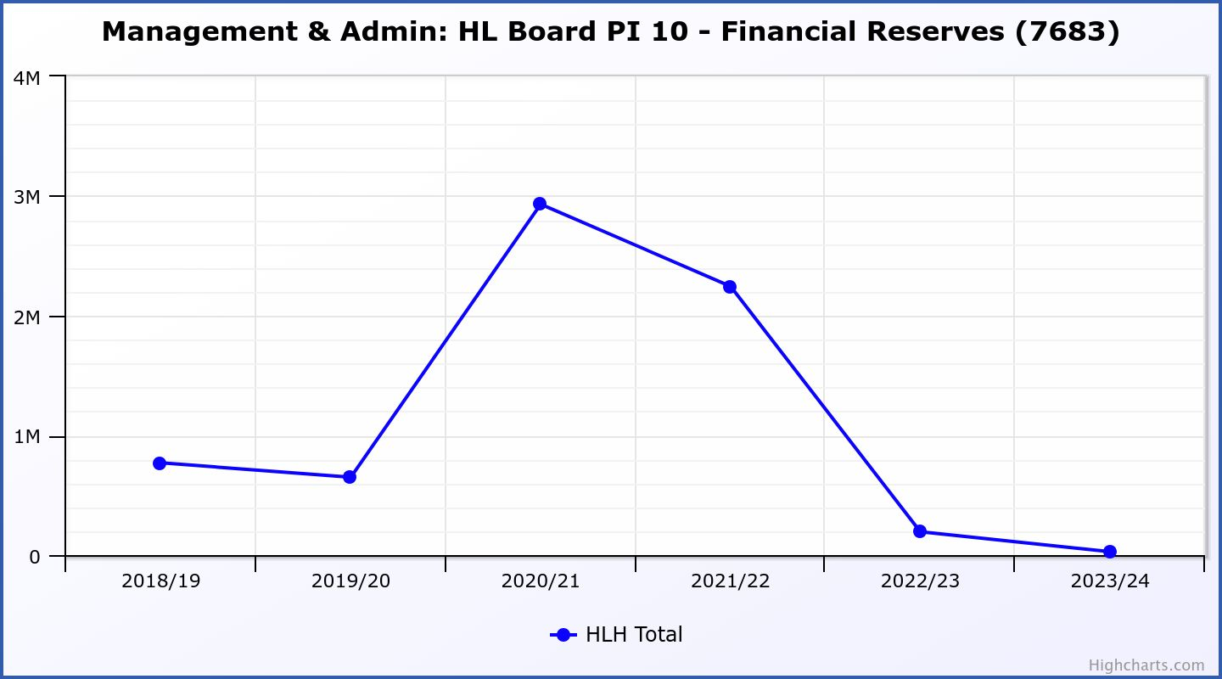

Business Plan Outcome | Performance Indicator | Reporting Frequency | RAG Rating Definition | RAG Rating Q1 23/24 | RAG Rating Q2 23/24 | RAG Rating Q3 23/24 | RAG Rating Q4 23/24 | Summary of Quarter Four Performance
5. Improve the financial sustainability of the company | 11. Number of highlife subscriptions (target is the required number to meet the budget). | Quarterly. | - Green= exceeds budgeted income target.  - Amber = risk of budget target not being met.  - Red = budgeted income target unlikely to be met. | Amber | Amber | Amber | Amber | For financial year 2023/24 income was 1% (£21k) short of the budget.  Please see section three of this report for further information.

Performance Indicator 11 - Number of High Life Subscriptions
As of April, subscriptions were 19,434.

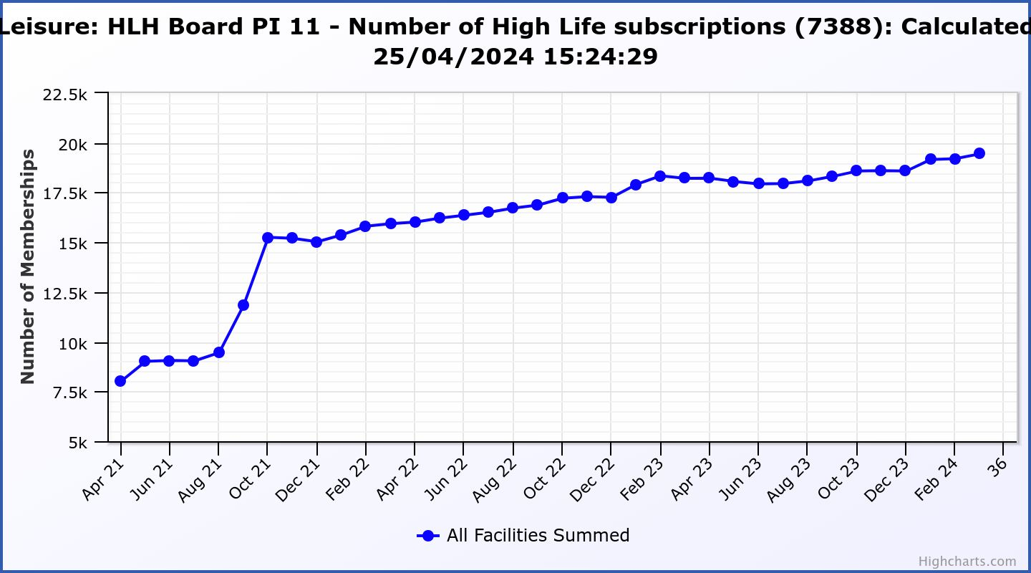

Business Plan Outcome | Performance Indicator | Reporting Frequency | RAG Rating Definition | RAG Rating Q1 23/24 | RAG Rating Q2 23/24 | RAG Rating Q3 23/24 | RAG Rating Q4 23/24 | Summary of Quarter Four Performance
6. Value and strengthen the relationship with THC. | 12. Delivery of the Service Delivery Contract (SDC) with The Highland Council (THC). | Six-monthly. | - Green = agreement of THC’s Education Committee that HLH has met or exceeded the terms of the SDC.  - Amber = agreement of THC’s Education Committee that HLH has met the terms of the SDC but has set some improvement targets.  - Red = agreement of THC’s Education Committee that HLH has not met the terms of the SDC. | NA | Green | NA | Green | The Council’s Education Committee considered the HLH Progress Report at its meeting held on 30 May 2024. The Committee noted that HLH continues to deliver the Public Service Obligations on behalf of the Council as set out in the Service Delivery Contract.

Business Plan Outcome | Performance Indicator | Reporting Frequency | RAG* Rating Definition  (*Red/Amber/Green) | RAG Rating Q1 23/24 | RAG Rating Q2 23/24 | RAG Rating Q3 23/24 | RAG Rating Q4 23/24 | Summary of Quarter Four Performance
7. Develop and deliver the HLH Corporate Programme and seek to attract capital investment. | 14.The HLH corporate programme covers investment; business process improvement; capital and asset management plans and plans will be developed as this area of work is developed. | NA | Should additional performance indicators be identified through the development of these plans they will be added in future. | NA | NA | NA | NA | NA

Business Plan Outcome | Performance Indicator | Reporting Frequency | RAG Rating Definition | RAG Rating Q1 23/24 | RAG Rating Q2 23/24 | RAG Rating Q3 23/24 | RAG Rating Q4 23/24 | Summary of Quarter Four Performance
8. Use research and market analysis to develop and deliver proactive marketing and promotion of HLH and its services. | 15. Media coverage from proactively issued media releases | Six-monthly. | - Green = Positive coverage 95%+  - Amber = Positive coverage 90% - 95%  - Red = Positive coverage 90%- | NA | Green | NA | Green | There were 8 media releases in Q4 which were all positively received. The number is low due to not having a post holder in the media and content post for most of Q4. Following the post having been filled on 2nd April 2024 there have been 12 media releases issued in 5 weeks. In addition, the team has secured coverage for archives and libraries from BBC and MFR.  It is planned to revert back to tracking positive, neutral and negative press coverage for future meetings.

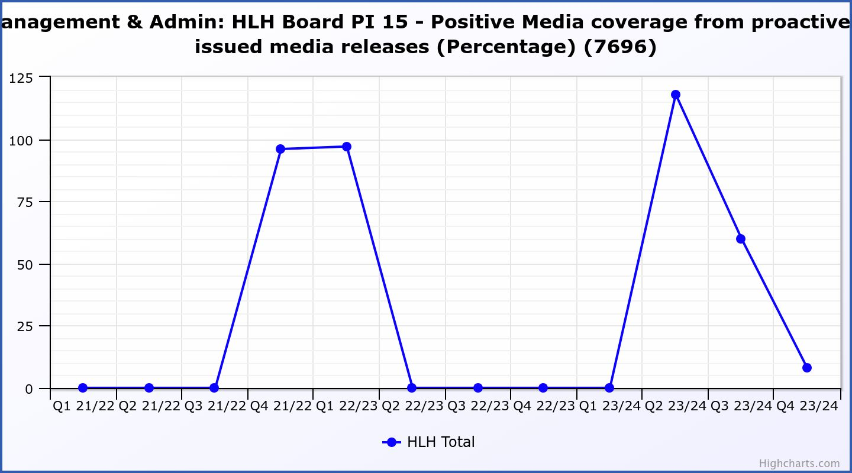

Business Plan Outcome | Performance Indicator | Reporting Frequency | RAG Rating Definition | RAG Rating Q1 23/24 | RAG Rating Q2 23/24 | RAG Rating Q3 23/24 | RAG Rating Q4 23/24 | Summary of Quarter Four Performance
8. Use research and market analysis to develop and deliver proactive marketing and promotion of HLH and its services. | 16. On-line engagement through social media channels. |  | - Green = 5% increase compared with the same period last year.  - Amber = no increase to 4.9% lower compared with the same period last year.  - Red = more than 5% lower or less compared with the same period last year. | Green | Red | Red | Green | Social media engagements were 29,832 in Q4 22/23 and increased to 36,410 in Q4 23/24.

Performance Indicator 16 - On-line engagement through social media channels.

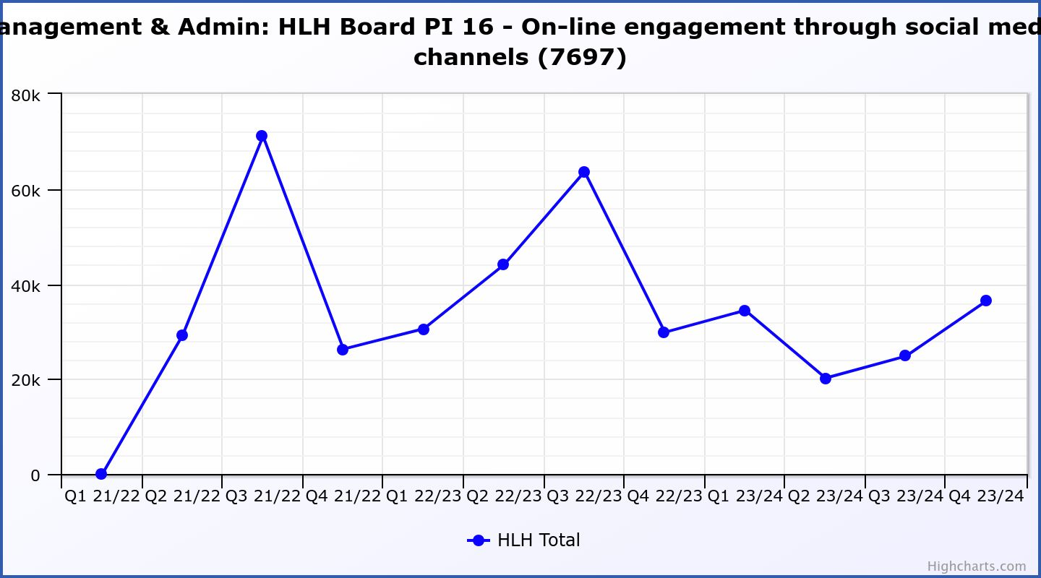

Business Plan Outcome | Performance Indicator | Reporting Frequency | RAG Rating Definition | RAG Rating Q1 23/24 | RAG Rating Q2 23/24 | RAG Rating Q3 23/24 | RAG Rating Q4 23/24 | Summary of Quarter Four Performance
9. Initiate and implement an ICT digital transformation strategy across the charity | 17. The HLH digital transformation strategy is yet to be developed. |  | Should performance indicators be identified through the development of these plans they will be added in future. | NA | NA | NA | NA | See note below.

There was a presentation to the HLH Board on the development of a digital strategy at its 26 March 2024 meeting to set the context for the strategy and seek Director input. It is expected that a draft strategy will be available for the consideration of the HLH Board at its March 2025 meeting with interim reports at the October and December meetings. The graphic below outlines some of the components of the current and future work. The new finance system is now in place; procurement of a leisure management system is underway with a target for board approval of the procurement at its August 2024 meeting and the tender specification for the new web site is being developed with a target for board approval of the procurement at its October 2024 meeting.

Business Plan Outcome | Performance Indicator | Reporting Frequency | RAG Rating Definition | RAG Rating Q1 23/24 | RAG Rating Q2 23/24 | RAG Rating Q3 23/24 | RAG Rating Q4 23/24 | Summary of Quarter Four Performance
10. Develop and strengthen relationships with customers, key stakeholders and partners | New approach to customer survey as per Business Outcome 3 above.  Same as PI 6 - Charity-wide customer satisfaction survey | Quarterly | - | Green | NA | NA | NA | NA – this indicator was considered by the HLH Board at its August 2023 meeting.

Business Plan Outcome | Performance Indicator | Reporting Frequency | RAG Rating Definition | RAG Rating Q1 23/24 | RAG Rating Q2 23/24 | RAG Rating Q3 23/24 | RAG Rating Q4 23/24 | Summary of Quarter Four Performance
10. Develop and strengthen relationships with customers, key stakeholders and partners | 18. Partnership work with sportscotland and other sports related organisations, NHS Highland and other health related organisations (including Memoranda of Understanding) etc. | Annual | - Green = Growth in partnership working  - Amber = continuation of current level of partnership work  - Red = cancellation of Partnership Agreements | NA | Green | NA | NA | NA

Business Plan Outcome | Performance Indicator | Reporting Frequency | RAG Rating Definition | RAG Rating Q1 23/24 | RAG Rating Q2 23/24 | RAG Rating Q3 23/24 | RAG Rating Q4 23/24 | Summary of Quarter Four Performance
11. Deliver targeted programmes which support and enhance the physical and mental health and wellbeing of the population and which contribute to the prevention agenda. | 19. An assessment of the RAG rating of the Health and Wellbeing Strategy action plan. |  | - Green = 80% or more of the actions are RAG rated green  - Amber = 60% to 79% of actions are green.  - Red = 59% or less are rated green. | NA | NA | Green | NA | The Health and Wellbeing update report was last considered by the HLH Board at its March 2024 meeting.

Appendix C
Information on travel performance indicator management/monitoring

PI 4 Travel - during 2023/24, travel has exceeded the ceiling set in financial year 2022/23 by 39,974. The travel miles exceeded the ceiling for: adult learning, archives, leisure, management and admin, music tuition, sport and youth work with other areas of work containing travel within the agreed levels.

Adult learning - has seen a small increase in travel miles relating to increased workforce development sessions and engagement with learners. This has in turn supported increased performance in the service. The team will continue to review the position and utilise blended learning wherever it is appropriate to do so.

Archives – the reason for travel miles exceeding in Archives during 2023/24 can be attributed to Angus Og travelling exhibition, a project funded by the National Island Plan (Scottish Government) and supplemented by Ward Discretionary Funding which enabled the Angus Og Project Officer (based in Skye and Lochalsh Archives) to successfully tour the west highlands and small isles with associated workshops and outreach activities reaching 865 people in 19 different venues. The costs associated with the touring element of the exhibition were directly reinvested in local communities through the payment of community hall hire and the use of local accommodation, food and transport providers.

Leisure - has exceeded the travel limit due to Leisure Management staff covering a multitude of sites, the requirement of the service to have an on site presence and increased (Quarterly) face to face meetings. The leisure team will continue to work with their team to utilise the most effective modes of transport available.

Management and admin - travel exceeded the ceiling by 281 reflecting increased management site visits.

Music Tuition – the music tuition team is very aware of minimising travel. Much of their timetabling depends on appropriate access to school premises which allows them to reduce travel as requested. The team will continue to promote the use of online and hybrid delivery to try and reduce pressure on travel targets. There have been tentative discussions with Council colleagues about the potential to access electric vehicles for some of the Music Instructors who have teaching areas which cover large geographical areas, but this discussion is at an early stage.

Sports Development - The Sports Team mileage is showing a slight increase on agreed levels because they needed to bring the team together for staff training. The sports service mileage is still forecast to fluctuate as staff are needing to spend more time out supporting new volunteers and establishing new activity groups within local communities.

Youth Work - travel has increased from an unusually low baseline in 22/23 resulting from staffing changes and carrying vacancies. The team has now returned to a full complement of Youth Development Officers with a corresponding rise in the requirement to travel. Also contributing to the increase in travel mileage is the location of this year’s Youth Convenor with the current post holder travelling from Skye to meet with and support young people. This fluctuates annually depending on the location of the current Youth Convenor.

Appendix D
Breakdown of Annual Customer Engagements by each of the HLH areas of work

Total Engagements (in-person and on-line) | 2019/20 | 2020/21 | 2021/22 | 2022/23 | 2023/24 | Difference 2019/20 – 2023/24 | % change 2019/20 – 2023/24
Adult Learning | 16,088 | 3,911 | 9,457 | 13,668 | 14,318 | -1,770 | -11%
Archives | 1,306,804 | 1,944,259 | 1,737,618 | 1,996,285 | 2,324,851 | 1,018,047 | 78%
Countryside Rangers | 15,044 | - | 5,122 | 11,366 | 11,857 | -3,187 | -21%
Leisure | 2,995,583 | 468,555 | 1,402,402 | 2,177,826 | 2,420,276 | -535,890 | -18%
Libraries | 3,698,919 | 2,251,855 | 2,575,025 | 3,514,620 | 4,497,811 | 798,892 | 22%
Museums and Galleries | 268,771 | 95,676 | 262,250 | 231,947 | 224,172 | -43,876 | -18%
Music Tuition | 99,734 | 40,687 | 84,330 | 105,821 | 111,837 | 12,103 | 12%
Sports Development | 374,522 | 29,955 | 196,489 | 274,822 | 277,706 | -104,245 | -28%
Youth Work | 71,631 | 24,874 | 54,947 | 74,595 | 81,602 | 9,148 | 13%
Total | 8,849,910 | 4,859,989 | 6,328,722 | 8,400,950 | 9,964,430 | 1,114,520 | 12%

Appendix E
Breakdown of Annual In-Person Customer Engagements by each of the HLH areas of work

In-Person Engagements | 2019/20 | 2020/21 | 2021/22 | 2022/23 | 2023/24 | Difference 2019/2023-24 | % Change 2019/2023-24
Adult Learning | 16,088 | 3,911 | 9,457 | 13,668 | 14,318 | -1,770 | -11%
Archives | 10,575 | 141 | 2,557 | 11,981 | 12,711 | 2,136 | 20%
Countryside Rangers | 15,044 | - | 5,122 | 11,366 | 11,857 | -3,187 | -21%
Leisure | 2,995,583 | 351,453 | 1,402,402 | 2,172,513 | 2,452,902 | -542,681 | -18%
Libraries | 2,162,655 | 55,742 | 394,534 | 1,370,763 | 1,871,585 | -291,070 | -14%
Museums and Galleries | 154,873 | 18,549 | 68,229 | 131,496 | 150,830 | -4,043 | -2.5%
Music Tuition | 99,734 | 40,687 | 84,330 | 97,161 | 100,097 | 363 | 0.5%
Sports Development | 374,522 | 29,955 | 252,224 | 274,822 | 270,277 | -104,245 | -28%
Youth Work | 71,631 | 24,874 | 54,947 | 74,595 | 80,779 | 9,148 | 13%
Total | 5,900,705 | 525,312 | 2,273,802 | 4,158,365 | 4,965,356 | -935,349 | -17%

Note that staff turnover continues to be low but if March were to be RAG rated in isolation the number of resignations would be RAG rated as red so information has also been provided on this indicator to assess whether there is an emerging issue.

