HIGH LIFE HIGHLAND  REPORT TO BOARD OF DIRECTORS  11 December 2024 | AGENDA ITEM 11 REPORT No HLH/30/24

FIVE YEAR STRATEGY - Report by Chief Executive
Summary

This report seeks to formalise the five year strategy following Directors of the HLH Board and HLH (Trading) C.I.C. having held a joint workshop using the “strategy on a page” format.

It is recommended that Directors:
i.
ii. iii. iv.

v.
note the facilitator’s report on the strategy workshop in Appendix A; approve the strategy on a page in Appendix B as the basis for service planning;
note that service plans will be developed for each area of HLH work to deliver HLH’s strategic objectives;
note that plans will be developed for specific areas of work highlighted in the strategy with these being brought to the HLH Board for approval over the coming year; and
note that a new performance management/monitoring framework is under development and will be brought to the HLH Board for approval at its March 2025 and future meetings as specific plans are developed.

1. | Business Plan Contribution
1.1 | High Life Highland’s (HLH) purpose is Making Life Better. The HLH Business Plan contains eleven Business Outcomes which support the delivery of this purpose, and this report supports all the outcomes from the Business Plan:  - Seek to continuously improve standards of health and safety.  - Commit to the Scottish Government’s zero carbon targets and maintain the highest standards in environmental compliance.  - Use research and market analysis to develop and improve services to meet customer needs.  - Increase employee satisfaction, engagement and development to improve staff recruitment and retention.  - Improve the financial sustainability of the company.  - Value and strengthen the relationship with THC.  - Develop and deliver the HLH Corporate Programme and seek to attract capital investment.  - Use research and market analysis to develop and deliver proactive marketing and promotion of HLH and its services.  - Initiate and implement an ICT digital transformation strategy across the charity.  - Develop and strengthen relationships with customers, key stakeholders and partners.

- Deliver targeted programmes which support and enhance the physical and mental health and wellbeing of the population and which contribute to the prevention agenda.

- Background

  - A joint workshop of the HLH Board, HLH (Trading) C.I.C. and the executive team was held on 1 October 2024 managed by an external facilitator following this having been agreed by the HLH Board at its meeting held on 28 August 2024. The facilitator’s report which was circulated to those who attended prior to it being finalised can be seen in Appendix A.

Strategy on a Page

  - The output from the workshop was a five-year strategy on a page. The executive team then ran a workshop with the wider HLH management team where:
    - proposed amendments to shorten the text in the vison and high level outcome were proposed for consideration of the HLH Board; and
    - key actions for each of the strategic objectives were developed for consideration of the HLH Board.
  - There was a final half-day workshop led by the facilitator who delivered the initial workshop with the executive team to finalise the strategy. The HLH Chair was then consulted on final changes and his updates were included. The strategy on a page is in Appendix B for consideration and approval of the Board.

Service Planning

  - The next stage of development is annual service planning based on the strategy for: Archives; Countryside Rangers; Leisure; Libraries; Museums and Galleries; Music Tuition and Sports Development. These plans will be developed by the end of January 2025.

Support Service Planning
  - There have previously been separate plans for some support services. It is proposed that specific plans which align to the five year strategy be developed for:
    - digital plan (the digital plan is being re-worked in response to the strategy and is scheduled for the March HLH Board);
    - marketing plan (this was under development and paused pending the work on the five year strategy, it is proposed that this be scheduled for the March HLH Board);
    - people/workforce plan (this would be new and will be developed over the coming year);
    - property investment plan (this would be new and will be developed in partnership with THC over the coming year);
    - net zero/sustainability (this work has commenced as previously reported to the HLH Board); and

    - health and wellbeing plan (the existing work is being maintained until the work with NHS Highland can be resumed).

Performance reporting

  - Service planning will be within the framework of the Strategic Objectives and Key Actions, with the performance reporting being used to track progress under the following headings.

    - Increase member numbers
    - Increase service users
    - Improving user/service satisfaction levels
    - Improving staff satisfaction levels
    - Improving financial sustainability
    - Capital investment levels
    - Health and safety performance
    - Sustainability results
  - As can be seen in the performance report elsewhere on this agenda, work on this is underway with a data set having been presented around the first indicator, increasing member numbers. This has been included so that the Board can comment on this as it is developed.

6.2 Narrative reporting has also been requested as part of the strategy workshop and this will be linked to service planning with annual reports for each service being developed in line with the new strategy. An example of an existing annual report is provided in Appendix C.

HLH (Trading) C.I.C

  - HLH (Trading) CIC protects HLH’s charitable status by delivering non-charitable activity linked to the charitable activities and gift-aids over £0.5m in profit to the parent charity. This adds to HLH’s c.£36m turnover and thereby allows it to deliver more services at less cost to the public purse.

  - Trading company Directors have been included in the strategy on a page workshop and have previously been developing the work of the trading company through identifying performance indicators to focus its work. Planning for trading activity will commence following HLH Board approval of the strategy.

Implications
  - Resource Implications – The service planning work described in this report can be developed within existing resources.
  - Legal Implications – There are no legal implications associated with the development of a business plan.
  - Risk Implications – There are no new risks associated with the development of a new business plan.

8.4 | Equality Implications – there are no new equality implications associated with  the development of a business plan.

Recommendation

It is recommended that Directors:
i.
ii. iii. iv.

v.
note the facilitator’s report on the strategy workshop in Appendix A; approve the strategy on a page in Appendix B as the basis for service planning;
note that service plans will be developed for each area of HLH work to deliver HLH’s strategic objectives;
note that plans will be developed for specific areas of work highlighted in the strategy with these being brought to the HLH Board for approval over the coming year; and
note that a new performance management/monitoring framework is under development and will be brought to the HLH Board for approval at its March 2025 and future meetings as specific plans are developed.

Designation: Chief Executive

Date: 29 November 2024

Author: Steve Walsh Douglas Wilby

Appendix A – Strategy Workshop Final Report



High Life Highland Strategy Workshop Monday 1 October 2024
Final Report

Report Prepared By:
David Gass Rural Matters LLP David.gass@ruralmatters.co.uk
6 October 2024

This document is an internal High Life Highland document. This document contains the findings of work conducted in support of a Strategy Workshop for the Boards of High Life Highland Charity and Trading Company. This document should not be disclosed to any person or referred to in part or in whole, other than for High Life Highland’s purposes, without prior written consent. Any decision to invoke the recommendations and conclusions in this document shall be solely a High Life Highland decision.

Introduction
The High Life Highland Strategy Workshop took place on 1 October 2024 at Inverness Library and brought together representatives from both the High Life Highland Board and the Trading Company Board together with the Executive Team, to consider and develop the principal components of a High Life Highland Strategy 2025-2030.

The outputs from this Strategy Workshop, using the Strategy on a Page facilitation process adapted for High Life Highland, will feed into the High Life Highland Business Planning processes for both the main Charity, and for the first time the Trading Company of High Life Highland.

An introductory meeting was held with the High Life Highland Executives and Business Support Team and the respective Chairs of High Life Highland and the Trading Company to discuss and agree the approach to the Strategy Workshop, and background documents from the High Life Highland Planning process were provided for review.

The Strategy Workshop was facilitated by David Gass, and attended by:

- Michael Golding, High Life Highland Board Chair
- Tracy Ligema, High Life Highland Vice Chair
- Councillor Marianne Hutchison, High Life Highland Board Director (online)
- Nick Finnigan, High Life Highland Board Director (online)
- Roddy Henry, High Life Highland Board Director
- David Finlayson, High Life Highland Charity and Trading Company Board Director
- Ken Nicol, High Life Highland Charity and Trading Company Board Director
- Councillor Andrew Jarvie, High Life Highland Charity and Trading Company Board Director
- Kirk Tudhope, High Life Highland Trading Company Board Director
- Steve Walsh, Chief Executive
- Douglas Wilby, Director of Corporate Performance
- James Martin, Director of Sport, Leisure and Safeguarding
- John West, Director of Culture and Learning
Thank are due to Susan Menzies, Business Support Officer, for her assistance in organising the Strategy Workshop and the preparation for it, and to all those who attended for their contributions to the day.

A copy of the slide set from the day has been circulated to all attendees, and this report captures the main agreed outputs from the day.

Principal Outputs from the Strategy Workshop
The objectives of the Strategy Workshop were agreed as:

- To set out a compelling Ambition for High Life Highland which can be communicated to your different audiences
- To agree the Strategic Priorities and Business Outcomes for High Life Highland 2025- 2030
- To provide the strategic decision framework to inform the development of the new High Life Highland Business Plan 2025-2028
- To provide the context for the High Life Highland Trading Company Business Plan.

The Strategy Context
Prior to the first discussion session of the Workshop, the Chair and Chief Executive of High Life Highland briefly set out the wider context for the Strategy, and the position of High Life Highland against the current Business Plan 2020-2025.

This covered in brief the continuing importance of the relationship with Highland Council both in terms of service delivery contracting and the Council’s future capital investment programme; the various Levelling Up projects in place and the opening of the Inverness Castle Experience in 2025 alongside the changing political landscape and the increasing focus and challenge of Net Zero and how High life Highland responds to this challenge.

In terms of High Life Highland performance to date there were significant positives from the
9.9 million customer engagements in 2023/2024 to the reducing reliance on Highland Council funding and the significant increase in High Life Highland’s own income generation, reaching
£18.1 million in 2023/2024. However future financial years remained challenging with deficit funding forecast in 2024/2025 and 2025/2026 before returning to a small surplus projection in 2026/2027, and High Life Highland is currently operating well below its 3% reserves policy.
The workshop also flagged the following areas as important factors in terms of the operating context for High Life Highland (HLH) over 2025-2030:

    - The growing importance of, and possibilities offered, through Artificial Intelligence, and new digital technologies.
    - The economic opportunities presented through, as an example, the Green Freeport development – whether corporate, sponsorships, or just the increased employment opportunities; and other regional opportunities such as the Flow Country World Heritage.
    - Similarly the continuing growth of tourism and visitor numbers to the region, and more international visitors as part of this.
    - The new experience for HLH of taking on a major visitor attraction and the different experience and skills needed for this, particularly in terms of visitor management.
    - The continuing importance of inclusion and diversity for HLH.
    - Finding and recruiting new staff is very competitive across the Highland region – but HLH job flexibility opens up other workforce possibilities and solutions.
    - The aging population in Highland region, and what this might mean for the HLH service proposition.
    - Also the different workforce opportunities this presents – with many young retirees looking for new work and volunteer opportunities.
    - The challenges of reaching out and engaging with the younger age group remain.
    - The growing divide between the Inverness catchment area and its growing population and economy, and the increasing depopulation in more rural and remote areas of Highland region – different service models such as mobile libraries, combining other services?
    - The growing interest in co-location of services at the heart of communities.
    - The continuing challenges of the transport infrastructure to, from and within the region, in particular the A9.
    - At regional and national level, the on-going public sector funding constraints.
    - The focus on entrepreneurship and innovation skills through the National Economic Strategy.
    - The focus on Net Zero – how can HLH best respond meaningfully to the Net Zero challenge when the buildings and facilities sit with the Highland Council? – more about sustainability than Net Zero, and what is within HLH’s control – training and awareness of the issues; and areas such as educational outreach through the work of the countryside rangers and the libraries as an example.

The Starting Point for the HLH Strategy 2025-2030
Whilst the wider context discussion raised a number of possibilities and opportunities, it was agreed that the foundations for the 2025-2030 Strategy remained the purpose of High Life Highland – Making Life Better – and the I-Care set of values in place – Integrity, Community, Accountability, Respect and Example.

There was a helpful discussion as to how much freedom and autonomy HLH actually had to set out a new Strategy, given its continuing dependency on Highland Council funding and as a wholly owned subsidiary of the Council operating as an Arm’s Length External Organisation (ALEO). Whilst the legal position of HLH was accepted, and there remained an expectation HLH will deliver the services the Council requires it to do, it was agreed that HLH had significant autonomy in how it chose to deliver across its services, particularly in terms of the Trading Company and with the Inverness Castle Experience a prime example – and as such the work to set out a new Strategy to inform the HLH business planning was welcomed and helpful.

There was agreement that HLH continued to perform well against its current Business Plan, and areas which had progressed well and provided a solid platform for the next stage of HLH growth were agreed to include:

- Very pleasing recovery of membership numbers after a very challenging period through COVID – demonstrating the value for money and increasingly effective marketing for the HLH Leisure card and wider HLH services, whilst accepting that in some more remote areas HLH services and facilities were the only option available to the local population.
- Clarity around the High Life Highland product.
- Strong partnership relationships with key stakeholders such as NHS and Sportscotland.
- Successful delivery of the Highland Council service contract.
- Positive working relationships across the Boards and the Executive team.
- A can do attitude across HLH, and a supportive environment for all staff.
- Achieving a positive balance between commercial success and positive social and community outcomes.
- Strong Trading Company performance – in particular the commercial success of catering operations through the Trading Company.
- The coverage of HLH services across the Highland region.
- The capital investment opportunity presented through Highland Council’s capital investment programme.

Areas which remained more challenging included:
- The reserves position was concerning, and challenged the “independence” of HLH.
- The significant capital investment needed in terms of the ongoing maintenance of many of its current facilities, with the Estate and buildings under the responsibility of Highland Council.
- Still some IT accessibility issues at sites.
- The limited value the population places on some of HLH services given HLH’s link to the Highland Council.
- The need to invest in IT and back-up systems for the membership structure, and to maximise future digital opportunities.
- The need to improve cross-marketing and cross-selling of HLH services across HLH staff.
- While customer feedback was generally good, it tended to be reactive and needed to be captured more proactively – and more ways of engaging with non-customers developed, both in order to develop and revise products and services as appropriate.

The Ambition of HLH to 2030
The next session focused on what success might look like for High Life Highland in 2030, and the outcomes it sought to achieve and contribute to. The ambition for HLH was described as follows:

- Full awareness across the region of High Life Highland and what it offers – and viewed as a successful and independent organisation from the Council - members and service users feel positive about using HLH services and facilities.
(it was suggested that it would be worth testing how important, negatively or positively, the perception was of HLH as a Council organisation, and if it was an important issue? Using for example Ipsos Mori)
- Extending the reach of HLH services to more of the Highland region population, and ensuring it meets the needs and provides access to services to all communities (geographically and demographically) across the Highland region.
- HLH facilities and service offer embedded at the heart of communities, through increased co-location and awareness of services.
- Customer feedback is continually and proactively sought, and listened to – with high customer satisfaction ratings across HLH services, and higher spend levels/customer achieved.
- Trust from Highland Council in how HLH chooses to develop and deliver its core services – with innovative and high value service delivery to the fore, and HLH services more accessible to all – and understanding within the Council of why HLH requires its reserves position and ability to re-invest in the service offer.
In summary, there was a desire from the Board members by 2030 to see High Life Highland as commercially successful and financially sustainable – and continuing to be socially responsible and making a positive impact on people’s lives across the region, as a trusted but independent partner of Highland Council.

The HLH Value Proposition
An important element of the Strategy on a Page process is the ability to clearly communicate the value the organisation brings to each of its different audiences – taking the purpose and the ambition of the organisation into account, but viewing it from the different perspectives of customer/stakeholder/staff as to what value it brings to them, and what makes the organisation unique or able to stand out from others.

This assists in developing and shaping the Strategy and Business Plan for an organisation – ensuring it remains true to, and is clear on, the value it is seeking to bring – whether commercially or socially – and testing the Strategy or Business Plan priorities against this.
A good discussion was had in the different groups with consideration of a number of values and differentiation HLH could offer including:

- The Charity importance – every £ spent is re-invested in the services, and the positive feel of working with/paying for services from a charity, and acting for the greater good.
- Accessible and affordable
- Health, learning and culture summarise the soon to be seven services
- For the people of the Highlands and in the Highland region – including both residents and visitors.
- ​
The two suggested Value Proposition statements that emerged from the day were:

A Highland-wide charity, embedded in communities, that reinvests every penny to deliver affordable and inclusive opportunities to improve physical, mental and social health and wellbeing.
We are a charity that gives people in the Highlands affordable and easy access to health, learning, and culture.

  - High Life Highland Operations 2025-2030
Building on the agreed purpose, ambition and value proposition for High Life Highland 2025- 2030, the afternoon sessions of the workshop sought to break this down into the key areas of where to play, in terms of the critical audiences for HLH over 2025-2030, and how to win in terms of what HLH will do – its high level strategic priorities.

The final session then considered at a strategic level, what would be some of the high level business outcomes HLH wished to achieve over the Strategy period, and would this require new or different approaches or skill sets within High Life Highland.

Where to Play – Your Critical Audiences
This focused on who the critical audiences for High Life Highland were, why were they so important, and how should HLH look to engage most effectively with each audience.
WHO | WHY | HOW
Highland Council  - Members  - Officers | - Service Delivery Contract  - Funding levels  - Capital investment opportunity and estate model  - The case for HLH reserves | - As a recognised and trusted partner  - Outcomes delivered  - Efficiencies delivered
Customers  - Resident  - Visitor  - Corporate  - Inverness Castle | - Cross promotion/selling  - Segmentation  - Service levels (learning from library award)  - Engagement process (learning from corporate membership success (71) – more of a sales approach)  - Castle visitor demographic – international | - Customer feedback  - Market intelligence  - Encourage local ownership and pride
Sportscotland | - Funding  - Capital investment  - Sector leadership | - As a recognised and trusted partner  - Exemplar in areas
Community Planning Partnership (CPP) Partners  - Particularly NHS | - Active Highland Outcomes  - Co-location opportunities  - Joint projects and delivery  - Joint funding | - CPP Forums and Meetings  - Progress reporting  - Innovative in approach

Staff  and Volunteers | - Your most important asset  - Increase corporate knowledge and awareness of other services  - Importance of succession planning at all levels  - Development opportunities | - Training (for example, Customer Care)  - Performance feedback and development  - Staff Satisfaction – survey and action plan  - Pathways
Regulatory/Compliance Bodies | - Health and Safety  - Duty of care  - OSCR compliance | - Visible priority
Media | - Profile in community  - Messaging/reach out to non-service users  - Specific Inverness Castle opportunity | - Proactive  - New media team now in place

How to Win – Your High Level Strategic Priorities

This exercise sought to establish the strategic priorities for High Life Highland which the Business Plan needs to be seen to address, and each service area respond to, as follows:

- Affordable and accessible services (easy to use in terms of physical ability/geography, and financially affordable)
- Inclusive (reaching out to all parts of the community)
- Efficiency in delivery (of particular importance to key stakeholders)
- Maximising commercial income/return (as a Trading Company but clear that this is to re-invest in the Charity and the HLH services)
- Innovative – in service delivery and in service offer (from embracing digital to the business case for a different or improved service offer)
- Customer value (demonstrating the unique value proposition HLH offers)
- Consistency of delivery across the HLH customer journey (to a consistently high standard but also recognising that one size doesn’t fit across all services)
- Contribution to sustainability (how this can be best delivered and demonstrated)
From the Strategic Priorities, the workshop then considered what some of the principal business outcome measures would be to start to guide the business planning, in particular for the Trading Company Business Plan. In reality, the group reached consensus around a series of “success milestones” – effectively a combination of Business Outcome Measures and Key Performance Indicators which will be further refined to better inform the business planning.

The Success Milestones were as follows:

- Member numbers, to include potential KPIs on: Member Retention Levels
Corporate memberships Hard to reach client groups

- Service users, to include potential KPIs on: By individual services
By geography/area

By penetration levels/reach
By affordability/accessibility criteria

- User/Service satisfaction levels

- Staff satisfaction levels, to include potential KPIs on: Staff turnover
Staff absences
Staff satisfaction baseline?

- Financial Sustainability, to include potential KPIs on: Reserves position
Income growth v THC funding Budget forecasts

- Capital Investment Levels, to include potential KPIs on:Financial levels
Criteria for Individual facilities

- Health & Safety performance

- Sustainability, which might include for example: Local Supply Chain Use/Benefits
Narratives/Case Studies
The above will be further developed with the HLH Corporate Performance team in terms of feeding through into the business planning process.

A Sustainable Operating Model 2025-2030
The final section of the Workshop briefly considered any areas of internal capacity building or ways of working that the new Business Plans needed to take into account to achieve the ambition and outcomes agreed over the next Strategy period.

The following areas were highlighted:
    - Digital and technology enabling – there needs to be an internal plan for this if it is to happen, engaging the service leads, and identifying the major opportunities and where there are quick wins.
    - Empowering culture – there should be an emphasis on innovation and supporting change and challenge in delivery.
    - Staff training focus on customer service (taking the learning from existing areas of best practice and the catalyst of Inverness Castle), customer care and upselling/cross- selling.
    - Demonstrate better that HLH is listening and responding to customer needs and feedback, and telling customers what has been done.
    - Defining the risk appetite across HLH? – agreed this is very challenging given the different services and projects – the Levelling Up projects and Inverness Castle Experience show high risk and reward levels; whereas areas of core HLH service delivery which form part of the service delivery contract with the Council, are often low risk with limited ability to challenge/change – but both approaches bring value to customers.

Conclusion
The Strategy Workshop allowed the Board members and Senior Executive Team of High Life Highland to step back from the normal operational Board and Management meetings, and look

longer term at what the next five years hold in store for High life Highland. This then allowed a wider discussion on the strategic ambition and outcomes High Life Highland wishes to prioritise and deliver to feed into the business planning process now underway for the new Business Plan 2025-2028.
The draft report of the Strategy Workshop was circulated to all attendees for any final comments or suggested amendments, and then this final Strategy workshop report produced to support the work of the Corporate Performance team in drafting the new High Life Highland Business Plan, and creating the High Life Highland Strategy on a Page.

77
I
high..l..i,f.e_ / MAuKING
� .. -Pd BD1ER
j
- -
2:02:5-2030,
Om performance rnsts 011 5 s1rntegic objectives for delivery ,exoellence:
Strategic Objeciive 11:  Deb,efY of afford!abl'e, acoessibl'e and  inclusive serviices across the region  Key Ac,tions: | Strategic ObjeciJive 2:  Maxililliise and grow ou1r iincome to re­ invest across our services  Key Ac,tions: |  | Strategic ObjeciJive 3:  Ensur,e a consistent high value of deliv,efY across HlH se1Vices  Key Ac,tions: |  | Strateg·c Objective 4\:  Commit to the net zem sustainability agenda  IKey Actions:
1) Optimiise service  deliv,efY to meet communiity needs.  2.) Ensure ilie affonfabillity and accessiibillity of servkes to the communiity..  3) Fle.xibl' adapt servkes to allign widil local  op,p,ortunity. | 1)  2.) | Increase ilillCOme  from hjghlife membe:rships M!aximise all income streams.. | 1)  2.) | IMoniitor and  improve the cu1stom:er  ,expe111ience.. Demonstrate how  ,each sewice  briings vallue to our customers. | 11,  2]  3], | Dev,elbp, an  AciJion Pllan for  ti:let Zero  airtd  Sustaiinability for  ,each servke.. Reduce energy consumptfon ac1ross our se:rvices. lmpl'ement findings of  ,energrysurveys..
Internally w,e shall focus on:

Strategic Objective 5: Efficient and effectiive service deliiverry111hrough our people and pmoesses

- 1Continuous staff deployment to meet customer requirnments efficiently.
- Dev,elop traiining1needs analysis to support delirvery of our strategic obj:ectiv,es at service llevel..
- Dev,e op a Dig itallPlan for se1Vioe delliv,ery and efficiency.
- lmprov,e se1Vices by using the customer jou mey mechanism.

Appendix B Strategy on a Page

T
Purpose |  | So that we i;each o 1n | By | being/having | 1(Val 11es) |  | Contlibming to: (011, Higilfov,eil
IMakiing  Lifo Better | + | vision of affoirda!Jle aooess to hea'ltil, IIeam'ing and cult11i;efo rnv,eiyone iin Higil'lands | + ,,..  ,.  ,.  ,. | Integrity Comm11nity Acco11ntability Respect Exalillp,le |  | + | OIJtoome):  IMaking a positive impact across the Hi,gh lands b,y im p,roving p,hysical, mental and social health and wellbeing

To maxIm1se our impact and deliiver the best resullts, we shalI focus on orn cliitical audiences:  - Highland Council  - Custame:rs  - Resiidents  - Visitors  -Business Communiity  - Staff & Volunteers  - Funding Partners  - Commun1ity  Pilanning Partners  - Regullatory/ Compliance Bodies  - Media  - Political | ■ | We V.iiilllllkinOWwelha\lle suooe,ede,d wih,en we:  lllmrease member n;umllbe:rs  - IMemlbe:rrete:ntion11,ei;els  - Go:rpo:ratemem'berslhips  - Haird to readhdi,enigroups  lln,c1rease se:rv ice users  - By iindii\lliduall se:l'Vlice & by g,eogra1phy  - By penetrati,o:ri lle\lleils &  readh  I m1prov in,ff use:rlse:rvice satisfaction leveIs  I m1prov in,ff staff satisfaction leveIs  - Staff tumo,re:rand albs1e:noes  I m1provin,1 firnrncial S'l.llstain.:ilbility  - HoM ap;p:ro;p:nialeres1e1rves  - IMeeislho:11a- nd11,o:ng-te1rm oommitments wihiillst ma;,:iimiizii1r1gaffo:rdaltll,e aooess  Ca1pitaI in,vestme nt leveIs  - l'n,areasiing cap iin\llestme:nt 11,e,reils  - l'ndii\lliduall faailliitiy iimp:rovem.ent  Health aml Safety Pe:rfonnam:e  Sustain.:ilbility rnsiults  - Locall S'up;plly Clhaiin Be:ne1iits  - Narrativel!l&.case5tt.Jd.ie1B

78

Appendix C Example Service Annual Report

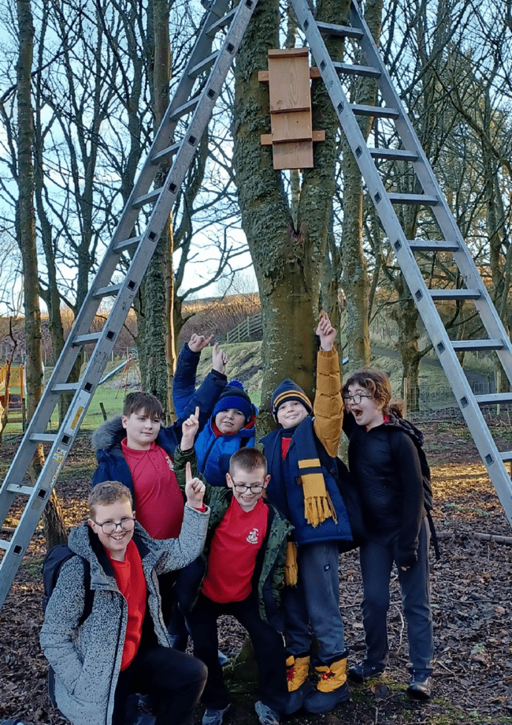

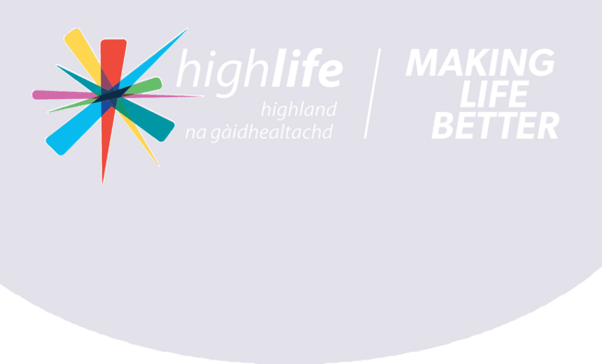
79

COUNTRYSIDE RANGERS

Annual Review 2023/2024

Photo:
School Children work with the local Ranger to improve habitats in Caithness

80

Executive Summary 4
TABLE OF CONTENTS
Strategic Partnerships 5
Biodiversity Report 6/7
Volunteering Report 8/9


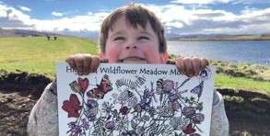
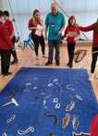
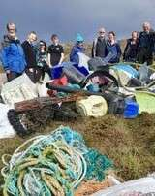
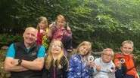
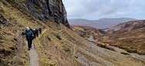

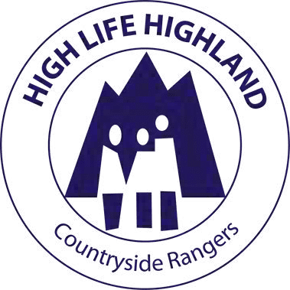
School Engagement Report Community Learning Report Health and Wellbeing Report
10/11
12

13

81
MEET THE RANGERS

Imogen Furlong Countryside Ranger Service Manager
Andy Summers Senior Ranger (North Highland)
Eilidh-Ann Phillips Senior Ranger (South Highland)

Paul Castle
North Sutherland and Caithness Countryside Ranger
Roz Summers
East Caithness /Relief Countryside Ranger
Kirsty Rosie East Caithness
Countryside Ranger
Patti Bremner East Caithness
Countryside Ranger

Marcia O'Hara Easter Ross and SE Sutherland Countryside Ranger
Jenny Grant Wester Ross Countryside Ranger
John Orr Inverness Area
Countryside Ranger
Saranne Bish Badenoch, Strathspey and Nairnshire Countryside Ranger


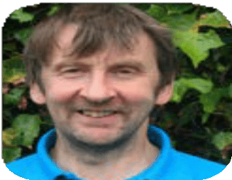



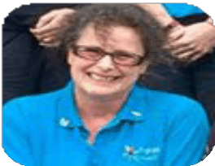
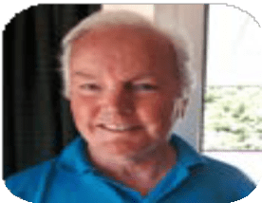

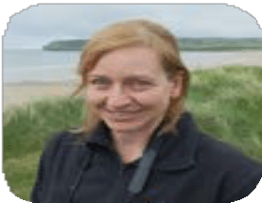
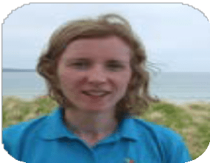
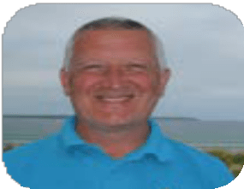
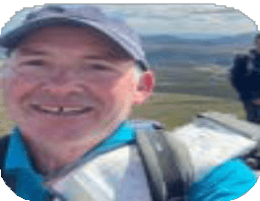
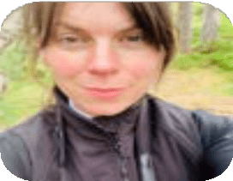

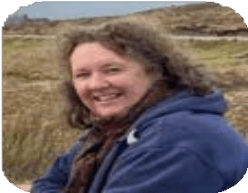
Pam Allan
Torrin Bunkhouse Warden (Skye)
Michelle Melville Highland Heritage Ranger (Lochaber based)
Donald Mitchell NW Sutherland
Countryside Ranger
Fiona MacLean Lochaber Countryside Ranger /Glennfinan Bunkhouse Supervisor






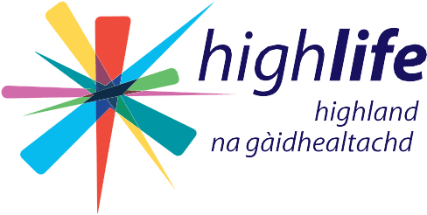
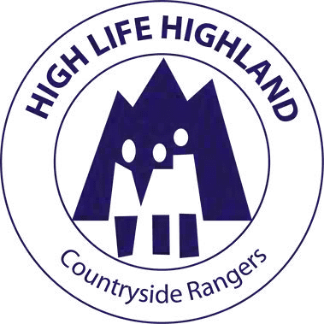
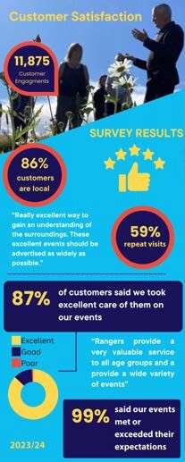
82

EXECUTIVE SUMMARY
The financial year 2023/24 was marked by success, with a 4% increase in face-to-face engagements, totalling 11,857 interactions. This reflects the dedication of the Ranger Service team and strong customer support.

Education and community outreach saw substantial growth, with
240 school visits engaging 5,898 students, while 21 classes accessed our Rangers' Google Classroom. A total of 449 community learning opportunities were offered, up 38% from the previous year, focusing on sustainability and environmental workshops.
In addition the grant-funded initiative ‘Shelf-Life’ allowed us to deliver climate education in libraries raising awareness of climate change and biodiversity loss. Volunteer involvement rose by 28%, highlighting increased community interest in environmental work.

Our wildlife work continued to strengthen, notable projects incude those in butterfly conservation, hedgehog and barn owl boxes, and seabird monitoring in collaboration with the British Ornithology Trust.

A key achievement in 23/24 was the Wildflower Meadow Creation project, which engaged over 1,000 individuals and established 60 mini-meadows, providing vital habitats for pollinators and showcasing collective conservation efforts.

Significant progress was made in raising income for High Life Services through Rangers managing two successful bunkhouse operations.

Digital engagement grew with the launch of Nature Unveiled, an online ranger publication that expanded our reach and provided new opportunities for interaction and environmental education.

In conclusion, the Ranger Service achieved significant growth and innovation, enhancing both digital and face-to-face engagements to make lives better for Highland communities

Imogen Furlong
High Life Highland Countryside Ranger Manager

4

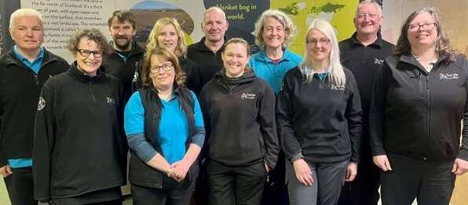

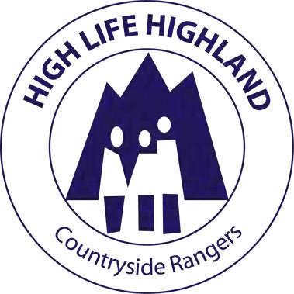
83

STRATEGIC PARTNERSHIPS
EDUCATION AND COUNTRYSIDE MANAGEMENT






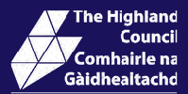
High Life Highland (HLH) Countryside Rangers have a central partnership with the Highland Council (HC) to deliver services within community and schools settings. We aim to have impact in the areas of environmental education and social responsibilty, by raising awareness of the Scottish Outdoor Access Code and providing community learning opportunites to engage with natural and heritage sites. HLH Rangers also aim to have a positive impact on local biodiversity, caring for and making habitat enhancements to a range of HC countryside sites. This contributes to both HC statutory biodiversity duties and HC ecology strategy, as well as providing on site support to HC access teams.
HEALTH & WELLBEING
Under the branding "Think Health Think Nature" the work of the Highland Green Health Partnership, , aims to encourage more use of the outdoors to promote outdoor physical activity, mental health improvement through nature connection and tackle health inequalities. HLH Ranger Service are both a strategic and delivery partner in this green health collaboration.
CLIMATE ACTION
High Life Highland Ranger service work strategically with both Highland Adapts and Highlands and Islands Climate Hub to create a prosperous climate ready Highland. Rangers support community action to create healthy eco-systems and promote nature positive solutions to climate change.
BIODIVERSITY
High Life Highland Countryside Rangers are partners within the Highland Environment Forum (HEF). HEF is funded by Highland Council and Forestry Land Scotland. The Edinburgh Declaration (2021) set out the commitments of members of the international community, the Scottish Government, its partners, and the wider local community in delivering for nature over the coming decade, by tackling biodiversity loss. This is delivered through the Highland Biodiversity Action Plan for which HLH Rangers are delivery partners.

Partner Funded projects in 2023/24

£11K from the Scottish Government's Nature Restoration Fund supported the Highland Wildflower Meadow Mosaic Project.
£5K from the Scottish Libraries Information Council funded Ranger-led Climate Change events in Highland libraries.

5

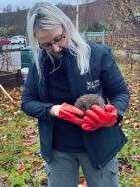

Hedgehog Habitat Improvements
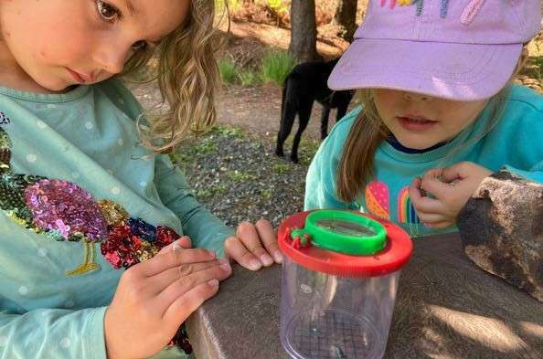
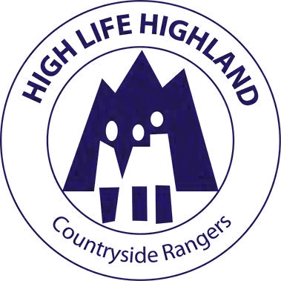
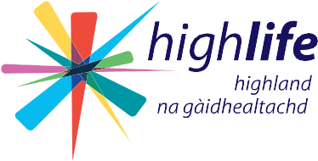

84

Photo:
Local Bio-blitz events teach species identification for biodiversity monitoring in Wester-Ross

BIODIVERSITY REPORT
Small grants and donations aid the High Life Highland Ranger Service to support our community work and wildlife assistance. In 2023/24, grants, fundraising and income generation facilitated important activities such as ranger led citizen science and biodiversity monitoring training. Habitat restoration projects, such as the Highland Wildflower mosaic project (see p7), repaired damaged ecosystems, while working togther with wildlife rescue operators and species specific conservation agencies saved and protected species. This work gets fed back into the Higland Council’s statuatory reporting on its biodiversity duties.
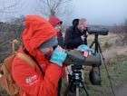
Community education programmes raised awareness about conservation (case study on p11), generating local support. Biodiversity monitoring ensured that interventions were effective and adaptive. These contributions have a direct, positive impact on biodiversity in the communities in our region, demonstrating how even modest funding can lead to significant environmental benefits. The four case studies of work in 2023/24 are highlighted on p7 and show how we are working towards achieving a sustainable coexistence between humans and wildlife.

Seabird survey
6





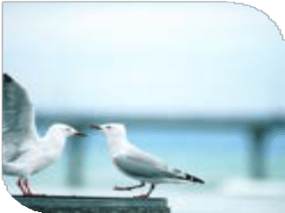
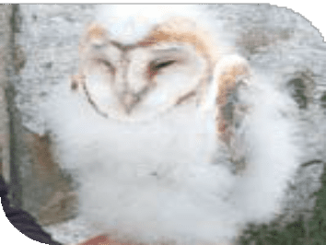
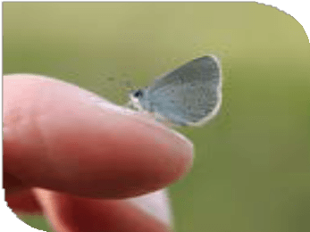

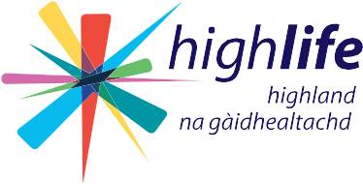

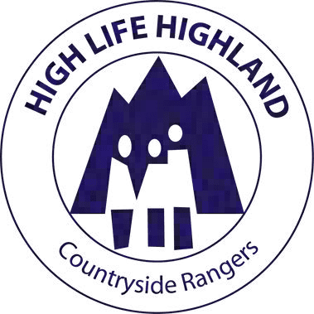
85

CASE STUDIES

Sea Gullsure Outlook - Surveys
The HLH Ranger team have contributed survey data to the British Trust for Ornithology (BTO), focusing in 23/24 on Sea Gull colony recording as part of the WinGS initiative. This vital work monitors gull populations, including red-listed species, and their wintering patterns, contributing to conservation efforts and enhancing our understanding of these important seabirds.

Butterfly conservation
John Orr, Inverness area Ranger and Paul Castle, North Sutherland and Caithness Ranger have been working closely with local volunteers and The Species on the Edge team within Butterfly Conservation Trust to seed sites with kidney vetch and birds-trefoil. These plants provide the habitat for the small blue and the dingy skipper butterflies. John has trained 15 new volunteers to undertake butterfly transects on the site.

Barn Owls
Public donations to our service have helped to create even more nesting sites in Sutherland for barn owls. The result has been really positive as breeding pairs are becoming more established in 2023/24. Andy Summers, Senior Ranger (North) has been monitoring progress and holds a licence to check these nests ,

Hedgehogs
Jenny Grant, Wester-Ross ranger and Fiona MacLean, Lochaber ranger have been working with wildlife rescue groups and communities to educate, and create hedghog friendly areas within urban and semi wild areas. These measures by the team and the local community groups and residents have seen new areas thrive as a hedgehog havens.

7

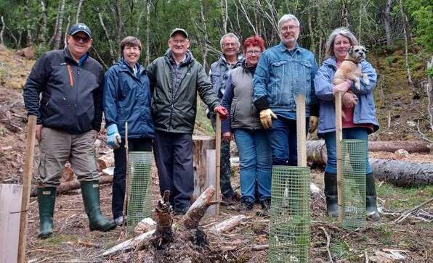

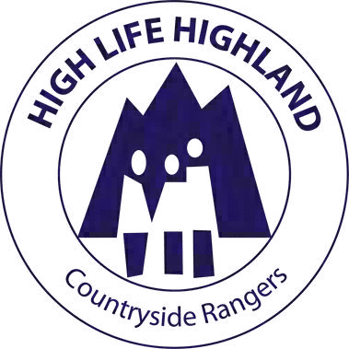
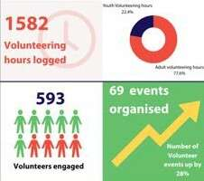
In 2023/24, the High Life Highland Ranger Service successfully organised 69 volunteer events, a 28% increase from the previous year. Our dedicated volunteers contributed 1,227 hours of adult volunteer time and 355 hours youth volunteer time, reflecting strong community commitment to nature.
86
Photo:
Volunteers tree planting native woodland species in Sutherland
VOLUNTEERING REPORT

With 593 volunteer engagements, our enhanced outreach efforts have developed a robust volunteer base, boosting our capacity to manage and preserve local natural areas. This remarkable participation aids in maintaining natural spaces and strengthens community bonds, promoting environmental stewardship.

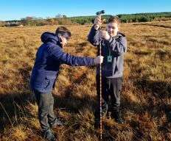
We extend our heartfelt gratitude to all our volunteers for their invaluable contributions.

Photo:
Young Volunteers undertaking peat monitoring


8
Beach Cleans Community Clean ups Footpath Maintainance Biodiversity monitoring Habitat Management Sessional delivery

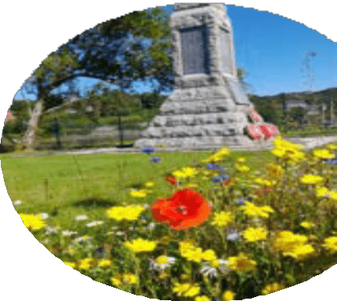
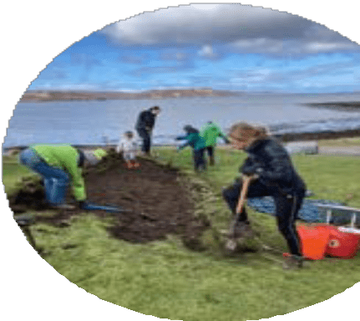
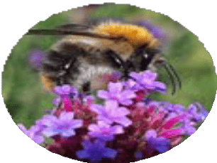
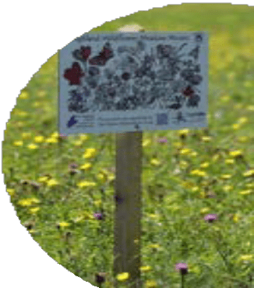
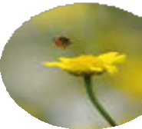
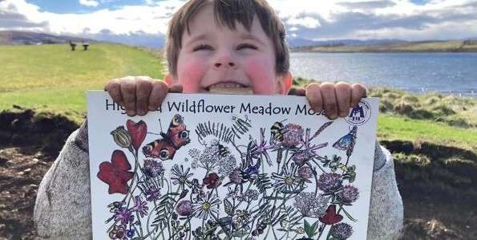
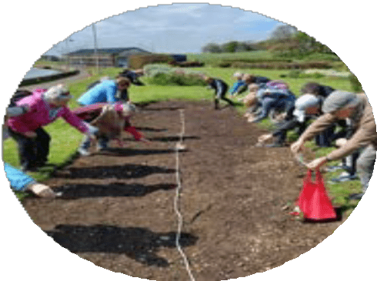
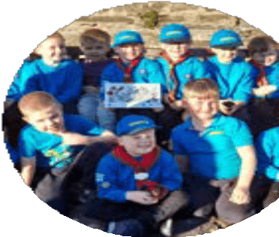



87

SHOWCASE
Highland Wildflower Meadow Mosaic
The Highland Wildflower Meadow Mosaic Project, led by the High Life Highland Countryside Rangers a community-driven initiative funded by a £11K grant from the Highland Council’s Nature Restoration Fund, aimed at reversing biodiversity loss. Engaging over 1,000 individuals in 23/24, the project established more than 60 wildflower mini-meadows across the Highlands, showcasing the power of collective action in conservation.

Key activities included identifying suitable sites with community input, securing necessary permissions, and preparing sites by lifting turf, planting seeds, and watering. The project emphasised community engagement, with 351 volunteers involved in meadow creation, 292 school children participating, and over 500 individuals attending workshops and events.

The project created a sustainable patchwork of wildflower meadows, enhancing local biodiversity and supporting pollinator populations. The initiative fostered community ownership and environmental stewardship, contributing to social cohesion and ecological awareness.

An interactive meadow map on the Highland Environment Forum webpage allowed for detailed progress tracking and increased community involvement.
https://www.highlandenvironmentforum.info/meadows-map/

The project has laid a foundation for ongoing environmental stewardship, ensuring the long-term success of these biodiversity havens. By fostering community commitment and providing ongoing support, the Highland Wildflower Meadow Mosaic Project serves as a replicable model for other regions.

This project demonstrates the significant impact of community involvement and innovative conservation practices on local ecosystems, making it a valuable case study in successful biodiversity restoration.
9

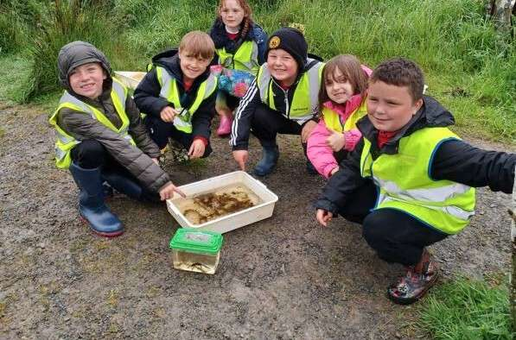


88

Photo:
engagements
92%
Increase in pupil
School Children learn about fresh water ecology in the puddles to pond project in Ross-shire

SCHOOL
240
School Ranger Visits
ENGAGEMENT
F
uture Plan

REPORT




During 2023/24, the ranger service significantly boosted its school engagement, conducting 240 school visits— a 100% increase from 120 in 2022/23. We engaged with 5,898 students, a 92% rise from the previous year. This growth was driven by successful initiatives such as the wildflower meadow project, which provided hands-on biodiversity enhancement experiences.

Teaching the Scottish Outdoor Access Code is vital in ensuring understanding and respect for the environment among young people. Our activities not only do this but also promote STEM (Science, Technology, Engineering, and Mathematics) and align with Learning for Sustainability (LfS) principles.

Our diverse delivery included a variety of exciting hands on conservation opportunities from fieldwork at Forsinard Flow Country to understanding freshwater ecology at both off-site and onsite sessions on school grounds. All sessions are designed to be inclusive and can be adapted to all ages and key stages.

We organised a wildflower poetry competition in both Gaelic and English, collaborated with the Royal Highland Education Trust to deliver farming lessons. Additionally, our presence at the Caithness and Dingwall science festivals, held at the respective high school campuses, highlighted our commitment to integrating environmental education within the broader school curriculum
10

89

62 Schools

engaged in 2023/24
(* those who partisipated in the wildflower project)

Caithness and Sutherland

Lochinver* Kinlochbervie* Durness* Tongue* Watten* Keiss*
Noss*
Scourie*

Inverness/Nairn/ Badenoch and Strathspey

Newton park* Dunbeath* Halkirk* Melvich* Pennyland* Castletown* Canisbay
Miller Academy Mount Pleasant Crossroads Scallywags ELC Kinlochbervie High Wick High
Thurso High
Aviemore * Newtonmore * Carrbridge * Grantown * Auldearn* Aldourie Drummond * Dochgarroch * Teanassie * Farr
Muirton Inverness High
Inverness Royal Academy

Wester Ross
Ullapool* Ullapool High Achiltibuie* Gairloch* Lochcarron* Scoraig* Bualnaluib* Poolewe* Applecross*

Lochaber
Ardgour * Lochaline * Lady Lovat * Arisaig * Caol * Banavie * Duror
Bun-sgoil Ghàidhlig

Easter Ross and SE Sutherland
Tarradale* Golspie*
Hill of Fearn* Culbokie* Avoch* Tore* Gledfield* Rogart* Kiltearn
Dingwall Academy*





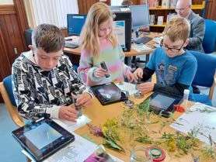
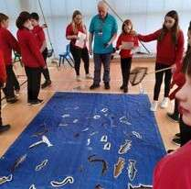
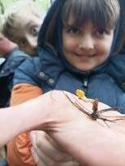
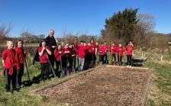
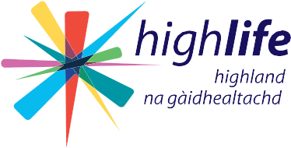
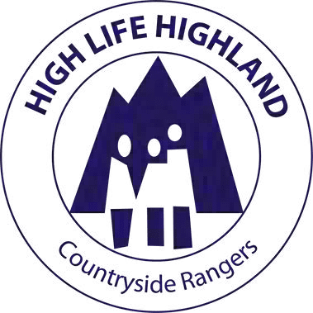

11

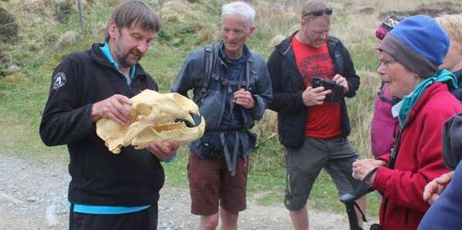
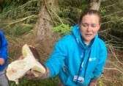
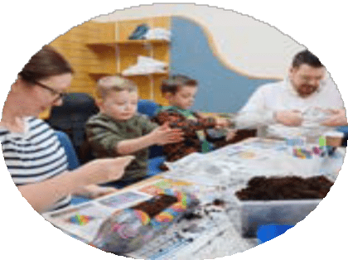
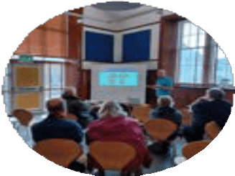

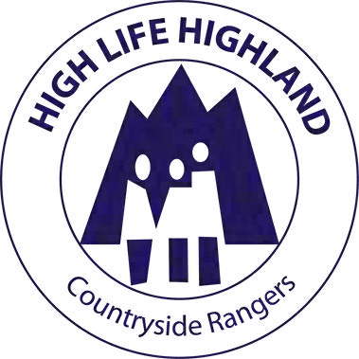
90

Photo:
COMMUNITY LEARNING REPORT
Participants learn about climate change and look at ice age relic bones on a guided walk in Sutherland

NATURE UNVEILED
Launched in November 2023, "Nature Unveiled" quickly gained over 200 subscribers by March 2024. This learning portal provides fun and accessible information about Highlands ecology, showcasing rangers' work and community conservation efforts. It promotes citizen science projects, engaging residents and visitors in preserving the region's heritage, and emphasises the vital connection between people and nature. We will start to report on digital engagments next year. https://highlifehighlandranger.substack.com
449
Communty Learning Opportunuties
During 2023/24, our ranger service engaged the community through 449 events, focusing on education for all ages. Highlights include Easter family fun events attracting large numbers of attendees, and highlighting the importance of families learning together. In total we saw 5382 learner engagements - an increase of 38%.

Our environmental educational outreach spanned diverse demographics, with a range of exciting in person learning opportunities, such as the whale and dolphin watching, the sand sculpture at Clachtoll (covered by STV news), bat walks, fungi forays, bird watching, nature safaris and other guided walks.

Rangers also delivered climate change learning sessions in libraries supported by the Scottish Library Information Council - engaging with over 150 participants of all ages. These sessions spoke to environmental stewardship and carbon literacy . A popular programme monthly talks held over the winter on topics like puffins and beavers demonstrated our commitment to accessible education being undertaken in a combination of online and at local venues.

Heritage events, teaching traditional crafts such wool crafting and leather working, the ‘wild escapes’ project working with several museums, and historic archeology walks such visits to The Schold sheilings - showcase the diverse community heritage learning opportunities on offer.
12

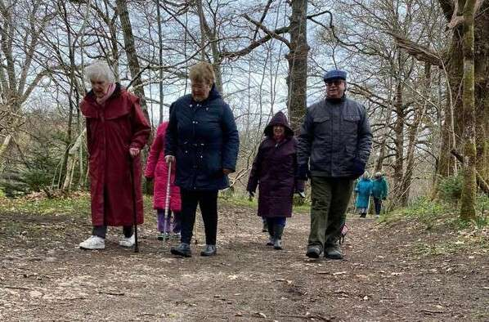


91
HEALTH ANutur FPlan WELLBEINGe REPORT
D

Photo:
Participants take a leisurely stroll in a regular themed nature walk in Lochaber

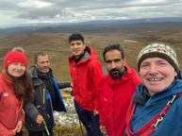
In 2023/24 the HLH Rangers significantly contributed to the Green Health Partnership. We were represented at the Green Health showcase event in May 2023, sharing a stall in the Atrium with Inverness Botanic Gardens and engaging with partners about our Nature, Health, and Wellbeing projects. The Healthy Minds project was highlighted at the event as an example of best practice with a short film presented to community planning partners.
COLLABORATIONS
Collaborating with NHS Highland, we built relationships with New Craigs hospital, delivered at their summer community fete, and provided mental health interventions such as Branching Out at Evanton and the Healthy Minds project in Badenoch and Strathspey. We also delivered sessions for the Brora Macular Support Group in Sutherland. HLH Rangers engaged in activities such as hill walking with High Life's Adult Learning team and Afghan Refugee groups. Staple events like family reading in the woodland, short walks to nature, and Connecting Carers nature walks continued. Ranger led craft events in libraries and other local outdoor venues thrived. The social prescription pilot study of nature and culture activities with UHI/Edinburgh University concluded.
13

92

Ways you can support us

Join highlife
Joining High Life supports our charity work to
improve lives and communities, membership
also gives free access to gym and leisure facilities, plus numerous discount benefits. Support us and Join High Life today!
Book a break at our bunkhouse
Why not relax and book a short break at our bunkhouse in one of two iconic Highland locations: Torrin on Skye and Glenfinnan in Lochaber.
Operated as a not-for-profit, any surplus benefits the charity. Enjoy a warm welcome from our wardens Pam and Fiona. Its the perfect getaway for groups or families. Scan or click for more information.
Read
Discover Nature Unveiled our HLH Ranger online publication filled with fascinating stories, nature and heritage articles, and news from our dedicated team of Rangers. Scan or click to read and pledge your support.

Donate
Give a one off gift to the Ranger service to support our conservation, education, and community work in the Highlands. Help us protect wildlife and sustain this unique region's natural heritage for future generations. Scan or click to donate now.

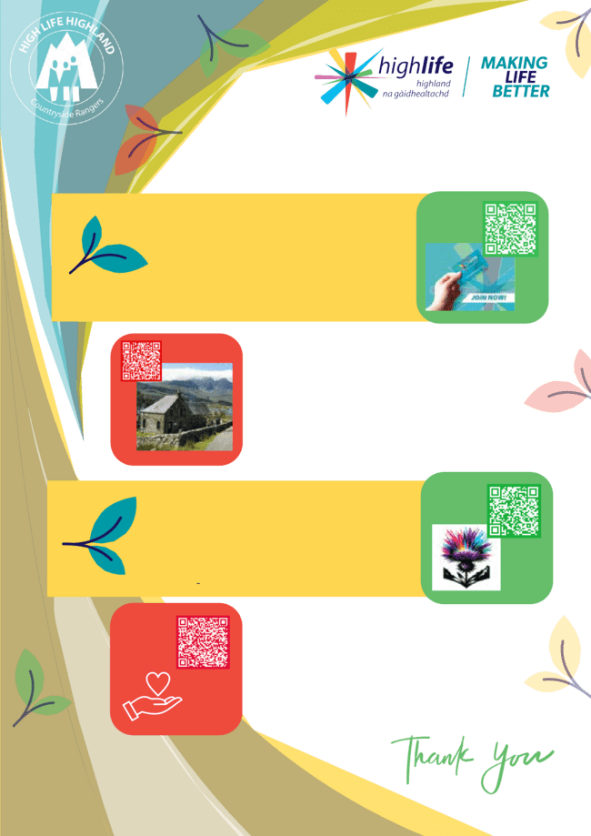
High Life Highland is a registered Scottish charity No. SC042593. Registered office Highland Archive Centre, Bught Road, Inverness, IV3 5SS.

highlifehighland.com/rangers

