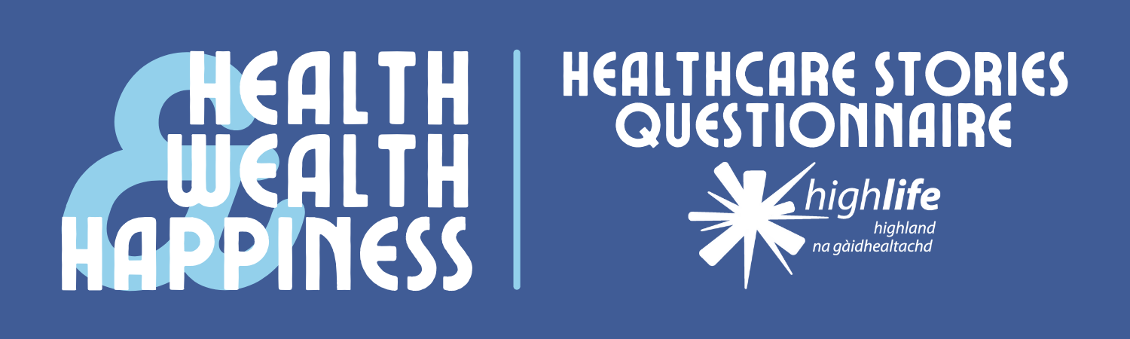
Do you have an item which tells a healthcare story? You can help Inverness Museum build a picture of life across the Highlands by offering to donate or loan a healthcare item (or items) to our collection.
Your contribution can relate to mental, physical, or social health; or reflect a lifestyle, occupation, or community. It doesn’t have to be old, expensive, or unique - all it has to do is tell a story.
We’ll give you the option to choose if you want your contributions to be credited or remain anonymous to the public.
A selection of items donated to Inverness Museum will be featured in our Health, Wealth, and Happiness exhibition on the history of healthcare in the Highlands. Launching in spring 2022, it will be shown in Inverness and Thurso.

- Please provide the following information.

Name [required]:

Occupation:

Address [required]:

Email [required]:

Telephone:

- Please give a description of the item(s) which you would be willing to donate or loan to Inverness Museum. [required]

- Please share any stories or additional information about your item(s) in the box below.

- Selected contributions will be shared online and in our Health, Wealth, and Happiness exhibition. Would you be happy to have your name and general place of residence shared publicly alongside your contribution? (e.g John Mackenzie of Dingwall) [required]

Please note that we will hold your details in accordance with GDPR regulations.

☐ Yes, I am happy to be publicly credited

☐ No, I wish for my contribution to remain anonymous to the public

- ☐ I understand that my details will be retained in accordance with GDPR regulations and Inverness Museum’s privacy policy. [required]

Thank you for supporting Inverness Museum by taking part in our survey. Please email your completed form to Museum Assistant Joe at joe.setch@highlifehighland.com, or post it to the following address:
Joe Setch
Inverness Museum & Art Gallery
Castle Wynd
Inverness
IV2 3EB

We’ll be in touch to follow up on your offer to donate or loan your items.
Please be aware that there are some donations which we may not be able to accept. Although we’re grateful for every contribution, sometimes an item can be too big, too fragile, or too similar to something we already have in our collection.
You can keep up-to-date with our Health, Wealth, and Happiness project by following Inverness Museum on Facebook, Instagram, and Twitter.

