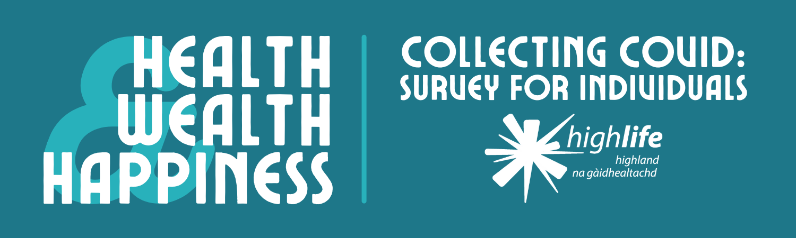
Inverness Museum is seeking help from businesses, groups, and individuals to create an archive that will reflect experiences of the pandemic in the Highlands and the NHS Highland area.
By adding your stories, items, and images to this archive, you’ll be leaving a record for future generations to appreciate and explore. We’ll give you the option to choose if you want your contributions to be credited or remain anonymous to the public.
A selection of these items and experiences will feature in Inverness Museum’s our Health, Wealth, and Happiness exhibition on the history of healthcare in the Highlands. This exhibition, which launches in the spring of 2022, will be shown in Inverness and Thurso.

- Please provide the following information.

Name [required]:

Occupation:

Address [required]:

Email [required]:

Telephone:

- What impact has the pandemic, and the regulations to control it, had on your life? [required]

- Do you have any items which illustrate your experience of the pandemic, and which you would be willing to loan or donate to our Collecting Covid archive? (e.g. posters, papers, letters, masks, equipment, memorabilia)
If yes, please describe these items below. The Inverness Museum team will contact you about including them in the Collecting Covid archive.

- Do you have any photographs of your experience of the pandemic that you would be willing to include in our Collecting Covid archive?
(e.g. photos of life events, socially-distanced gatherings, and changes at home, work, or outside.) [required]

If your answer is yes, the Inverness Museum team will contact you directly to discuss adding these images to our archive.

☐ Yes ☐ No

- Do you have any other Covid-related experiences, items, or information that you would like to share as part of our Collecting Covid archive? Please include any additional information below.

- Selected contributions to our Collecting Covid archive will be included in our exhibition and online. Would you be happy to have your name and general place of residence shared publicly alongside your contribution?
(e.g John Mackenzie of Dingwall) [required]

Please note that we will hold your details in accordance with GDPR regulations.

☐ Yes, I am happy to be publicly credited

☐ No, I wish for my contribution to remain anonymous to the public

- ☐ I understand that my details will be retained in accordance with GDPR regulations and Inverness Museum’s privacy policy. [required]

Thank you for supporting Inverness Museum by taking part in our survey. Please email your completed form to Museum Assistant Joe at joe.setch@highlifehighland.com, or post it to the following address:
Joe Setch
Inverness Museum & Art Gallery
Castle Wynd
Inverness
IV2 3EB

We’ll be in touch to follow up on your offer to donate or loan your items.
Please be aware that there are some donations which we may not be able to accept. Although we’re grateful for every contribution, sometimes an item can be too big, too fragile, or too similar to something we already have in our collection.
You can keep up-to-date with our Health, Wealth, and Happiness project by following Inverness Museum on Facebook, Instagram, and Twitter.

