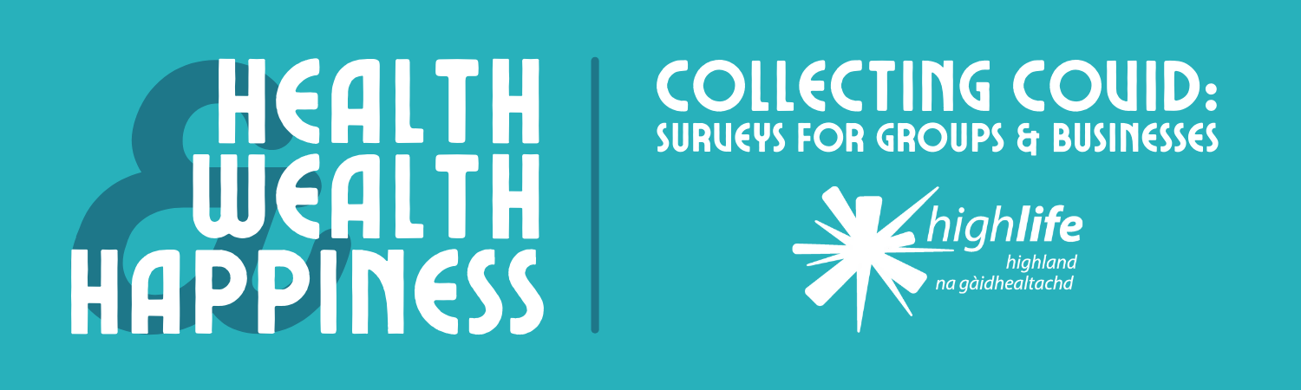

**Inverness Museum is seeking help from businesses, groups, and individuals to create an archive that will reflect experiences of the pandemic in the Highlands and the NHS Highland area.**

By adding your stories, items, and images to this archive, you’ll be leaving a record for future generations to appreciate and explore. We’ll give you the option to choose if you want your contributions to be credited or remain anonymous to the public.

A selection of these items and experiences will feature in Inverness Museum’s our [*Health, Wealth, and Happiness*](https://www.highlifehighland.com/inverness-museum-and-art-gallery/health-wealth-and-happiness-project/) exhibition on the history of healthcare in the Highlands. This exhibition, which launches in the spring of 2022, will be shown in Inverness and Thurso.

1. **Please provide the name, address, and contact details of your group or business.**

Contact name [required]:

Name of group or business [required]:

Address or web address of group or business:

Email [required]:

Telephone:

2. **Please write a brief description of your group or business.** [required]

(e.g. Inverness Museum & Art Gallery has 1 premises and 15 staff, operating since 1823. Collects and displays items relating to life in the Highlands.)

1. **What impact has the pandemic, and the regulations to control it, had on your group or business?** (e.g. Did you close premises or stop operating altogether? Did you move online? Did you adapt your services, products, or purpose as regulations changed? Did the changes present any opportunities, or only challenges?)[required]
2. **Do you have any items which illustrate your experience of the pandemic, and which you would be willing to loan or donate to our *Collecting Covid* archive?**

(e.g. social distancing signage or pavement stickers, ‘closed’ signs, ‘card payments only’ signs, branded masks or sanitiser bottles.)[required]

Yes  No

If yes, please describe these items. The Inverness Museum team will contact you to discuss including them in the *Collecting Covid* archive.

1. **Do you have any photographs of your experience of the pandemic that you would be willing to include in our *Collecting Covid* archive?**

(e.g. photos of signage, changes to interiors, staff in PPE, rainbows showing support for the NHS, customers queuing 2m apart, online meetings or events)[required]

If your answer is yes, the Inverness Museum team will contact you directly to discuss adding these images to our archive.

Yes  No

1. **Do you have any other Covid-related experiences, items, or information that you would like to share as part of our *Collecting Covid* archive? If yes, please include your additional information below.**
2. **Selected contributions to our *Collecting Covid* archive will be included in our exhibition and online. Would you be happy to have your name, group or business name, and general location shared publicly alongside your contribution?** (e.g John Mackenzie of Mackenzie’s Music Shop, Dingwall) [required]

Please note that we will hold your details in accordance with GDPR regulations.

Yes, I am happy to be publicly credited

No, I wish for my contribution to remain anonymous to the public

1. ­­ **I understand that my details will be retained in accordance with GDPR regulations and** [**Inverness Museum’s privacy policy**](https://www.highlifehighland.com/gdpr/wp-content/uploads/sites/229/2021/07/Privacy-Policy-Collections-Management.pdf). [required]

Thank you for supporting Inverness Museum by taking part in our survey. Please email your completed form to Museum Assistant Joe at [joe.setch@highlifehighland.com](mailto:joe.setch@highlifehighland.com), or post it to the following address:

Joe Setch

Inverness Museum & Art Gallery

Castle Wynd

Inverness

IV2 3EB

We’ll be in touch to follow up on your offer to donate or loan your items.

Please be aware that there are some donations which we may not be able to accept. Although we’re grateful for every contribution, sometimes an item can be too big, too fragile, or too similar to something we already have in our collection.

You can keep up-to-date with our *Health, Wealth, and Happiness* project by following Inverness Museum on [**Facebook**](https://www.facebook.com/InvMAG), [**Instagram**](https://www.instagram.com/invernessmuseumandartgallery/), and [**Twitter**](https://twitter.com/InvMAG).